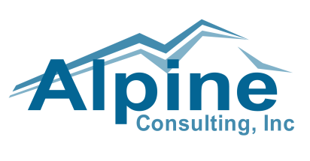
Marketing Internship

Alpine Consulting, is an award winning Solution Provider specializing in Information Management, eCommerce, Managed Services and Enterprise Analytics for medium-market and larger companies. Alpine's vertical expertise spans manufacturing, wholesale, retail, insurance, distribution, financial services, gaming and transportation.

With over 17 years’ experience delivering end-to-end solutions for mid-market and enterprise customers alike, Alpine's expertise ensures our client success. Our expertise includes technologies such as Magento, Cognos, IBM Information Management, IBM WebSphere, i2, SPSS and Informatica.

Alpine Consulting is seeking a highly motivated Intern working towards a degree in marketing (or a related field). This position will be based in San Antonio, Texas, working with our Director of Marketing. This position is being sought for the summer but we would consider some part time on-going for the right individual as well.

As an Intern for Alpine Consulting, you will be involved in developing creative ads to help promote and brand Alpine Consulting to clients, prospects, partners, employees and prospective employees as well as others seeking information about Alpine Consulting.
You will be responsible for assisting with maintaining our web site, developing and assembling creative content, printed or electronic brochures about Alpine and who we are and what we do. The Intern will assemble Power Point presentations to aid our sales team and when engaging with our strategic partners. You will work alongside the sales team to help assemble custom content that may be used for a particular sales proposal, RFI or a trade show.
We are looking for an individual that is able to work independently and take the initiative to lead these overall efforts. The right candidate would coordinate various parties, write creatively in such a way that positions and enhances the Alpine brand, assemble and coordinate content for use in various mediums, and is able to communicate with all parties.

The following background and experience is required for this Internship:
- Skilled with Adobe PhotoShop
- Skilled with Adobe InDesign
- Ability to write creatively in a professional environment to put compelling invitations together that will be sent via large scale eMail campaigns
- Major in Marketing
- Ability to think independently
- Fundamental skills with Microsoft Office (word, excel, powerpoint, outlook)

Additional skills which would be very helpful include:
- Knowledge of WordPress
- Knowledge/awareness of Hubspot
- Any experience in helping prepare for trade shows or events

If you possess the required background and are looking to gain exciting and broad experiences that will propel your career, please send your resume directly to Kathy Monte-Christo, Corporate Recruiter at Alpine Consulting. kathymc@alpineinc.com 224-520-7426

