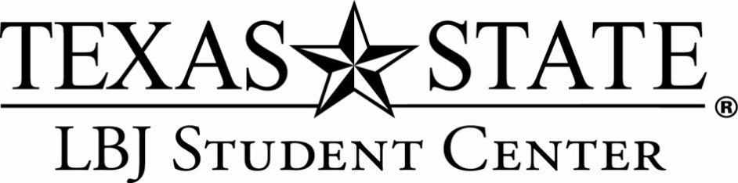
Student Employee Confidentiality Agreement

As a student employee of the LBJ Student Center, I recognize that I may have access to
records that contain individually identifiable information, the disclosure of which is
prohibited by the Family Education Rights and Privacy Act of 1974 (FERPA). Releasing
this information could be damaging to the student/supervisor involved and could result in
legal ramifications.

I acknowledge that I fully understand that the intentional disclosure by me of this
information to any unauthorized person could subject me to the University Judicial Process
and/or criminal and civil penalties by law. I further acknowledge that such willful or
unauthorized disclosure also violates Texas State University’s policy and could constitute
just cause for disciplinary action including termination of my employment regardless of
whether criminal or civil penalties are imposed.

I also understand that I am not permitted to enter or modify any information or grades on
my own academic or financial records.

If determined that I have altered or deleted any student’s financial or educational records
without any authorization while in my tenure of duties, this will be sufficient cause for
immediate discharge and disciplinary action.

Student Employee Signature Date

Student Employee Name (printed)

__________________________________
Witness Signature

