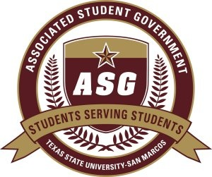
Author:
Senator Justin Solomon

Sponsors:
Senator Adam French
Senator Maxfield Baker
Senator Dominique Jackson
Senator Adam Brass
Senator Andrew Henley

Date of First Reading: March 5th 2012

S.R.S. 2011-2012/

“Amendment of Associated Student Government Scholarship Requirements”

WHEREAS: The Associated Student Government serves as the voice of the student body; and

WHEREAS: The Associated Student Government negotiated funding for merit-based scholarships for undergraduate and graduate students and established eligibility requirements for students and distribution of aforementioned awards; and

WHEREAS: Current federal and state economic conditions have unduly increased the financial burdens upon students of Texas State University; and

WHEREAS: It is recognized that it is possible for a student to receive a grant that does not cover the full cost of tuition, fees and associated costs of higher education; and

WHEREAS: It is the position of the Associated Student Government to reward students committed to furthering their intellectual pursuits whilst being engaged in Texas State University and, maintaining satisfactory academic progress; therefore

BE IT RESOLVED: That the eligibility requirement stating that a student, “cannot be receiving need-based aid except for loans and work-study only (if you are receiving grants, you do not qualify),” be removed as a requirement for both undergraduate and graduate students of Texas State University; and

BE IT FURTHER RESOLVED: That this eligibility change go into effect for the 2012-2013 Academic Year upon passage of this bill and will be enforced in all cases as it pertains to Associated Student Government scholarships in perpetuity; and

BE IT FURTHER RESOLVED: That this piece of legislation be forwarded to ASG Advisor Kathy Weiser, Dean of Students Dr. Margarita Arellano, Vice President for Student Affairs Dr. Joanne Smith, Director of Financial Aid and Scholarships Dr. Christopher Murr and President Dr. Denise Trauth upon passage.

