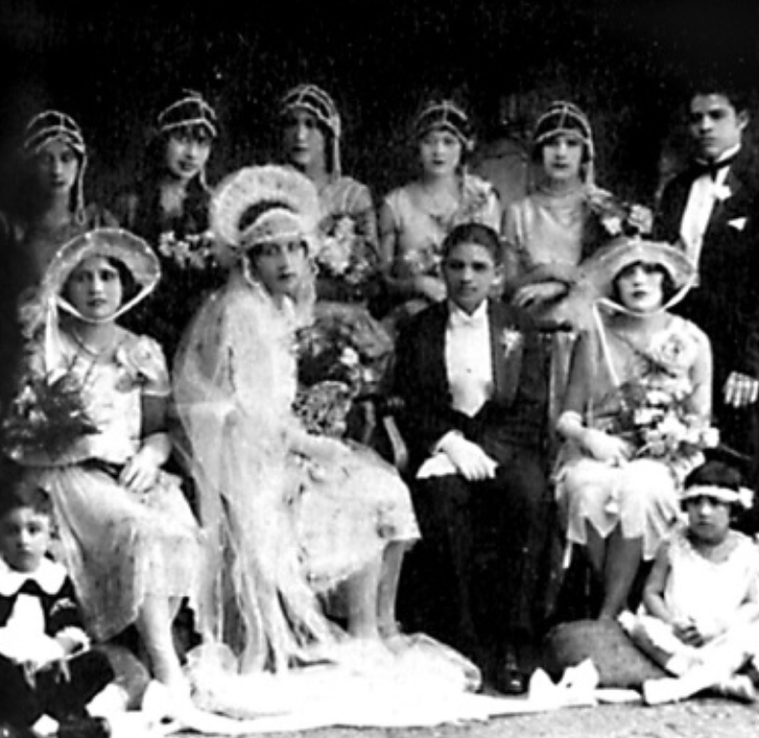

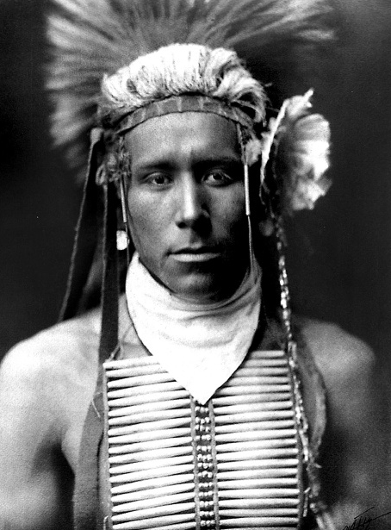

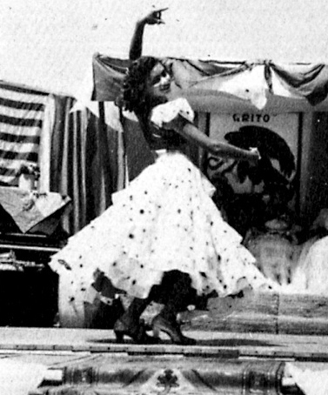

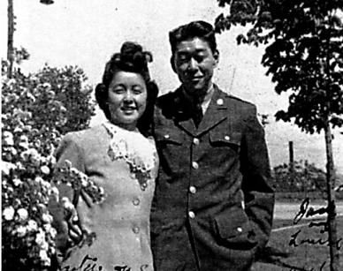

General Requirement Block

ANTH 3324 Mexican American Culture
CJ 4326 Women and Criminal Justice
ENG 3331 Literature of Black America
ENG 3344 Chicano/a Narrative and Social History
GEO 3308 Latin America
GEO 3329 Geography of Texas
HIST 1310 History of Europe, 1815-1919
HIST 3359 African-American History
HIST 3372 Texas History: A Survey
HIST 3373 Special Topics in American Women’s History
HIST 4371 Introduction to American Indian History
PHIL 4372 Latin American Philosophy
POSI 3395 Ethnicity and Nation Building
POSI 4331 Minority Politics
SPAN 3305 Survey of Spanish-American Literature
SPAN 3371 Spanish-American Civilization
SOCI 3350 Men, Women, and Societies
WS 3376 Images of Women

General Concepts Block

ANTH 1312 Cultural Anthropology
ANTH 3301 Principals of Cultural Anthropology
ANTH 3309 Cultures Through Film
COMM 3329 Intercultural Communication
COMM 4322 Rhetoric of Protest Movements
ENG 3345 Southwestern Studies I: Defining the Region
HIST 3375A American Labor History, 1877-1945
HIST 3372 Texas Histories: A Survey
HIST 4337 Germany and National Socialism, 1918—1945
HIST 4376 History of Texas Music
POSI 3319 Metropolitan Politics
POSI 3395 Ethnicity and Nation Building
PSY 3334 Psychology of Human Diversity
SOWK 4310 Social Services to Minorities
SOCI 3327 Multicultural Relations

Center for Multicultural and Gender Studies
Dr. Audwin Anderson, Director
Center for Multicultural and Gender Studies
UAC 478
512-245-2361
www.txstate.edu/mcgs

Texas State University
is a member of the Texas State
University System

