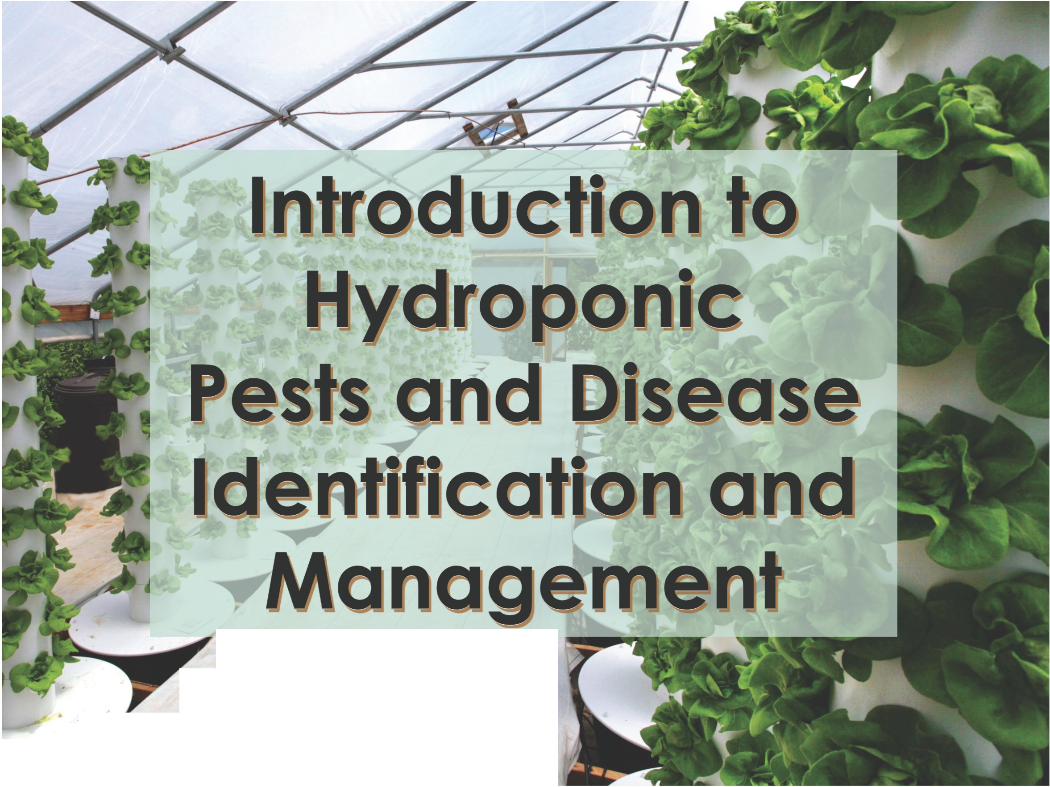

/
I
I
/
_,_/ I I
2
/

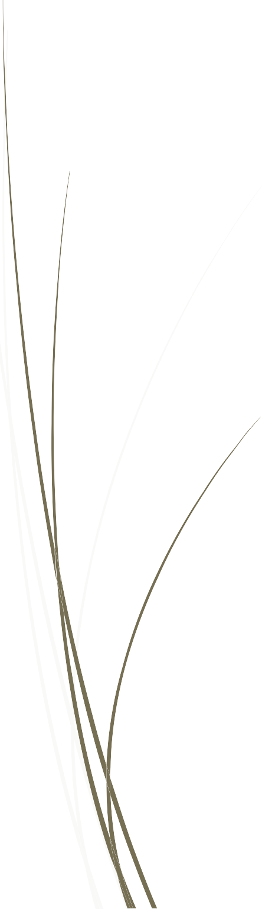
Objectives
Students will be able to:
- Define the basic types of pests and diseases found in hydroponic systems
- Define beneficial and pest
- Identify the common pests
- Identify the common beneficials

Reading Materials
https://extension.psu.edu/pythium https://www.maximumyield.com/parasitic-pathogens-infectious-diseases-in-
hydroponics/2/1317 https://www.uky.edu/Ag/CCD/introsheets/hydrolettuce.pdf http://www.hydroponics.com.au/issue-111-keeping-it-clean/ http://plantclinic.cornell.edu/factsheets/basildiseases.pdf

Pests in Hydroponic Systems
Definition: anything that damages the economic outcome of production

Types of pests

Microscopic: viroids, virus, bacteria, fungus,

Macroscopic: invertebrates (annelids, nematodes, insects), rats, mice, cats, snakes

Pests in Hydroponic Systems
Viroids and Virus: Cause plant death, deformaties and low yield

Viroids are composed of a short strand of circular, single- stranded RNA without protein coat

Two families:
Pospiviroidae – infect potato, tomato, citrus, hops, apple, coconut
Avsunviroidae – avocado, peach and eggplant (a hydroponic crop)

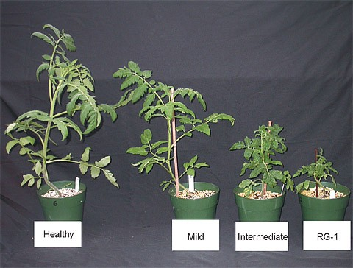
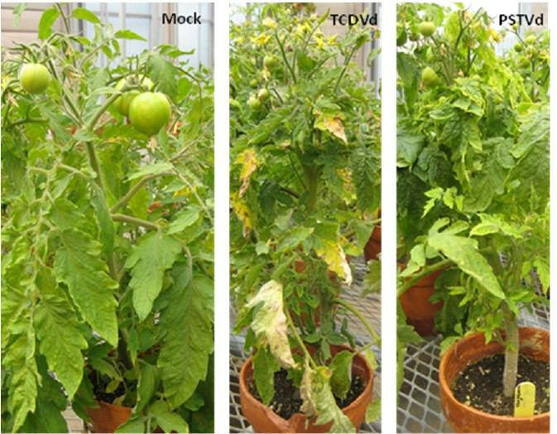

Viroid infected tomatoes

Pests in Hydroponic Systems
Bacteria: microscopic single-celled organisms. Pathogenic, beneficial and commensal.

Beneficial bacteria include:
Baccilus thuringensis (Bt) a larvacide Rhizobium spp a symbiotic nitrogen fixer Frankia spp a non-symbiotic nitrogen fixer And many more

Pathogenic bacteria include:
Psuedomonas syringae with more than 50 pathogenic variants

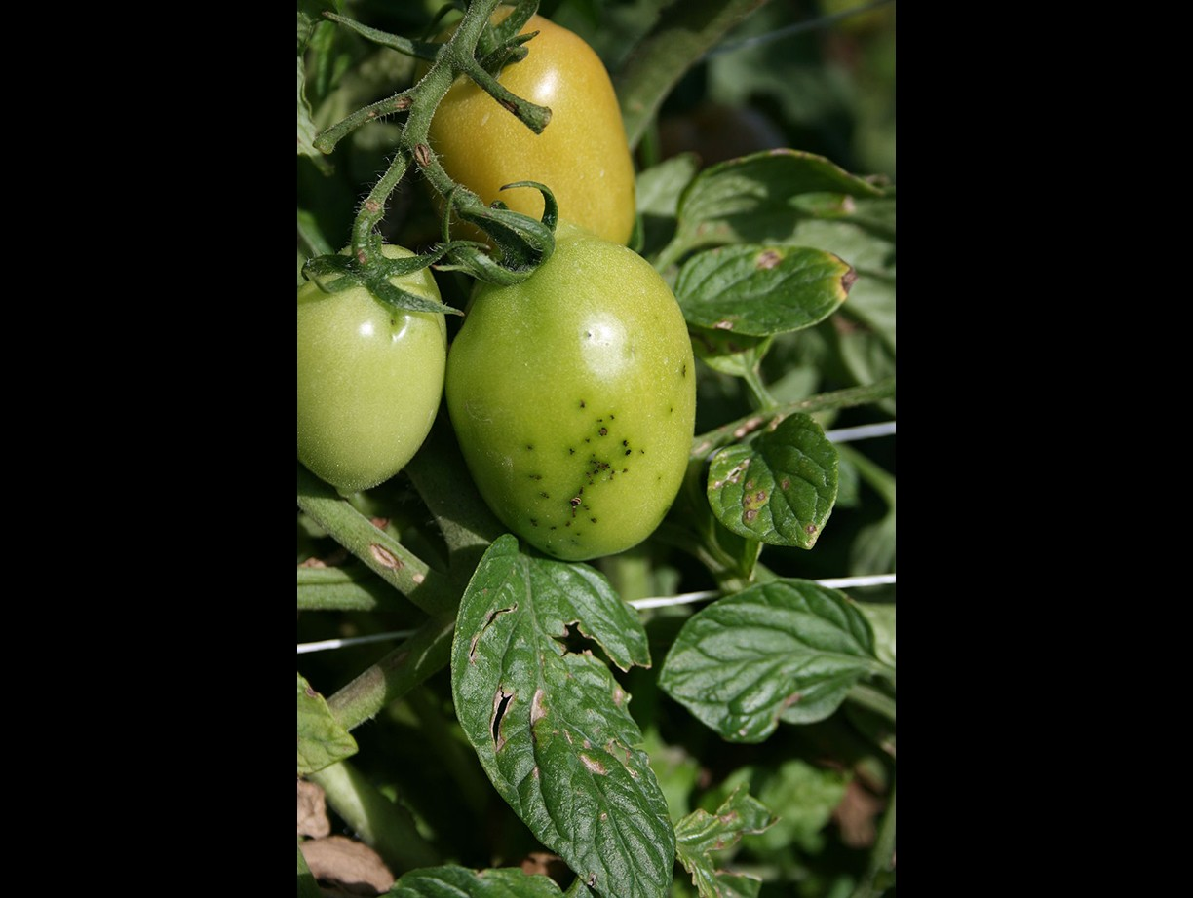
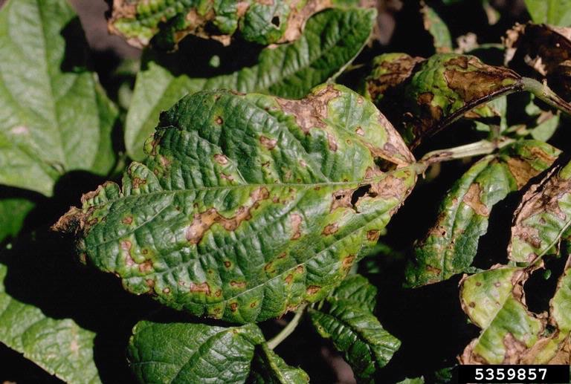

Below: Psuedomonas syringae presented as bacterial speck on tomato fruit

Above: Psuedomonas savastanoi pv. phaseolicola presented as bacterial speck on common bean leaves

Pests in Hydroponic Systems
Fungus: infectious, saprophytic organisms. They can be single-celled to largest known organism on the planet.

Beneficial fungus include:
yeasts
Botrytis cinerea – noble rot in grapes multiple mycorrhizae spp

Pathogenic fungus include:
Ascomycetes:
Fusarium spp Verticillum spp Sclerotinia sclerotiorum
Botrytis cinerea – gray mold
Colletotrichum orbiculare -
Anthracnose
Basidiomycetes:
Rhizoctonia spp Ustilago spp (smuts)
Oomycetes:
Peronospora belbahrii - mildew
*Anthracnose – a symptom not a species

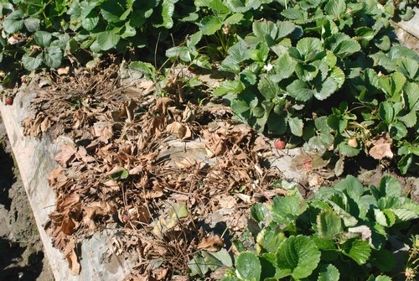
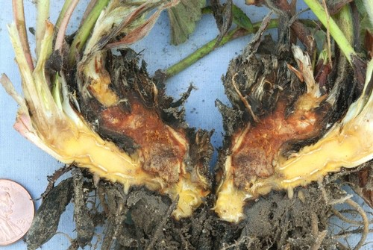

Figure 2. Internal crown tissue of strawberry infected with Fusarium will show a dark to orange brown discoloration.

Figure 1. Fusarium results in the collapse and death of strawberry plants.

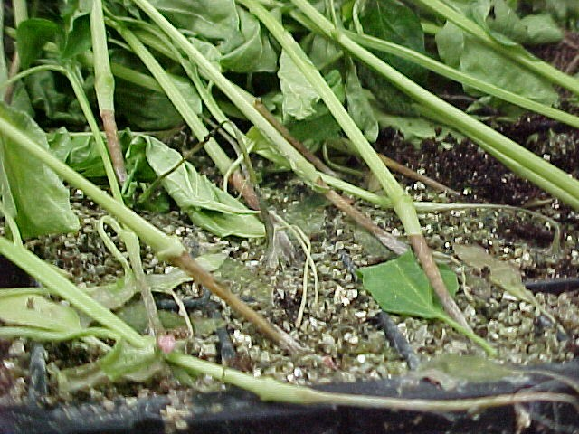
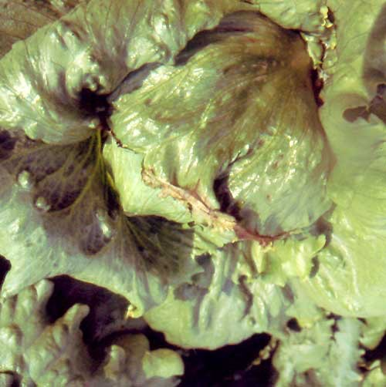
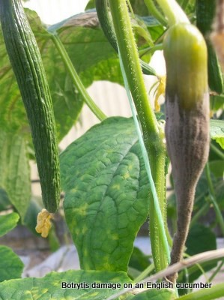
Girding lesions caused by Rhizoctonia solani

Botrytis cinerea
- Gray mold

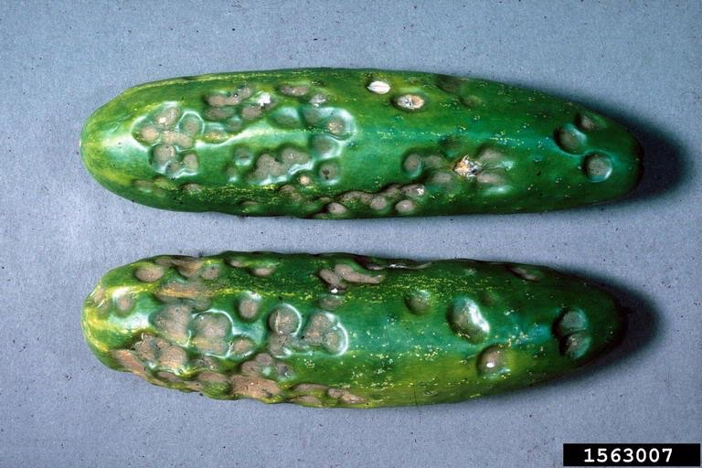
Anthracnose - Colletotrichum orbiculare

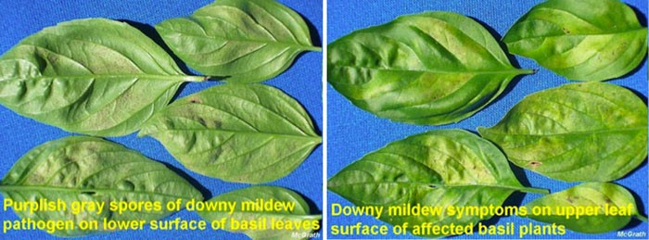

Downy mildew of basil, caused by the oomycete pathogen Peronospora belbahrii,

Pests in Hydroponic Systems

Fungus control:

Sanitation – sterilize equipment between bays Use sanitation entry –
Sodium bicarbonate (baking soda) has been effective against several fungal species and particularly powdery mildew races.
Baking soda/oil sprays also provided good control of urocladium leaf spot in cucumber, alternaria leaf blight in muskmelon, and gummy stem blight in muskmelon. Other diseases against which baking soda may prove effective include anthracnose in cucurbits; rust, dollar spot.

Pests in Hydroponic Systems
Invertebrates: Any organism within the Animal kingdom without a notochord

Beneficial invertebrates include: Hymenoptera Coleoptera
Diptera Nematoda

Pest invertebrates include: Blattodea
Diptera Homoptera Nematoda

Pests in Hydroponic Systems
Blattodea – roaches

Their main food is decaying organic matter. Therefore remove all debris and organic plant waste from any non- growing area.

Use borax box baits – if label allows

Introduce Ampulex compressa and Evaniidae wasps. The former is a predator/parasitoid and the latter a egg parasitoid

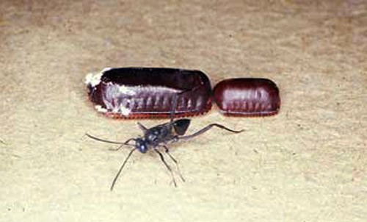
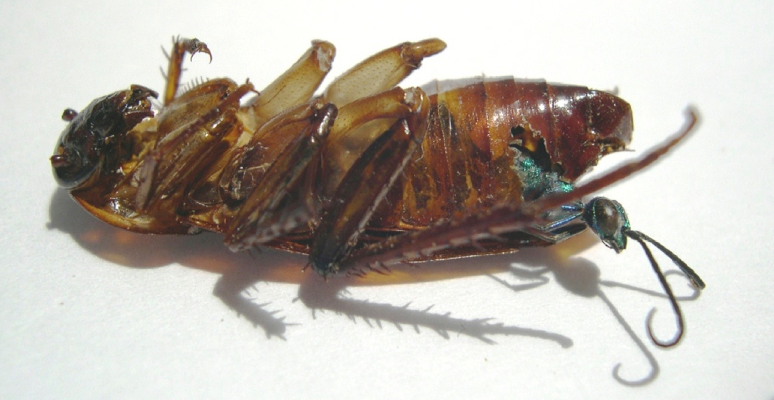

https://youtu.be/rQAa0VtD32U

Pests in Hydroponic Systems
Diptera – flies

Fly pests can have many forms and foods. Fruit flies will infest overripe fruit, especially strawberry.

Fungus gnats will be a nuisance and reduce plant growth if feeding on roots; also invite disease. They are also a sign the media is not properly dried between wetting intervals

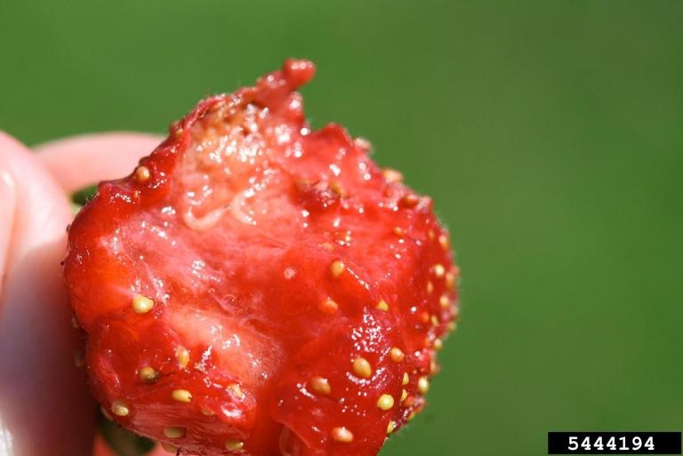

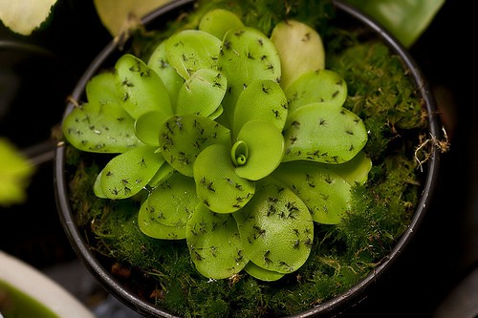

Pests in Hydroponic Systems
Homoptera – whiteflies, aphids, scale, mealybug

All of these are major pests and can be vectors of disease. Controls with parasitoids and predators are effective.

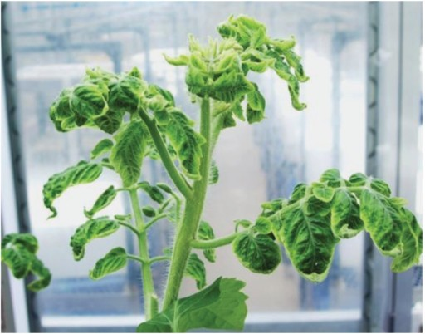

Whitefly vectored TYLCV (tomato yellow leaf curl virus)

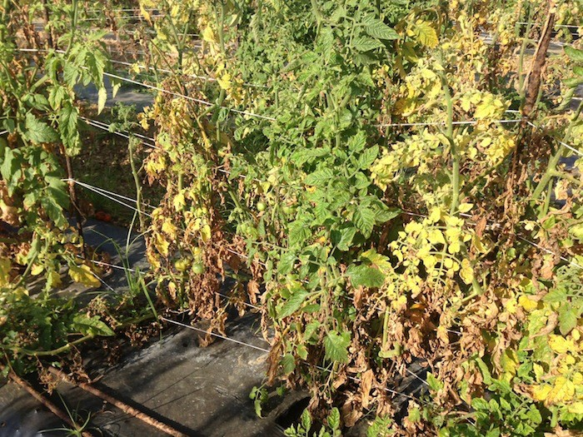

Whitefly vectored TYLCV (tomato yellow leaf curl virus)

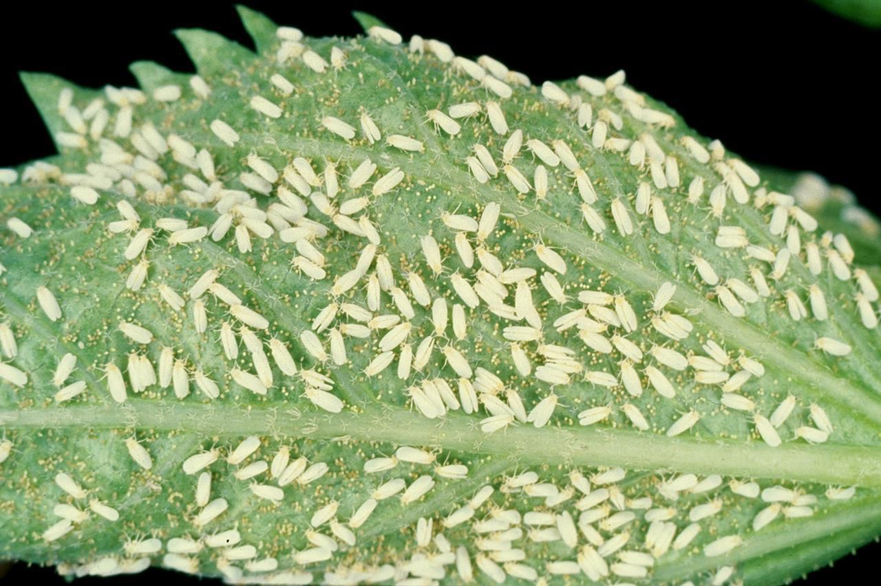

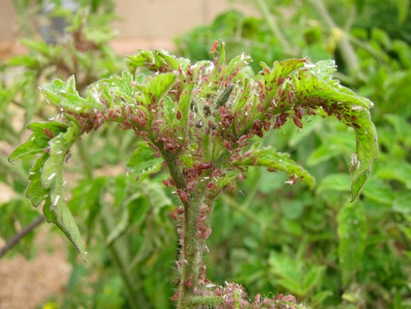

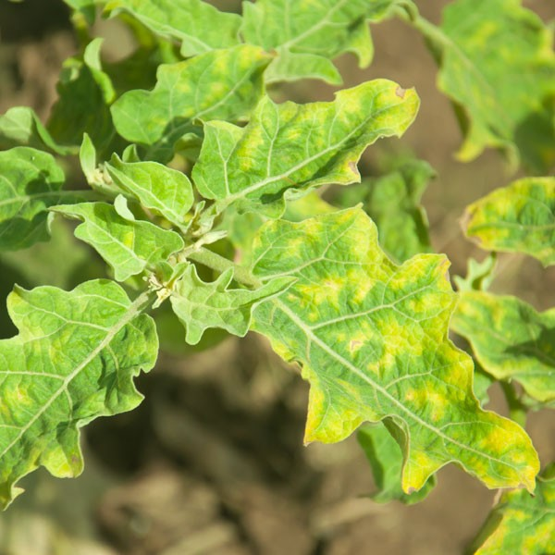

Aphid vectored mosaic virus on eggplant

Pests in Hydroponic Systems
Hymenoptera: parasitoids – they lay their eggs in other organisms and feed on them until they pupate

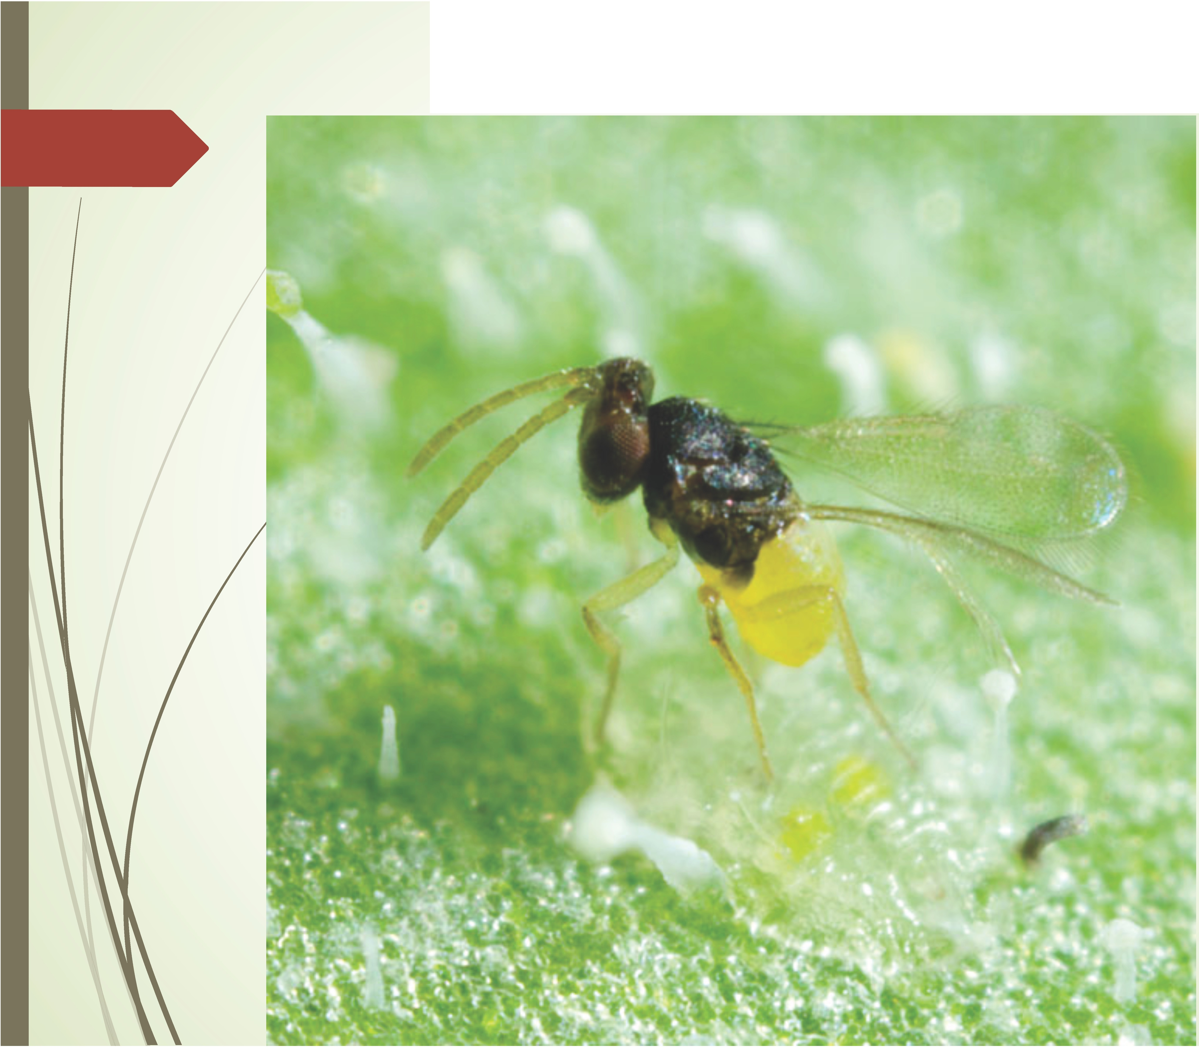

Wasp laying egg inside scale insect

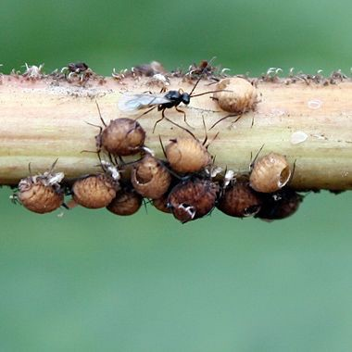
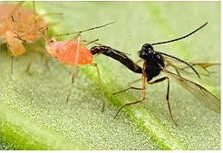
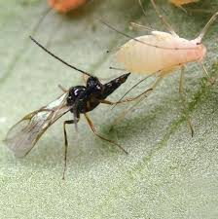

Wasp after emerging from aphid mummy

Wasps laying eggs in aphids

