WS 5377

Realities of Women

Spring 2013

Instructor: Dr. Lijun Yuan

Tuesdays and Thursdays

2:00PM–3:20PM

Centennial Hall G01

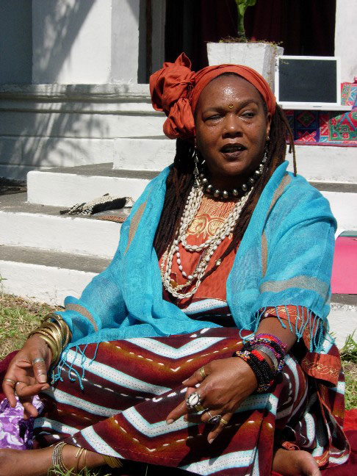











Students Will:

• Explore gender in relationship to love, friendship, and violence

• Become familiar with feminist theory

• Gain competence in theory and methodology to examine sex, gender, race, and class

Dr. Sandra Mayo

Director

Center for Multicultural and Gender Studies

Lampasas 303

512 245 2361

www.txstate.edu/mcgs

Critically examine prominent themes concerning women

• Consider gender from multiple disciplines

• Understand how gender impacts families, work, and education