After you run ZBUDACT and you get your report, you will be able to set the default settings so that the extra pages, with the labels, don’t print out. Here are the steps you should follow:
- Click on the Printer icon.
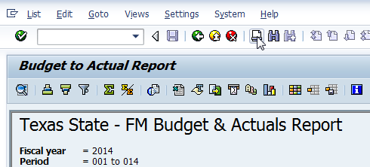

- Click on the “Properties” button.
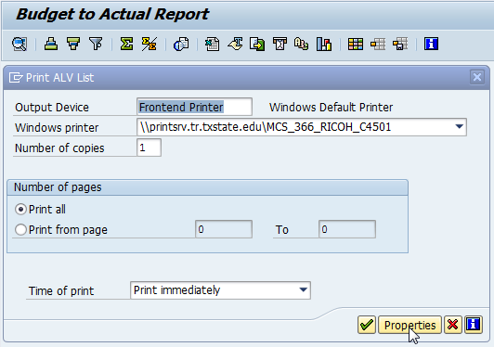

- Expand the “Cover Sheet” folder.
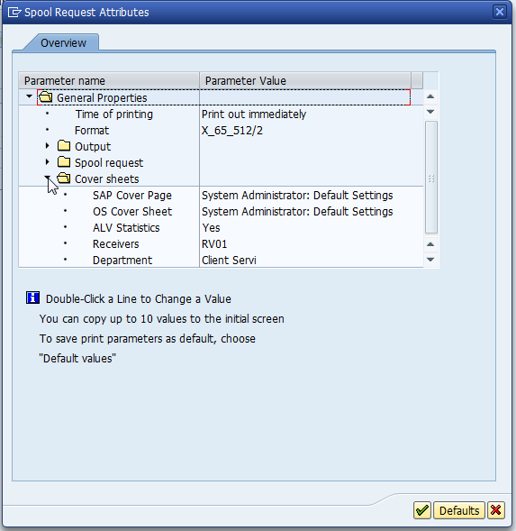

- Double-click the “ALV Statistics” line so that your screen looks like this and uncheck the box to the left of “ALV Statistics”.
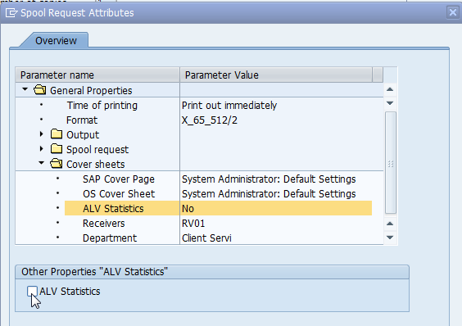

- Click on the “Defaults” button.
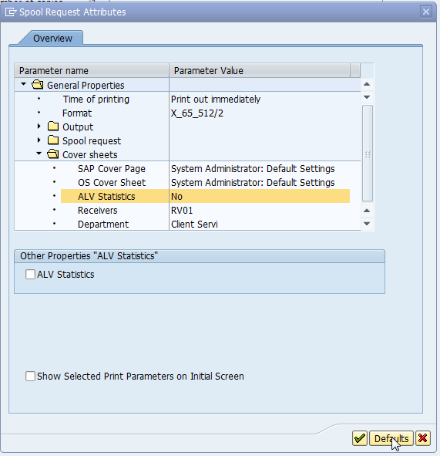

- Make sure to select “Valid for all reports” and then click on the “Copy Settings” button.
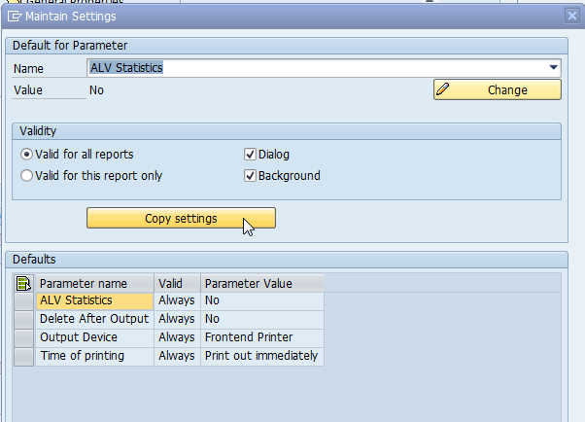

- To finish the set-up, click on the green checkmark at the bottom of the “Maintain Settings” dialog box.
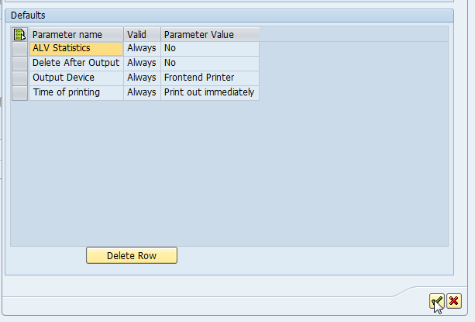

- This will return you to the “Spool Request Attributes” box. Just click on the green checkmark at the bottom to continue.
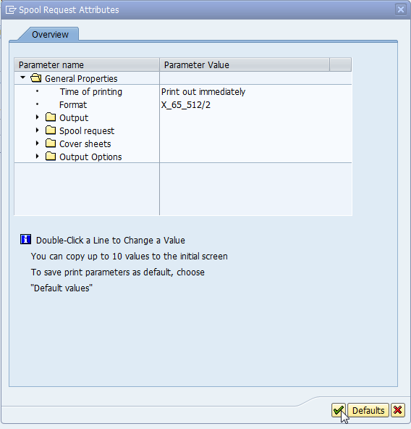

- Now you’re ready to print out the report by clicking on the green checkmark on the “Print ALV List” box.
