Mini-Jector(Model: #55.1) Disassembling and Assembling :Instructions

Location of Machine: Composites Lab, RFM 1218
Location of SOP and Machine Operating & Safety Manual: Composites Lab website under resources; Composites Lab TRACS site; and Hardcopy near machine.
Emergency Contact:
- Call 911
- Call EHS & Risk Management at 512-245-3616
- Call Head Lab Technician, Dr. Ray Cook (office 512-245-2050)
- Call Dr. Jitendra S Tate (office 512-245-4872)

Before Disassembling this machine:
- You must have permission from Dr. Tate.
- You must have received formal training from technician or, trained research student (designated by Dr. Tate) related to machine safety and operation.
- You must read and understand SOP and Machine Operating & Manual.
- You must use this machine under direct supervision of Dr. Tate or, Dr. Cook or, trained research student (designated by Dr. Tate).
- You must have signed “Lab Rules” document with Dr. Tate. This document must be signed every semester fall, spring, and summer (as applicable).
- If you do NOT follow above instructions you will be held responsible for your own safety and damages.

Safety Precautions:
Protective Equipment: Prior to performing this procedure, the following personal protective equipment must be obtained and ready for use: Safety Goggles, insulated gloves, and lab coat
Important Safeguards:
- Always wear safety glasses and insulated gloves for dismantling process.
- Always make sure that machine is properly purged before dismantling.
- Never reach into the machine when the machine is going through its cycle or at any time other than when loading or unloading the ‘V’ mold.
- Make sure the machine is securely bolted to its table or workbench before dismantling.
- Always shut off power the power to the machine when performing maintenance task.
- Never purge the machine without using the purging fixture supplied with machine.
- Always make sure that machine is in cold state before dismantling..
- Always make sure that water supply is turn off and all the power supply is switched off.

Mini-Jector Disassembling :Instructions
- Unscrew and take out the hopper. | 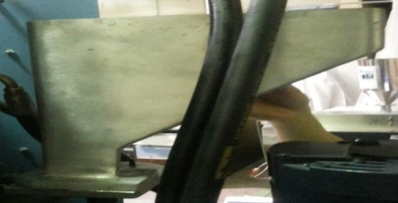
- Remove the cables and have them numbered with the sockets. | 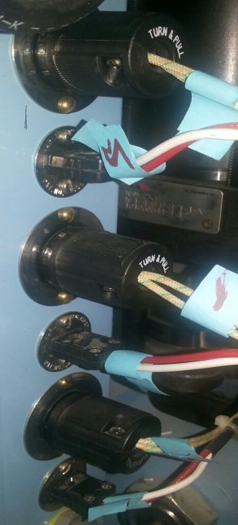
- Unscrew the hopper holder with the use of Allen key. | 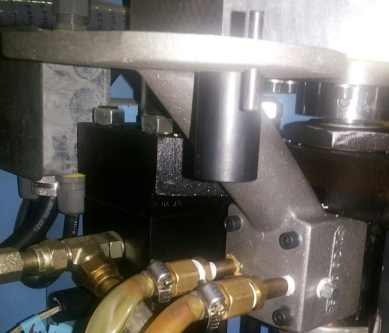
- Take out the front casing by unscrewing it with allen key and screw driver. | 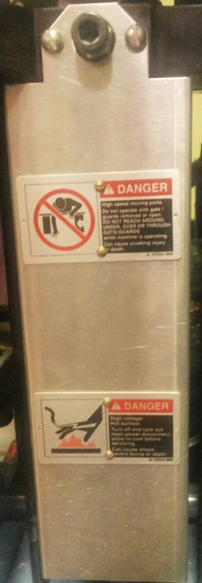

5. Take out the front end bolt with the help of allen key by unscrewing it.  For information : This is the bolt which holds the screw and gives support for the movement | 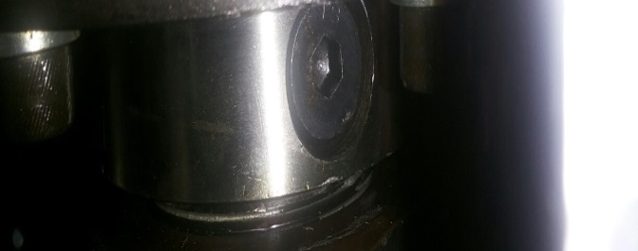
- Unscrew the barrel holding nut with the help of Wrench. | 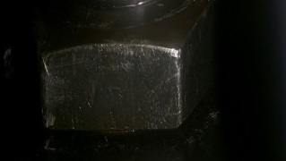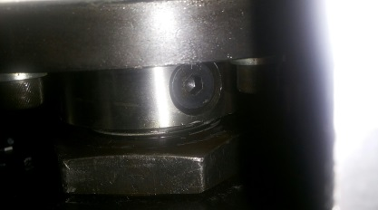
- Take out the barrel carefully from the from the mini jector machine | - 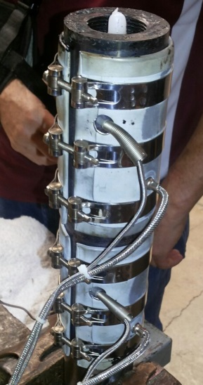
- Put the barrel on a table and unscrew the clamps with the screw driver.  (Take out the heater wrapped to the nozzle as well by unscrewing) | 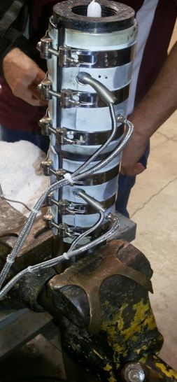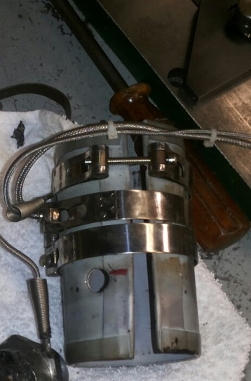
- Put the barrel in a vice and unscrew the nozzle . Take it out. | 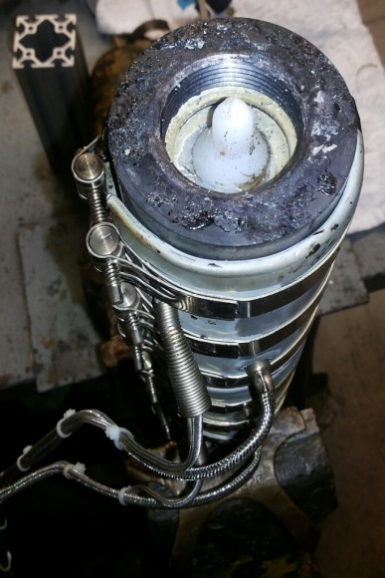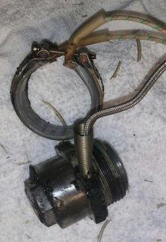
- Hook up the Screw from the other end with means of any iron rod and pull it out of the barrel.  Note : Before this step it is advised to heat the barrel upto 500 degree c, it makes convenient to take out the screw as it is hot. | 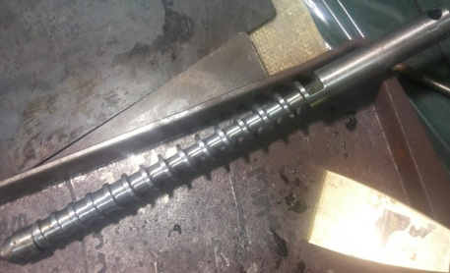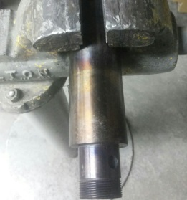
- Remove the screw tip by unscrewing it out of screw. | 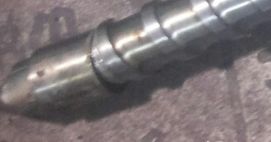
- Clean thoroughly the barrel, screw, screw tip, Barrel body outside and inside .  Note : It is advised to heat all the parts upto 500 degree c in order to clean them properly. | 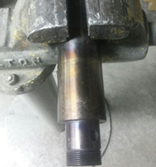

Mini-Jector Assembling :Instructions
1. Clean thoroughly the barrel, screw, screw tip, Barrel body outside and inside .  Note : It is advised to heat all the parts upto 500 degree c in order to clean them properly. | 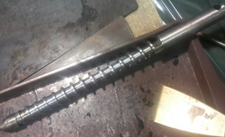
- Screw up the screw tip to the screw after proper cleaning of screw tip. Make sure it doesn’t have any particle stuck in it.
- Slide the screw inside the barrel make sure it pass through without any obstruction in the path.

- Screw up the nozzle in the barrel make sure it is firmly tightened.

(Note: Apply molycote or thread lubricant to the thread for better sealing)

- Put the barrel on a table and put the heaters on it and tighten the clamps with the screw driver.

(Make sure both the heaters are properly align to top and bottom)

- Place the barrel in the mini jector machine, it needs to be holded on the same position until it is tightened .

( It needs to be done with care as barrel with the screw may seems heavy while holding at same position)
- Tighten the barrel holding nut while holding barrel in the same position.
- Tighten the screw holding bolt with the allen key , make sure it is tightened completely as it hold the screw and is responsible for the movement of screw inside barrel.

- Screw in the bolt of casing after putting the casing in place with the help of Allen key and screw driver .
- Screw up the hopper holder with the help of Allen key.
- Plug in the heater cables to the socket as numbered before.
- screw up the hopper.

