Course Module (for Agronomic Crops and General Horticulture):

Introduction to Vertical and Horizontal Hydroponic Methods

Overview:

This course module will involve a lecture on the fundamental principles of hydroponics production followed by a multi-week set of activities. Two hydroponics systems will be explored, specifically a vertical nutrient film technique (NFT) system and a horizontal pond system.

*Objectives:*

After completion of this module, students should:

* understand the differences among hydroponic production methods, specifically NFT and pond systems
* recognize the advantages and disadvantages of hydroponic systems compared to field production
* be able to measure and interpret important environmental parameters and set points for successful hydroponic production

Part 1: Hydroponic Production Fundamentals

**Background**

Hydroponics, from the Greek words *hydro* (water) and *ponic* (work), is practice of growing plants in nutrient solution. Specifically, plants are grown either in 1) liquid systems or 2) aggregate systems in which the plants are grown in a soilless media comprised of vermiculite, perlite, sand, coconut coir, expanded rock, gravel, rockwool, and/or peat.

**History**

Hydroponic production can be traced to ancient times. The hanging gardens of Babylon were early hydroponicsystems, and the Aztecs grew all their vegetables hydroponically because the swampy area in which they lived was unable to support field agriculture. The Aztecs excavated soil from the swamp lands and placed it on floating wooden rafts. In this floating system, they raised crops with roots that grew through the raft structure into the water below.

While hydroponics crops are generally better suited for vegetables, herbs, some flowers, and non-tree fruit crops than they are for large dry-land field crops such as corn, wheat, and cotton, it is important to explore the advantages and disadvantages of growing crops hydroponically.

Advantages of hydroponicsover growing plants in soil include:

* Plant density may be greatly increased per unit of growing area compared to field production, allowing more product to be grown in a smaller amount of space.
* Plants can be grown where soil resources are unavailable, such as urban settings.
* Yield per plant is often increased.
* Plants grow faster than field grown plants.
* Using artificial lights, hydroponicsystems may be stacked vertically, further increasing the plant yield per unit of floor space.
* Growing plants indoors allows greater control of temperature, light intensity, light quality, light duration, nutrient composition and concentration, humidity, and gasses supplied to the roots.
* Nutrient solutioncan be reused, so less fertilizer is needed.
* There is a smaller weed problem in hydroponic system than in fields.
* Plants do not need to have soil washed off, so they are ready to eat right away.

Disadvantages of hydroponicscompared with plants grown in soil include:

* There can be higher setup costs than field grown or conventionally grown greenhouse plants.
* If equipment stops working, maintenance is needed immediately because plants will start to wilt. By contrast, a soil-based system provides a buffer for moisture, nutrients, and temperature.
* Equipment (e.g. pumps, heating system, infiltration system) and lights require energy often obtained through fossil fuels.

**Horizontal and Vertical Hydroponic Methods**

**Horizontal hydroponic techniques**

*Nutrient Film Technique*

[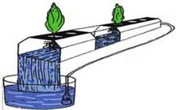](http://www.homehydrosystems.com/hydroponic-systems/images_systems/nft3.jpg)One popular type of horizontal hydroponic system is the nutrient film technique (NFT). NFT systems are best suited

[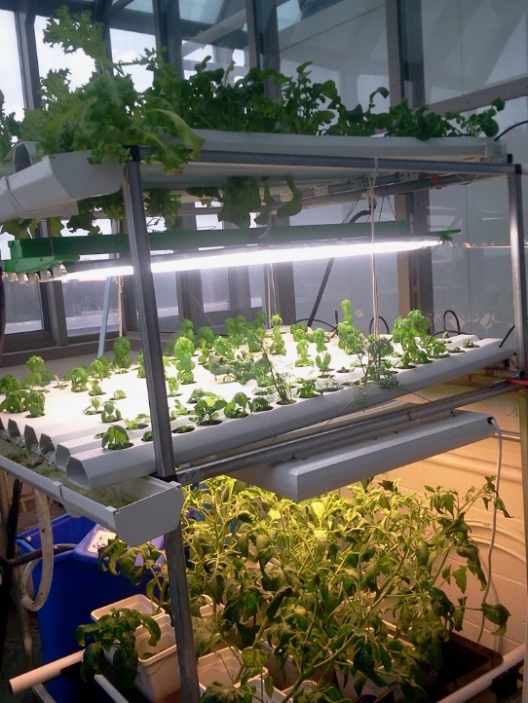](http://csl.nsta.org/wp-content/uploads/2017/03/Seeding_the_Future_Figure_2_multi-tier.jpg)and most commonly used to grow small and fast producing plants such as leafy greens and herbs. NFT systems have a shallow nutrient solution that flows through the tubing or trays (that are on a slight incline), where plant roots come into contact with the nutrient solution. The disadvantage of NFT is that plants are vulnerable if there is any interruption in the flow of water and nutrients, as in a power outage. If this happens, plants will begin to wilt very quickly, thus impacting production efficiency.

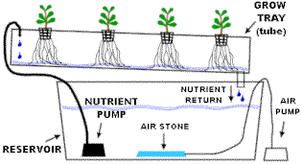

Sources:

<http://www.homehydrosystems.com/hydroponic-systems/nft_systems.html>, <http://csl.nsta.org/2017/05/seeding-the-future/>

*Pond Systems*

Another horizontal hydroponic system that is often utilized by large commercial producers and aquaponics systems, is the pond system (see the following photo). Pond hydroponic systems refers to a floating system, where plants are grown in buoyant trays or rafts that sit in water-nutrient basin. This type of system is advantageous because it is more robust and forgiving than other hydroponics systems, such as when there is a power outage that may shut down pumps, or when the nutrient solution becomes imbalanced. The pond horizontal system will be explored through the following laboratory exercise.



Source: Cornell University <http://www.cornellcea.com/attachments/Cornell%20CEA%20Lettuce%20Handbook%20.pdf>

**Vertical hydroponic techniques**

Within the category of vertical systems, there are subcategories, and the phrases *vertical farming* and *farming vertically* are often used to describe these type of systems. Farming vertically means stacking horizontal beds (see the photo below right), while the true vertical farming technique means growing plants in towers, such as in photo on the left below. The vertical tower method was designed to maximize space and reduce the load (weight) of stacking horizontal racks. Vertical tower companies specifically aim to construct their towers out of light food grade materials to reduce the cost of building an infrastructure to support a heavy bed system.

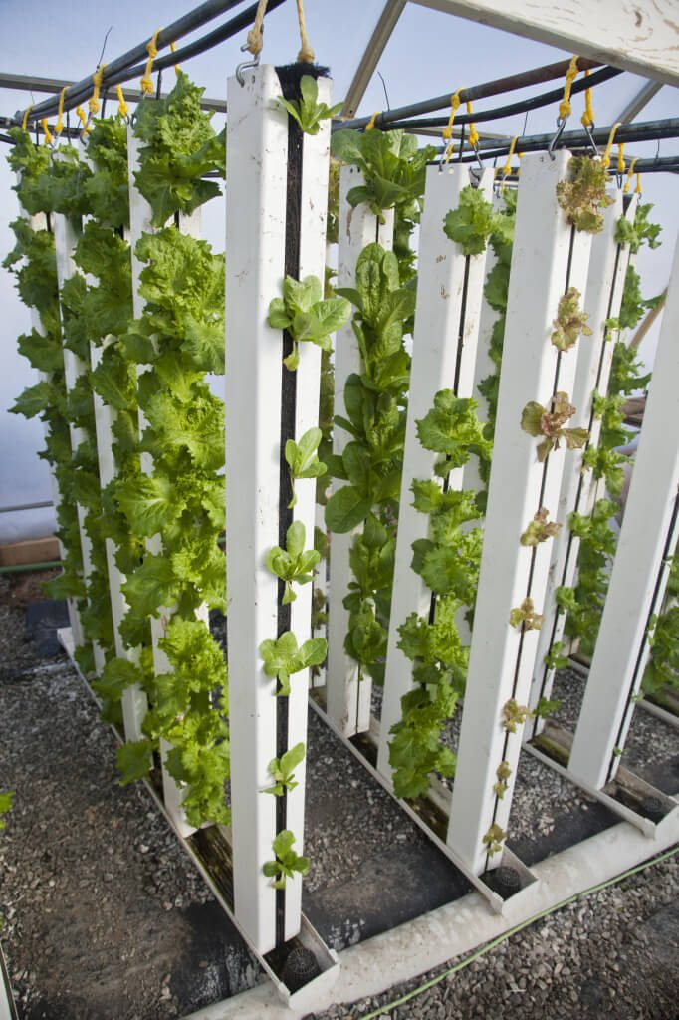 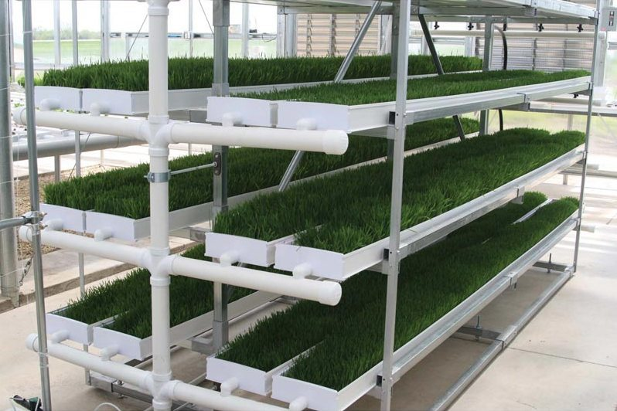

Sources:

Left photo above: <https://blog.brightagrotech.com/vertical-farming-vs-farming-vertically/>)

Right photo above: <https://www.alibaba.com>

**Important Environmental Parameters in an Indoor Hydroponic Crop System**

*(The following information is directly from the Cornell University CEA Program)*

**Temperature**

Temperature controls the rate of plant growth. Generally, as temperatures increase, chemical processes proceed at faster rates. Most chemical processes in plants are regulated by enzymes which, in turn, perform at their best within narrow temperature ranges. Above and below these temperature ranges, enzyme activity starts to deteriorate and as a result chemical processes slow down or are stopped. At this point, plants are stressed, growth is reduced, and, eventually, the plant may die. The temperature of the plant environment should be kept at optimum levels for fast and successful maturation. Both the air and the water temperature must be monitored and controlled.

**Relative Humidity**

The relative humidity (RH) of the indoor air influences the transpiration rate of plants. High RH of the greenhouse air causes less water to transpire from the plants, which causes less transport of nutrients from roots to leaves and less cooling of the leaf surfaces. High humidity can also cause disease problems in some cases. For example, high relative humidity encourages the growth of botrytis and mildew.

**Carbon Dioxide (CO2)**

The CO2 concentration of the air directly influences the amount of photosynthesis (growth) of plants. Normal outdoor CO2 concentration is around 390 parts per million (ppm). Plants in a closed greenhouse or indoor growing room during a bright day can deplete the CO2 concentration to 100 ppm, which severely reduces the rate of photosynthesis. In greenhouses, increasing CO2 concentrations to 1000-1500 ppm speeds growth. CO2 is supplied to the greenhouse by adding liquid CO2. Heaters that provide carbon dioxide as a by-product exist but we do not recommend these because they often provide air contaminants that slow the growth, like for lettuce and leafy green crops.

**Lights**

Light measurements are taken with a quantum sensor, which measures photosynthetically active radiation (PAR) in the units *μmol/m2/sec*. PAR is the light between the wavelengths of 400-700 nanometers (nm), which is important to plants for the process of photosynthesis. Measurements of PAR give an indication of the possible amount of photosynthesis and growth being performed by the plant. (Foot-candle sensors and lux meters are inappropriate because they do not directly measure light used for photosynthesis.)

**Dissolved Oxygen**

Dissolved oxygen (DO) measurements indicate the amount of oxygen available in the nutrient solution for the roots to use in respiration. Leafy green crops will grow satisfactorily at a DO level of at least 4 ppm. If no oxygen is added to the system, specifically in a pond system, DO levels will drop to nearly 0 ppm. The absence of oxygen in the nutrient solution will stop the process of respiration and seriously damage and kill the plant. Pure oxygen is added to the recirculation system in the ponds. Usually the level is maintained at 8 ppm, however there is no advantage to the plants until a level of 20 ppm is reached. For sufficiently small pond systems, it is possible to add air to the solution through an air pump and aquarium air stone but the dissolved oxygen level achieved will not be as high as can be achieved with pure oxygen. In an NFT system, the roots will be exposed to air, and thus plants will achieve adequate oxygen.

**pH**

The pH of a solution is a measure of the concentration of hydrogen ions. The pH of a solution can range between 0 and 14. A neutral solution has a pH of 7. That is, there are an equal number of hydrogen ions (H+) and hydroxide ions (OH-). Solutions ranging from pH 0-6.9 are considered acidic and have a greater concentration of H+. Solutions with pH 7.1-14 are basic or alkaline and have a greater concentration of OH-.

The pH of a solution is important because it controls the availability of the fertilizer salts. A pH of 5.8 is considered optimum for the described growing system, specifically for leafy green crops, however a range of 5.6-6.0 is acceptable. Nutrient deficiencies may occur at ranges above or below the acceptable range.

**Electrical Conductivity**

Electrical conductivity (EC) is a measure of the dissolved salts in a solution. As nutrients are taken up by a plant, the EC level is lowered since there are fewer salts in the solution. Alternately, the EC of the solution is increased when water is removed from the solution through the processes of evaporation and transpiration. If the EC of the solution increases, it can be lowered by adding pure water, e.g., reverse osmosis water). If the EC decreases, it can be increased by adding a small quantity of a concentrated nutrient stock solution. When monitoring the EC concentration, be sure to subtract the base EC of your source water from the level detected by your sensor.

**Recommended Set-points**

* Air Temperature: 24 C Day/19 C Night (75 F/65 F)
* Water Temperature: No higher than 25C, cool at 26C, heat at 24C
* Relative Humidity: minimum 50% and no higher than 70%
* Carbon dioxide: 1500 ppm if light is available, ambient (~390 ppm) if not
* Light: 17 mol/m2/day from supplemental light (unless sunlight is available)
* Dissolved oxygen: 7 mg/L or ppm (drop failure will occur at less than 3 ppm)
* pH: 5.6-6

______________________________________________________________________________________

Part 2: Hydroponics Activities

The following supplies and equipment will be utilized in this exercise.

For the horizontal pond system:

* Rubbermaid bins which will serve as the ponds containing hydroponic solution and floating plants. (Rubbermaid bins that are not translucent will be used to discourage growth of algae.)
* Aquarium air pump with air stoneand air tube per bin
* Light source (such as a utility light, LED, or fluorescent rack) per bin
* A Styrofoam or polystyrene tray that is the dimensions of the top of the Rubbermaid bin that has holes for ‘baskets’ (plastic perforated pots) to hold plants per bin

For the vertical NFT system:

* Buddha Box – a pre-fabricated growing system comprised of vertically stacked racks, water reservoir, light source and pump

For both systems:

* Seeds, specifically leafy green crops, herbs, and perhaps cut flower crops
* pH paper
* Diluted potassium hydroxide used to raise pH
* Diluted hydrochloric acid used to lower pH (lemon juice can be used as an alternative)
* Nutrient solution, specifically a premixed solution from a science supplier (an advance course module can explore alternative nutrient sources and the specific nutrient components of the nutrient solution)
* Stick for stirring the nutrient solution (e.g. a yardstick)
* 5- gallon bucket for mixing the nutrient solution
* Rulers for measuring length of leaves, stems, roots etc.
* Camera to record experiment photographically (optional)

Over several weeks, we will explore hydroponic production fundamentals, with a deeper exploration via hands-on activities. The following list details a multi-week schedule of activities.

Week 1

* Introduce hydroponic fundamentalsvia lecture**.**
* Set up the mini horizontal pond systems using the Rubbermaid bins: put lights on timers, install pump and air stone.
* Mix nutrient solution and add to each system (i.e. Buddha Box and mini horizontal pond systems).
* Transplant lettuce and herb plants (that have been previously started in the greenhouse) into the Buddha Box and mini horizontal pond systems.

Weeks 2 & 3

* Take the following measurement in both hydroponic systems and record their values:
  + plant height
  + average internode length
  + plant/leaf color (visual observation on plant vigor)
* Check for pests and identify them if present. If pests are present, develop a pest management strategy with help from the instructor.
* Take the following measurements in both hydroponics and record their values:
  + DO
  + pH
  + EC
  + RH
  + Minimum and maximum temperature
* Adjust pH and add water and nutrient solution if necessary. Record the final DO, pH, and EC.
* Perform plant maintenance tasks for both systems, specifically check all equipment, check water level. Make sure all pumps and lights are working and their timing is correct.

Week 4+

* Measure and record height and plant development.
* Check for pests and identify if present.
* Perform plant maintenance tasks for both systems (see above). Continue for as many weeks as necessary until plants have reached their final size. Lettuces and herbs will probably be ready for harvested by week 4.

When plants are ready to be harvested, record any final differences observed between the two hydroponic systems. Record your observations, and include what you observed to be the advantages and disadvantages of each hydroponic system.

Sources

Brechner, M., A.J Both*. Hydroponic Lettuce Handbook*. Cornell Controlled Environment Agriculture, Cornell University.

SOLE Sciences of Life Explorations through Agriculture. Teacher Guide, Unit: Simplified Floating Hydroponics <https://www.agclassroom.org/ny/resources/pdf/activities/hydro.pdf>