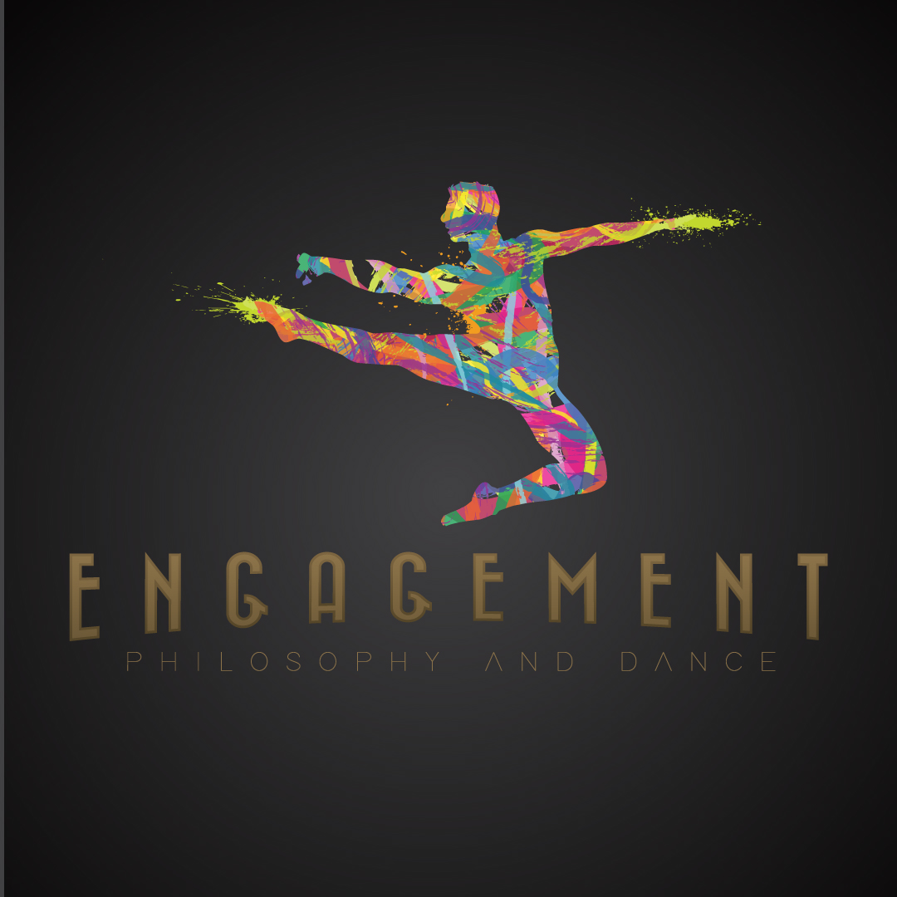

Book Proposal:
Engagement: Philosophy and Dance
Editors: Rebecca Farinas, Craig Hanks; Co-Editor: Julie Van Camp

Brief Description
This is a source book, including papers emerging from a recent symposium, additional scholarly papers, and an eclectic mix of materials such as exposes, descriptions of dance therapy sessions and demonstrations. It highlights current interrelated research, involving philosophical research, performances, art practices, and therapies. Our main objective in collecting these materials is to document the intersection of dance and philosophy, recognizing an area that can have real societal impact rather than as a purely academic exercise. Engagement: Philosophy and Dance covers topics such as; how we learn through dancing, the benefits to our well-being through dance therapy, the experiential nature of choreography, what dance videography brings to dance and culture, the fascinating symbiosis of musicality and dance, the dynamics of community-building through dance, and uncovering the ethical and artistic issues involved with dance plagiarism and dance criticism. Its distinguishing feature from other books is the presentation of a diversity of approaches, as we have included contributions by scholars who are well- known in the field of philosophy of dance, as well as exposes and discussions by scholars from other disciplines, dancers, art directors, choreographers, and dance therapists. While this might seem a broad eclectic mix, the book is philosophically focused while contextually rich, as each essay brings up questions of how theory becomes enlivened through practice and performance. We envision the book as an interactive artifact that can be a resource for educators and the general public. It is meant to be engaging and useful for both academic and non-academic lovers of dance.
“Engagement: Symposium of Philosophy and Dance” was a three day symposium, including talks, demonstrations, performances and a dance therapy session, held at Texas State University September 8-10, 2016. This book reflects the interdisciplinary approach of those events, in that people with varied approaches raised philosophical questions coming from current practices thereby opening horizons for themselves and others. Philosophical areas such as epistemology, phenomenology, ontology, semiotics, ethics, and critique are brought into play in this book, yet all of the insights are made in relation to actual dance practice. As examples of the unique way practice comes together with theory, there is Jeff Friedman’s paper, “Entanglement: A Multi-layered Morphology of Post-Colonial African Philosophical Framework of Dance Aesthetics”, Rebecca Whitehurst’s expose on her demonstration “The Phenomenology of Choreography, a Creative Embodied Encounter,” and David Leventhal’s “Dance for PD: A Universal Movement.” This mélange of perspectives is organized by chapters, which are titled in relation to current philosophical discussions in aesthetics. Each chapter presents a question, to which the author of the Introduction to that chapter, and the authors of that chapter’s papers, responds. All of the scholars included in the proposal have confirmed their willingness to contribute their essays.
The book is framed by each chapter’s question about aesthetics, to which the introductions and the chapter respond. Within the particular investigations are differing approaches including in some explications of inquiry done in the studio, those being labeled as Workshops. As well each chapter has one or two contributions with a more focused, specific topic than the others that accompany them, these are marked out as Case Studies. This multi-faceted presentation lends clarity with interactive and engaging reading in mind.

Narrative
INTRODUCTION: John Fleming, “Presenting Philosophy and Dance”
CHAPTER 1: Introduction: Julie Van Camp, “Presenting an Engagement of Philosophy and Dance”
Philosophy, at least stereotypically, is all about ethereal abstractions of the mind. How can it meaningfully engage the physicality of dance and the dancing body? The challenge opens several avenues for engagement, all at least promising, if not equally fruitful.
Can the wealth of diverse dance cultures pry open more hide-bound philosophical traditions? “Presenting Diversity in Dance” will try.
Workshop: Could our intellectual explorations of space, time, and movement benefit from encounters with physicality in these elusive dimensions? Integrating movement practices with big ideas of all kinds engages the project on “Teaching Dance and Philosophy to Non-Majors.”
The wealth of philosophical work in other areas can also enrich our explorations. Action theory and value theory bring insights to the art form in “Dance, Normativity and Action.” Aesthetic insights and methodologies from other art forms enlighten our understanding in “Aesthetics and the Philosophy of Dance.”
Case Study: Recent research in cognitive science further enlightens us in “Embodied Aesthetics and Proprioception.”
CHAPTER 2: Introduction: Edyta Kuzian, “Reflections on Practice”
Describing the unique aesthetic qualities of dance as using ephemerality, embodiment and process unlike static art, such as sculpture or architecture, Kuzian presents her philosophical insights as well as introducing some of the most practically oriented papers in the book. How is choreography framed by our experiencing the world and vice versa is a questions explored by means of practice, in “Phenomenology – Case Study: A Creative Embodied Encounter”. “Discovering Collaboration in Dance” is a creative, exploration of the engagement of music and dance, thinking in terms of learning life skills as well as art skills.
Workshop: In “Philosophizing Improvisation: An Artist-Researcher Collaboration,” practitioners inquiry about the relationship between improvisation and dance theory, while philosophers in workshop dance and dancers theorize.
“Falling Up: An Explication of a Dance” describes and explores the changing nature of process in dance as an art form and the role audience reception and interpretation plays in such process. “Philosophizing Improvisation: An Artist-Researcher Collaboration” explains how dance theory and practice meet in a pedagogical workshop environment.
Case Study: Theory and practice is synthetically process oriented in American Modern dance tradition, and the essay “Early Floating in the Here and Now: The Radically Empirical Immediate Dance Theater of Erick Hawkins and Luci Dlugoszewski”, deconstructs such processes in terms of immanent relationships between choreographer, composer, practitioners and their audiences and staged environments.
Case Study: “From Patients to Dancers: a Case Study in Identity Transformation through the Arts” describes and finds the meaning of identity changes with patients of Parkinson’s Disease and their dance facilitators.
CHAPTER 3: Introduction Stephen Davies, “Cross-currents in Philosophical and Dance Traditions”
In Chapter 3, Davies introduces studies, concerned with meanings and dynamics of dance, from around the globe. Davies’ introduction draws on his research of Balinese dancing and his well-known philosophy of art, as dance being anthropologically transformative and culturally transactional. The scholars included ask questions about how dancing can be responsive to traditions, and how that engagement informs cultures. “A New Universality: Pragmatic Symbols in Drawing and Dance” begins the discussion, looking at the seminal semiotics of American Modern Dance in relation to commonly held pragmatic values; beauty, peace, and love. Brining to the fore the prowess of embodied orientations of dance, “Groovy Bodies: the 1970’s Somatic Engagement in Dance” breaks new ground in relation to culture and ontology. Do practitioners actively interpret or re-interpret their movements and dramatic presentations while dancing, thereby contributing to a non-static process of tradition making?
This is a question investigated in “Interpretation in Dance Performance”. Continuing, by looking closely at ‘thinking and dancing’, we ask, while reading “Thought, Dance and Aesthetic Reason”, whether epistemological/traditional boundaries are more fluid for dancers. Radical changes to traditional dualisms were made during the Twentieth Century, and choreographers and dancers experimented with new forms of the art. Furthering discussions about understanding dance without dualist structures, “The Experience of Self-Transcendence: Traditional Hindu Perspective on Art and Dance” gives new insights into meditative practices embodied through dancing experiences, thereby opening up a space of realization including self-identity and traditions.
Radical changes to traditional dualisms were made during the Twentieth Century, while choreographers and dancers experimented with new forms of the art. “A New Epistemology of Body and Movement in Modern and Contemporary Dance” discloses how dancers and choreographers contributed to breaking free of conventional philosophies and normative conceptions of life. Does choreography and art dance belong to culture in a traditional sense at all, or can it stand out as ‘authored work’; this question is approached in relation to minimal dance art and Nelson Goodman’s philosophy of art in “Who Authored Hockey Seen?” “Entanglement: A Multi-layered Morphology of a Post-colonial African Philosophical Framework for Dance Aesthetics” “rewires” ontologies of personhood, metaphysics of being, and philosophies of science through the lens of African philosophy, aesthetics, and more specifically the African Arts Complex, including dance.
Case Study: “The Semblance of the Sacred? Langer on Dance” asks the questions, philosophically, about ritual and the art form of art, channeling Susanne Langer.
CHAPTER 4: Introduction: David Davies, “Extending Dance Performance”
David Davies and authors ask questions about physiological, experiential, and technological changes made through our engagement with dance in relation to videography and digital technology. The focus is on how does an ontology of being physically involved with dance or reception, shift once the camera, ‘as an eye,’ becomes part of the dance experience. The authors are asking questions about that shift in respect to aesthetic sensibilities, changes that might occur in how we are finding ourselves in the world through dance, and the meanings of dances once the dance becomes a digitalized experience. Is shifting our understanding of dance, with a sense of ambivalence or confusion made more clear when presented through technologically moderated dance? “Performance: Disability or Cyborg Utopia? Ambivalent Readings of Marie Chouinard’s “bODY rEMIX/gOLDBERG vARIATIONS” asks this forward-looking question.
Does filmed dance extend the aesthetic values of our lives, is the question of “An Aesthetics of Video Dance.” In “What Do We Lose to a Video” the question is asked with a different approach, by mining differences between reception of live performance, and by means of lens, projection and screen. Finally, “Agency and Attending: How Might Liveness Matter for Artistic Performance” finds asking how live performance might inspire agency and the realization of aesthetic social values, more so than film.
Case Study: Finding what honest representation, or the lack of such might infer, in a dance performance, in the context of a film’s historicity, is the task of the case study , “The Mask which the Actor Wears is Apt to Become His True Face: How Jon Cryer Toes the Line Between Homage and Mimicry in Pretty in Pink’s Ultimate Lipsync.”
CHAPTER 5: Introduction Julia Beauquel, “Critical Reflections on Dance”
As explicitly stated by Julia Beauquel, in her Introduction to this chapter, “Given these considerations, producing a relevant critical discourse about such a rich form of expression, that belongs to human behavior across the cultures as well as to the most encompassing and sophisticated productions of the art world is an ambitious task.” Beauquel asks the general question, how is dance criticism done in respect to practice, and what does such relationship mean to dance, practitioners, audiences and readers? She and the other authors are asking questions about what kinds of critical approaches are appropriate and useful to dance and society, as well as the nature of that critical perspective.

“Movement on Record: Poetry, Presence and Radicalism” finds a view of dance, by taking the position of the ‘Other’, as a way to investigate what kinds of recognition and powerful senses of social critique does fluid movement record. “Structure, Form and Function of Dance Criticism and the Ways it Relates Audiences to Works of Art” asks how historically dance criticism has emphasized the embodied, reception of critique. Unconventionally, “Dancing-with: A Theoretical Method for Poetic Social Justice” poses critical questions about how dance critique expands on critical philosophy. The author posits a critical approach to philosophy coming from the experience of “dancing-with” a Latin American Dance partner. “How Effective is Political Dance Theatre” asks the reader to question the sustainability of political motivations arising through dance performances, thereby offering both a serious critique on political dance, as an art form, and on the intentions of choreographers, dancers, audiences and critics.

Case Study: Employing a realistic approach to dance criticism is meshed with constructivist critique in the essay “The Economic Politics of Pleasure in Gaga,” bringing forward questions about commercial appropriation of practitioners, as a form of ‘marketing of pleasure,’ and how such might affect social justice.

Table of Contents
Introduction: John Fleming, “Philosophy, Dance, and Shared Experience”
CHAPTER ONE: Presenting an Engagement of Philosophy and Dance. Introduction by Julie Van Camp, Aesthetic Question: Describing aesthetics as practice and practice as aesthetics
Workshop: Kristopher G. Phillips, Megan Brunsvold Mercedes, Kira Knapp: Teaching Dance and Philosophy to Non-Majors: The Integration of Movement Practices and Thought Experiments to Articulate Big Ideas
Graham McFee, Dance, Normativity and Action
Julie Van Camp, Aesthetics and the Philosophy of Dance
Case Study: Barbara Montero: Embodied Aesthetics and Proprioception

CHAPTER TWO Reflections on Practice, Introduction Edyta Kuzian, Aesthetic Question: Describing the unique aesthetic qualities of dance as using ephemerality, embodiment and process unlike static art, such as sculpture or architecture.
Rebecca Whitehurst, The Phenomenology of Choreography, a Creative Embodied Encounter
Richard Hall, Discovering Collaboration in Dance
Kaysie Seitz Brown, Falling Up: An Explication of a Dance
Workshop:Aaron Meskin: Philosophizing Improvisation: An Artist-Researcher Collaboration
Case Study: Louis Karvouras, Early Floating in the Here and Now: The Radically Empirical Immediate Dance Theater of Erick Hawkins and Luci Dlugoszewski
Case Study: David Leventhal, From Patients to Dancers: a Case Study in Identity Transformation through the Arts

CHAPTER THREE: Cross-currents in Philosophical and Dance Traditions, Introduction Stephen Davies, Aesthetic Question: Why dance and the philosophical tradition belong together.
Rebecca Farinas, A New Universality: Pragmatic Symbols in Drawing and Dance
Caroline Sutton Clark, Groovy Bodies the 1970’s Somatic Engagement in Dance
Aili Bresnahan, Interpretation in Dance Performance
Kristin Boyce, Thought, Dance and Aesthetic Reason
Edgar Vite and Diana Palacio, A New Epistemology of Body and Movement in Modern and Contemporary Dance
Renee M Conroy, Dancing on the Edge
Binita Mehta, The Experience of Self-Transcendence: Traditional Hindu Perspective on Art and Dance
Jeff Friedman, Entanglement: A Multi-layered Morphology of Post-colonial African Philosophical Frameworks for Dance Aesthetics
Case Study: Randall Auxier: The Semblance of the Sacred? Langer on Dance
CHAPTER FOUR: Extending Dance Performance:, Introduction David Davies, Aesthetic Question: Here the authors are thinking about the experiential changes made in dance and in watching dance, as the ontologies of the dance changes. The authors are thinking about a particular aesthetic activity presented through a particular context or way of being in the world.
Arnold Berleant, An Aesthetics of Video Dance
Ian T Heckman, What Do We Lose to a Video
Andrea Woody, Agency and Attending: How Might Liveness Matters for Artistic Performance?
Case Study: Archer Porter, Performance: Disability or Cyborg Utopia? Ambivalent Readings of Marie Chouinard’s “bODY rEMIX/gOLDBERG vARIATIONS
Case Study: Addie Tsai, The Mask which the Actor Wears is Apt to Become His True Face: How Jon Cryer Toes the Line Between Homage and Mimicry in Pretty in Pink’s Ultimate Lipsync
CHAPTER FIVE: Critical Reflections on Dance, Introduction: Julia Beaquel, Aesthetic Question: The authors are thinking critically, in relation to various problems of the human condition, and meta-critically, meaning that we are thinking about what kinds of critical approaches are appropriate and useful to dance, as well as the nature of that critical perspective.
Jonelle Seitz, Ways of Looking: Association, Presence, Radicalism
Henrique Rochelle Meneghini Structure, Form and Function of Dance Criticism and the Ways it Relates Audiences to Works of Art
Joshua Hall, Dancing with a Theoretical Method of Poetic Social Justice Essay Received
Eric Mullis, The Power of Political Dance: Representation, Mobilization, and Context Apparatus Essay Received with pictures
Case Study: Meghan Quinlan, The Economic Politics of Pleasure in Gaga
The papers will use Chicago Style formatting. The book will include bibliographies after each paper. The book will include original images from the conference of performances, therapy sessions, and demonstrations. If possible we would like to include weblinks to some dance videos.
Competition
In recent years there has been a growing body of books on philosophy of dance, and some of these pioneering texts feature essays by scholars who are confirmed to contribute to the Engagement anthology. Engagement will be an important addition to this scholarship as it will bring new approaches of doing philosophy, rather than only theorizing, to the current discussions surrounding dance. None of the existing texts have integrated theories of the philosophy of dance with voices from professional performers and dance therapists. Engagement spans the field by including international contributors employing a diversity of methodologies.
For example, Anthology Thinking through Dance: the Philosophy of Dance, Performance and Practices (2013), includes scholars who will contribute to Engagement. Yet, these writers have broadened their thinking when discussing practically oriented areas of people’s engagement with dance; some staying with conventionally philosophical approaches but others taking on first-hand or community oriented points of view. Thinking through Dance set a bench mark for philosophy of dance as a subgenre of aesthetics and philosophy of art. Engagement will broaden the genre further by presenting a pluralistic approach, bringing formulaic analysis and phenomenological studies together, alongside discursive discussions that take on critical and cultural approaches. And as mentioned, but emphasized as one of the most original aspects of the book, each writer takes seriously dance practice as an active mode of philosophical disclosure. Engagement’s uniqueness lies in fresh disclosures in the field of aesthetics because the sources of the investigations come out of a pluralism of experiences, from studying philosophical traditions, to performing on stage, to learning dance in the studio, to watching dance on video, to dancing with communities.
Engagement crosses boundaries of thinking about classical and popular dance, as the chapters arise from the practice and shared experience of dance. Bodies of Sound: Studies Across Popular Music and Dance (2013, 2016), is a strong text in the sense it concerns the musicality of dance in relation to popular culture, yet many of the papers are written in an academic voice, thereby limiting the readership. In Engagement, many of the papers are of academic interest yet accessibly written to a general readership, for example there is Addie Tsai’s paper on dance in the movies, and what a specific performance of mimicry meant to her generation. As well there is an expose by David Leventhal, who is the director of the Mark Morris Dance for Parkinson’s Disease program, outlining how dance and music therapy is a vital source of well-being for patients and a moral event for the participant’s community.
In general, it cannot be stressed enough that Engagement’s topics are unique from other publications in the field. The first section lays out some of the groundwork for the field as a distinguished area of aesthetics, as both Julie Van Camp and Graham McFee give accounts of the philosophical field. I have already mentioned the special aspects of the next section, “Reflections on Practice”, in terms of presenting the revelations of dance practice. The third section is focused on dance as aesthetic reasoning, mixing papers that include dance as a way of sharing common goals. The section on dance and video is particularly unique. Dance videography is an emerging subfield of philosophical inquiry, and Arnold Berleant contributes a fascinating philosophical engagement with some of the pioneering contemporary videographers. Currently there is not a major anthology on this topic. The final section “Critical Reflections” includes themes from dance criticism, in relation to poetics, and dance as a tool for social justice. In all of these sections there is a creative spirit running through the more descriptive exposes as well as the scholarly investigations.
Audience
We think Engagement, with the included scholarship on aesthetics and philosophy of art/dance will be important to graduate level courses. Yet, its emphasis on practice, critique, and dance therapy allows for a wider audience including classes working with interdisciplinary studies and general education. Dance departments which offer a PhD in the philosophy of dance but are dance not philosophy programs, such as the University of North Texas in Denton and the University of Roehampton, London, will find the book instrumental to studio classes on practice and method. As well, dance therapists and performers can use the book to inform and enrich their practices. The field of philosophy of dance is now internationally widespread, so the book will be appreciated in the U.S., Europe and beyond.

Completion date, Length and Imagery
The book will be approximately 325 pages long. We expect to use about 25 images and 15 drawings and schematic graphic material. We would like to include weblinks to dance videos. As mentioned, all of the essayists have confirmed that they will submit their papers to a peer review process, done by experts in the field. We will have the book reviewed and compiled by August, 2017.

