Macintosh HD:Users:english:Desktop:thesis-proposal.pdf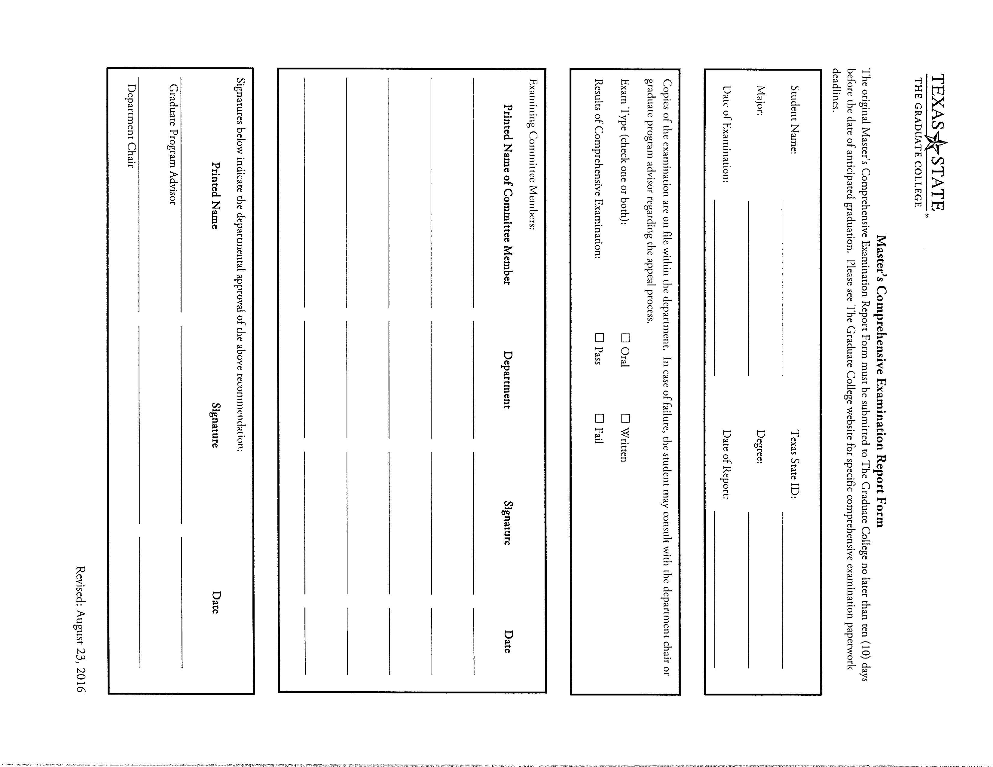Macintosh HD:Users:english:Desktop:thesis-member-change.pdf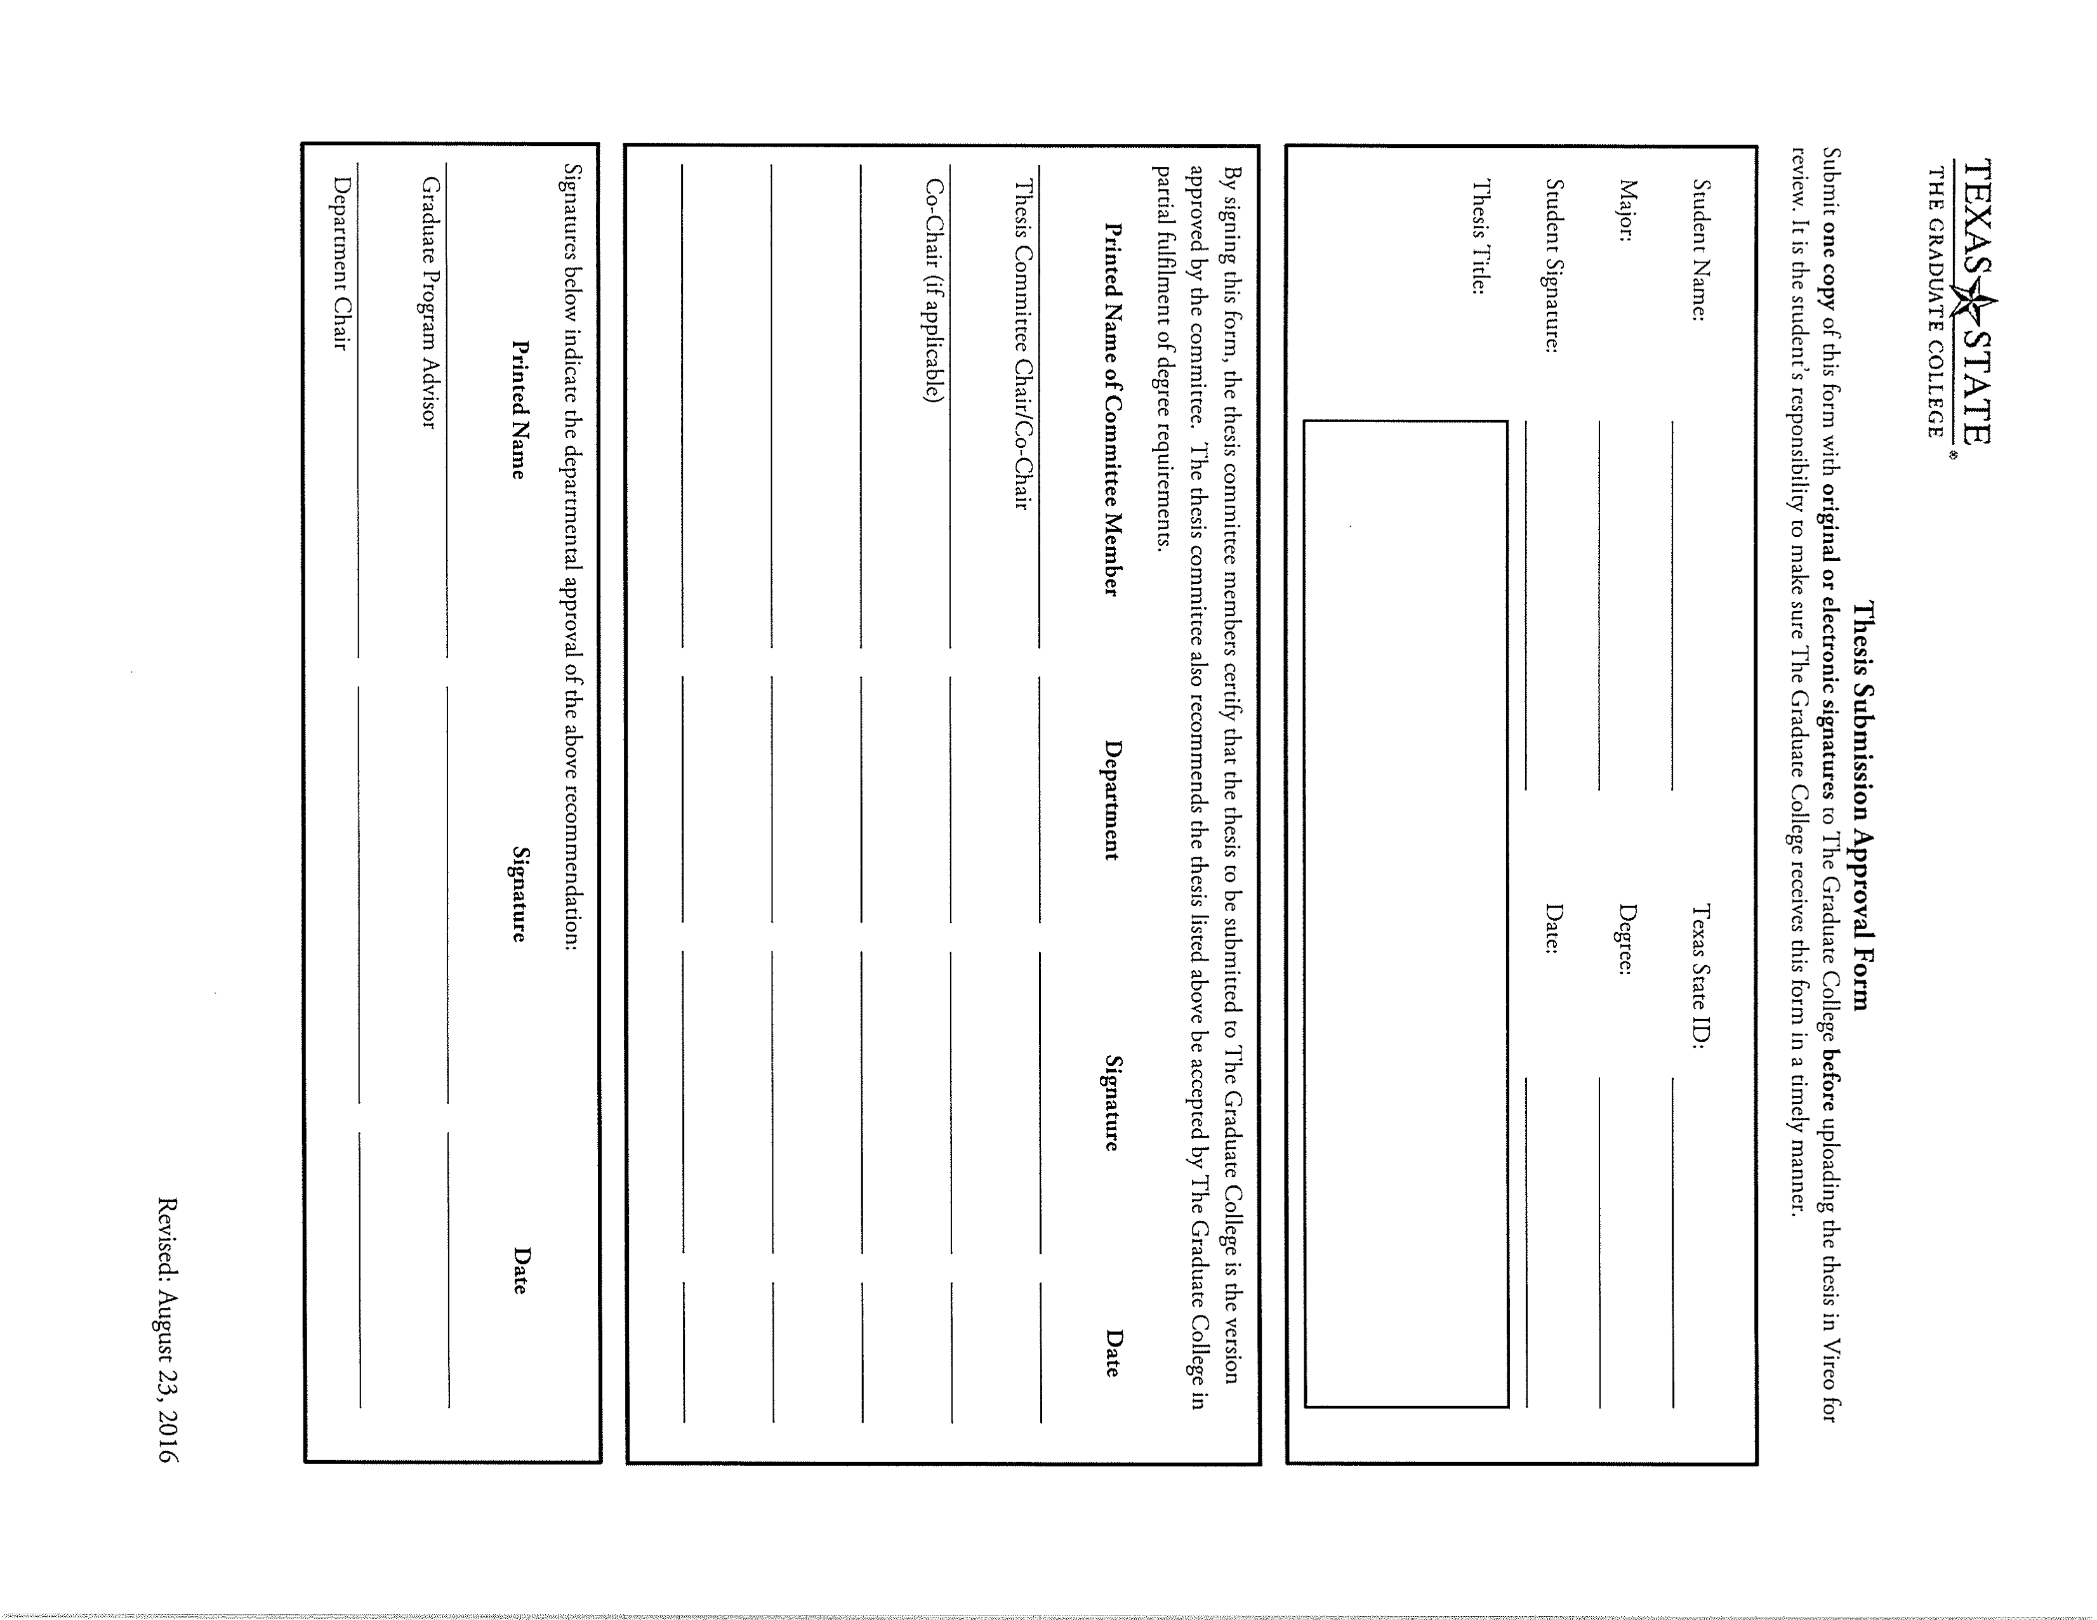

2

___Submit a copy of your Thesis to the Graduate College with a signed *Thesis Submission Form*. Details can be found here: **gradcollege.txstate.edu/docs/Thesis_Diss_Guide.pdf**

___Complete both parts of Comprehensive Examination:

**malit.english.txstate.edu/forms/Booklets**

___General Examination (4 hours; written; offered the first Saturday in February, June, and October)

___Thesis Defense (oral; completed by deadlines found here: **gradcollege.txstate.edu/students/deadlines**)

1

**THESIS TRACK**

**MA Literature Degree Requirements**

___Complete coursework requirements for Major:

___Literary Scholarship (5301)  
___Medieval Literature (5353)  
___Renaissance Literature (5354)  
___American Literature  
___British Literature (post-Renaissance)  
___Any post-Renaissance literature

___Complete 6 hours of coursework requirements for Minor/Area of Emphasis/Cognate. Include **course department and number**.

___ ______________________________  
___ ______________________________

___Complete Thesis Credits [official Thesis deadlines can be found at: **gradcollege.txstate.edu/students/deadlines**]

___Consult with graduate advisor  
___Obtain commitment of Thesis advisor  
___Enroll in 5399A by emailing Dr. Flore Chevaillier fc@txstate.edu  
___Complete Thesis proposal

___ Establish Thesis committee

___Submit proposal and *Thesis Proposal Form* for approval by the Program Director Dr. Teya Rosenberg FH358

___Enroll in 5399B by emailing Dr. Flore Chevaillier fc@txstate.edu

___Submit complete draft of Thesis to committee by agreed upon deadline  
___Conduct Thesis defense with committee (date, time, and room reservation arranged by committee and student)

**Thesis Guidelines**

**for M.A. in Literature Students**

**I. What is a thesis, and what special requirements do I need to meet to graduate?**

A thesis is essentially a lengthy research paper that makes an original, well-supported argument. The body of the thesis is normally divided into chapters and may include an introduction. There is no set page limit, but generally theses are no shorter than 60 pages, not counting documentation, and no longer than 120 pages.

To graduate, you will take the General Exam, write a proposal, submit a thesis, and complete an oral defense.

**II. When should I start to think about my thesis?**

If you are on the thesis track, you will begin to think about ideas for your thesis during your first year of graduate study. The sooner you select a thesis topic, the sooner you can begin the process of putting together your thesis committee and doing research on that topic. Researching and writing a thesis can be a very time-consuming process, so beginning early can make it less stressful for you and your committee.

**III. How do I know what to write about?**

You should choose a topic that interests you because you will be spending a lot of time researching and writing about that topic. Also, your topic must be original. The thesis will be published electronically, and you would frustrate future scholars who obtain copies of your thesis only to find that much of it repeats earlier scholarship.

Many students choose to expand on a research paper that they wrote for a course. It is helpful, once you have an idea or two, to do some preliminary research to see what kinds of things

3

have already been written about your topic. If you think, after investigating your topic, that you can make an original argument, then you should discuss your idea with a faculty member to get feedback.

It would be a good idea to look at some theses to get a sense of the kinds of topics people choose, how they organize their arguments, and so on. A selection of maroon-bound theses is available on the right-hand shelves in FH 361 for in-room browsing. Copies of all Texas State theses are also available in the Alkek Library.

**IV. Are there any limits on the topics from which I can choose?**

You need to work with a text or texts in English rather than translations into English. So much of a text is inevitably lost in translation that scholars cannot really say they know a text unless they have read and studied it in the language in which it was written. Even if you are fluent in another language and wish to write about a text in that language, chances are that you will not be able to find three committee members who are also fluent in that language. For these reasons, you should avoid translated texts when choosing a thesis topic.

**V. How do I put together my thesis committee?**

Once you have an idea for your thesis, you should consider which faculty members are experts on, or at least knowledgeable about, your topic. One faculty member will act as the chair of your committee, also called the thesis director, and two additional faculty members will act as readers. You will be the most involved with the chair of your committee, so you should choose a professor with whom you feel comfortable and whose academic methods and viewpoints you respect. The

4

chair of your committee will want to read and comment frequently on your thesis as you write it; the two additional readers, on the other hand, may choose to read and comment on your writing less frequently, and may become involved relatively late in the writing process. You should discuss with them what they would prefer.

You should meet with the faculty member whom you would like to direct your thesis. After discussing your idea with him or her, ask if he or she would be willing to direct. Please note that professors might not be in a position to accept this responsibility. For example, they may be planning a sabbatical, or may already be chairing too many theses. If this is the case, approach your second choice. When a professor agrees to chair your thesis, discuss with him or her other possible readers. At this point, invite the other two professors to be readers on your committee.

**VI. Am I limited as to who can be on my committee?**

You should note that only Graduate Faculty may serve on a thesis committee. This would normally include anyone who teaches graduate literature courses. If you are unsure whether a professor is a member of the Graduate Faculty, ask the MA Literature GA in FH 358, at 245-7685, or at malit@txstate.edu, or consult the Faculty list online at:

**malit.english.txstate.edu/Resources/faculty**

At least the first two faculty members on your committee must be from the English Department, but you may choose a third member from any Department at Texas State University who you think will be able to give you helpful feedback on your chosen topic. For example, if you are writing your thesis on some aspect of Shakespeare’s work that involves an historical element, you might choose to invite a history professor who specializes in the English Renaissance to be on your committee. Such an outside reader must be listed as the third reader.

5

**VII. What if I can’t find anyone who will agree to chair my thesis?**

While this circumstance is rare, sometimes the topic you have chosen doesn’t correspond with the areas of expertise of the professors in the English Department. In this case, you may need to revise your topic, perhaps with the aid of a faculty member who can advise you. If you find that you are unable to revise your topic or select a new topic, you may want to consider the non-thesis track option for graduation.

**VIII. Once I have a committee, what’s next?**

When you have established at least your thesis director, you should inform Flore Chevaillier at fc@txstate.edu or 512.245.7683. She will give you a course code so that you can register for ENG 5399A.

Before your second semester working on your thesis begins, email again for a course code for 5399B. If you need additional time to work on your thesis, you will have the option to take a one-credit-hour Thesis B course. Please note financial aid will not always cover hours over your required coursework.

You will not meet in a formal class setting for these credits, but will rather work with your thesis chair and readers as you write your thesis in your own time.

**IX. When should I register for 5399A (Thesis A) and 5399B (Thesis B)?**

If you are moving through your program at the typical pace of two years, you should register for 5399A during your third semester and 5399B during your fourth semester. You can only register for 5399A once, but you can, if need be, register for

6

8

**XI. What is a thesis proposal and how do I write one?**

The Graduate College has very specific requirements for the thesis proposal. It need not be lengthy, but it should include the following in this order:

1. A detailed description of the problem or question you will be approaching in your thesis
2. An overview of the contents of your thesis
3. A bibliography in MLA format. A sample thesis proposal appears as an Appendix at the end of this booklet. Read it over as you prepare to write your own proposal

**XII. How do I submit my thesis proposal?**

Your thesis proposal needs to be approved first by your thesis committee. Have each member of your committee read it and use their feedback to make any necessary revisions.

You will need to submit your complete proposal with a thesis proposal cover sheet. You may get a blank cover sheet in the MA in Literature office, or you may go to:

**gradcollege.txstate.edu/docs/thesis-proposal.pdf**

Follow the directions on the cover sheet exactly. Be sure to fill in names of the professors in your committee followed by the department to which they belong (e.g., Dr. Teya Rosenberg, English). Bring the full proposal to each committee member, and get his or her signature on the cover sheet. Then bring the full proposal and signed form to the Director of Graduate Studies, Dr. Teya Rosenberg in FH 358, who will then pass it along to the Department Chair, Dr. Dan Lochman, who in turn will send it to the Graduate College for review by the Dean.

7

5399B as often as necessary, even during the same semester as other 5399A or 5399B hours. However, considering the early deadlines discussed in Section XIV below, it is essentially impossible to complete the entire thesis in a single semester.

You can register for thesis hours in the summer instead of a long semester, but this can be tricky to schedule, especially for Thesis B. Your entire committee will need to be available on key dates, and many faculty members travel through part or all of the summer. If you want to try to take thesis hours in the summer, get a firm commitment from all three committee members.

If you do this, you register for the hours at the time of registration for Summer Session I, but you are registering for the one course for the full summer, rather than for a single Session.

**X. What should I accomplish during the semester in which I am enrolled for Thesis A?**

You need to do at least three things:

* If you have not already done so, invite two graduate faculty members to be second and third readers on your thesis committee.
* Complete a thesis proposal, and submit it for approval (see Section XII below) within the first few weeks of the semester. *Delaying this is very risky.*
* Write a substantial portion of the thesis itself.

graduate. You need to schedule an oral defense of your thesis with your committee for about 33 days before commencement. This gives your committee time for the final reading.

When you and your committee have settled on a convenient date and time, ask Shaula Rocha (FH 365, ssr16@txstate.edu, 512.245.2163) to reserve a room, and let your committee know.

After the defense, you will make any final changes requested by the committee. Then at least 24 working days before commencement, you will turn your thesis in to the Graduate

College. The deadlines for submission to the committee and to the Graduate College are firm; don’t risk failure to graduate. Official deadlines can be found here:

**gradcollege.txstate.edu/students/deadlines**

The Graduate College requires two forms be signed by your committee (examples are located in Appendix A of this booklet):

1. **Comprehensive Examination Report Form** - Your committee chair will obtain a copy of this form in an Oral Defense Packet from the MA Literature Graduate Assistant in FH 361 prior to your Oral Defense. You and your chair are responsible in determining who will turn the form in to the Program Director, Dr. Teya Rosenberg, in FH 358 directly after you pass your Oral Defense.
2. **Thesis Submission Approval Form** - This form will be located in your committee chair’s Oral Defense packet as well. You are responsible for the form once your committee has signed it. It must be turned in to the Program Director, Dr. Teya Rosenberg, by the day you submit your final thesis to the Graduate College. It is suggested you have your committee sign at your defense, as it can be difficult to track down signatures as semesters end.

**XIII. Are there specific guidelines for writing a thesis?**

Yes. The Graduate College holds seminars to help students with the many requirements involved in writing a thesis. You will receive email notification during your Thesis A semester, and you can check the Graduate College website for upcoming seminars:

**gradcollege.txstate.edu/students/thesis-dissertation**

For all matters of style and format, you must follow the guidelines in the *MLA Handbook, Eight Edition*. The *MLA Handbook*’s rules are quite complex, and you must follow every one to the letter or your thesis will be rejected. Look up everything; assume nothing. Your Thesis Director, and the

Writing Center can help, but they will not be your proofreaders. The ultimate responsibility is yours.

Also, you must consult the *Texas State Graduate Thesis and Dissertation Handbook* at:

**gradcollege.txstate.edu/docs/Thesis_Diss_Guide.pdf**

This Handbook contains a wide array of information that will be crucial for you to have on hand as you write your thesis.

In the unlikely event of a discrepancy between the *MLA Handbook* and the *Texas State Graduate thesis and Dissertation Handbook*, check with your director and/or the Graduate College.

**XIV. When do I need to finish writing my thesis?**

You need to finish writing your thesis early in the semester in which you are enrolled for Thesis B, and turn in the final, complete thesis to your committee at least 41 working days before the commencement date on which you plan to

9

10

**XV. What is the Oral Defense?**

During the one-hour oral examination, the student will answer questions, concentrating on the thesis, posed by the committee. With the student’s approval, observers may attend the Defense. Students will receive one of three evaluations from their committee:

1. Passing with Distinction
2. Passing
3. Not Passing

The evaluation Passing with Distinction is rare and must be a unanimous decision. Committee members may also have revision suggestions for the thesis that will need to be completed in time to turn in your completed thesis to the Graduate College.

**XVI. What happens if I don’t pass my Oral Defense?**

If your committee approves, you will register for 5399B again the following semester and retake the Defense then. That would normally be the final attempt, unless extraordinary circumstances lead your committee to make special arrangements with you.

**XVII. What happens if I get behind and can’t finish the thesis on time?**

If you are unable to finish writing your thesis during the semester in which you register for Thesis B, you will need to register for it again the following semester. There is no limit to the number of times you can register for Thesis B; however, repeating this course multiple times can get expensive. Set realistic writing goals for yourself and strive to finish writing your thesis on time.

11

12

**Appendix A: Sample Forms**

All of the following forms are located in the Graduate English Office FH 361 and can be found on the Graduate College’s website here: **gradcollege.txstate.edu/forms**

**I. Thesis Proposal Form**

**III. Comprehensive Examination Report Form**

(This form will indicate that you have passed both the General Examination and your Oral Defense)

14

**II. Thesis Chair/Committee Change Request Form**

13

15

**IV. Thesis Submission Approval Form**

16

**Appendix B: Sample Thesis Proposal**

**(without cover sheet & Bibliography)**

Franzen’s *Corrections*, Jameson’s Connections

Fredric Jameson, America’s preeminent Marxist critic, suggests a number of ways in which a critic can (and should) approach a literary text. Primarily, he follows Marx, via Hegel, in viewing history as a totality, substituting Hegel’s “ideal” or “spiritual” dialectic of history with a “real-world” narrative, wherein the dialectics are acted out by humanity. This commitment to a historical totality requires that, in order to fully understand the manifest and latent contents of a text (or of any cultural artifact), a critic must pay strict attention to the economic, political, and cultural contexts under which it was produced. For Jameson, history does not exist in specific time periods; everything throughout history is somehow connected, and everything in the future will be somehow connected to everything in the past. Jameson, as a Marxist critic, sees these connections made according to the economic base of a society, which in turn determines the society’s superstructure and cultural beliefs, which in turn wholly affects the art and literature produced under that particular economic base. In this model, postmodernism, for example, becomes not a style or period, but one point in a totalizing history. Postmodern literature from the United States, then, reflects not simply a shift in writing styles, but a shift from imperial to late capitalism. More importantly, Jameson contends that the closest we can come to understanding reality, a reality without oppressive cultural ideologies, is to interpret texts, as the latent aspects of any given text will approximate the Real.

Keeping these ideas in mind, this thesis will do a reading of Jonathan Franzen’s most recent novel, *The Corrections*, a postmodern (in the Jamesonian sense) portrayal of an extremely dysfunctional mid-western family, spanning fifty years. In addition to applying Jameson’s ideas of historicity, totality, and dialectics, I will incorporate several other aspects

in production, and a series of e-mail messages. In so doing, I hope to uncover the latent aspects of the text, and approach an idea of the late-capitalist Real.

While the majority of the thesis will concentrate on Jameson’s theories and ideas, I will also briefly utilize the work of several other theorists, via Jameson, including Theodor Adorno, Louis Althusser, Jaques Lacan, and Sigmund Freud. I will also incorporate theories and ideas from cultural critics who have drawn from, been influenced by, or commented on Jameson’s ideas, including Perry Anderson, Michael Bérubé, Clint Burnham, Sean Homer, Terry Eagleton, Steven Helmling, and Slavoj Žižek. The discussion on form will include the ideas of Kenneth Burke and Milan Kundera.

18

of Jameson’s theories such as his concept of Utopia and his applications of Freudian psychology, in a tentative structure as follows:

Introduction: The purpose of the introduction will be to outline the most relevant of Jameson’s theories, and illustrate how they relate and are applicable to Franzen’s novel and characters, existing as they are in a postmodern, late-capitalist society.

Chapter One will make an argument for the patriarch of the family being the most “Marxist” of all the characters, and how his ideologies, or more specifically, his denial of dominant ideologies, conflict with those of the rest of the family, specifically those of his wife.

Chapter Two will address the ways in which the matriarch of the family is dialectically opposed with her husband, as she is wholly and willingly immersed in the dominant ideologies of her time(s). Furthermore, this chapter will explore the ways in which her exposure to and use of the drug Aslan, which rids people of all shame and guilt, begs the question of the positive uses of and need for cultural ideologies.

Chapter Three will focus on the couple’s three adult children, and how the influences of their parents have shaped and formed their characters, including their relations with each other as well as with the rest of society. Topics here will touch on sexuality, clinical psychiatric conditions, and whether or not there is actual individual freedom in a late capitalist society.

Chapter Four will treat the W----- Corporation, a monolithic company that affects many of the major characters, as a character itself, highlighting the ways in which it embodies a physical, emotional, and economic dialectic.

Finally, Chapter Five will concentrate on issues of form, analyzing the ways in which the form and structure of the novel reflect, in Jameson’s words, “the cultural logic of late capitalism.” Here I will be looking at the divisions of the novel, the narrative ruptures, and the meta-texts, which include portions of a Ph.D. dissertation, a movie script, an actual movie

17