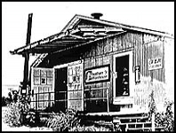

Calling all aspiring songwriters ages 12-18
(Lyrics, Instrument, or Both)
The Cheatham Street Foundation &
Central Texas Writing Project Proudly Present

Young Songwriters’ Camp ’15

Mon-Sat June 15-20, 9am-Noon @ Cheatham St. Warehouse
Live Performance by Young Songwriters Sat. June 20, 6-8pm

Camp cost-$250/camper; Cost includes t-shirt, notebook, memory stick, and daily workshop interaction with established Texas songwriters
Guest Artists include Foscoe Jones, Sterling Finlay, HalleyAnna, Kathleen O’Keefe, Missoula Slim, Pake Rossi, Victor Holk, David Beck, Robyn Ludwick, Gary Hickenbotham, Dr. G (and some of) the Mudcats!!!

Camp schedule and registration: yswc.cheathamstreetfoundation.org

