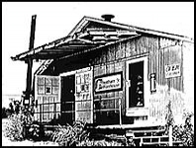

Calling all aspiring songwriters ages 12-19
(Lyrics, Instrument, or Both)
The Cheatham Street Music Foundation &
Central Texas Writing Project Proudly Present
Young Songwriters’ Workshop ’16

Mon-Fri June 20-24, 9am-Noon @ Cheatham St. Warehouse
Live Performance by Young Songwriters kicks off Day 2 of BIGFest Sat. June 25 at Cheatham St. Warehouse and will be broadcast by Radio Free Texas!

Camp cost-$250/camper; Cost includes t-shirt, notebook, one ticket to Saturday’s BigFest performances, and daily workshop interaction with established Texas songwriters, including HalleyAnna, Manzy Lowry, Missoula Slim, Sean Makra, Sami, Marshall Anderson, Dr. G, and MORE!!!

For information/registration, please visit youngsongwritersworkshop.weebly.com
Or email youngsongwriters@yahoo.com

