How to Add a Dependent for Those with a Texas State Username and Password

- Go to https://recconnect.campusrecreation.txstate.edu
- Select “Log In” from the upper right hand corner of the screen
- Enter your Texas State username and password and select “Log In”

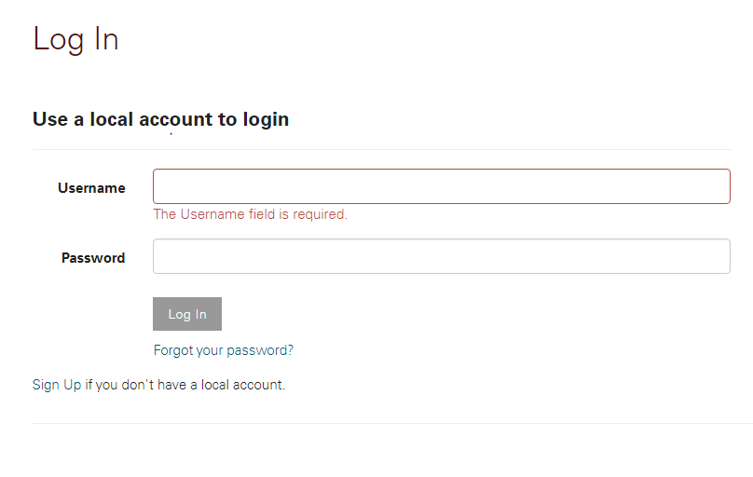

- It will take you back to the main page, click on your username in the upper right corner and then select “profile”
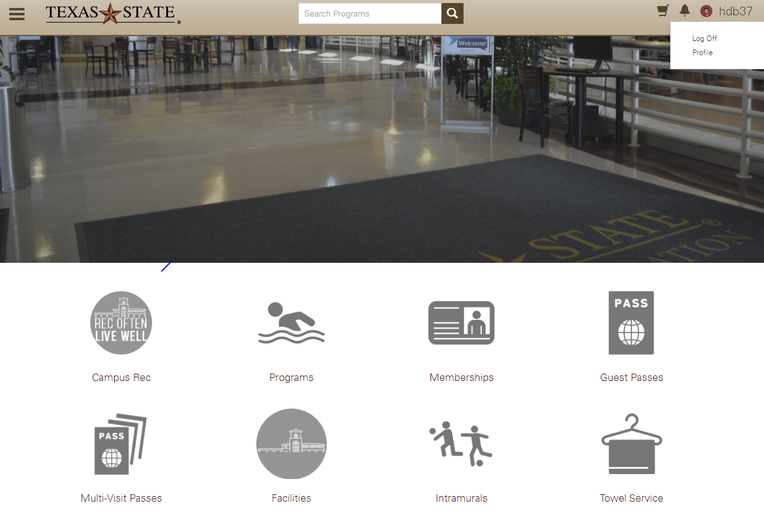
- Scroll down and select “Add a Dependent”
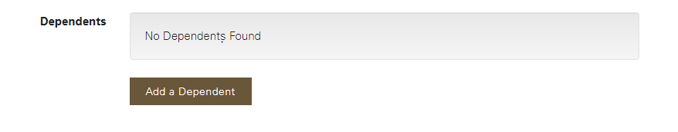
- Fill out the requested information and select “Save”
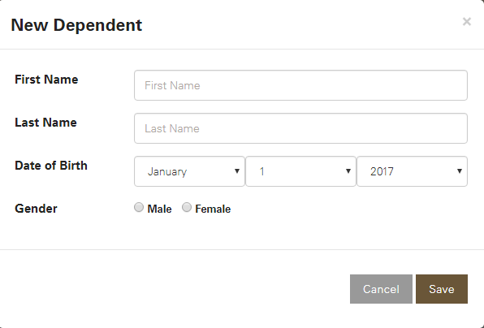

- After adding all of the dependents you wish to sign up, click on the three parallel bars in the upper left-hand corner
- Select “Programs” from the slide over menu
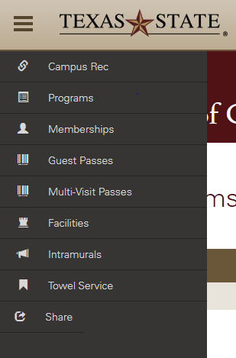

- All programs Campus Recreation offers may be listed at this point. You may also click on “Aquatics and Safety” and then “Swim Lessons” to view only the swim lessons. Select the class you wish to register for, be sure to read all of the information about it, and then click register. It will take you through the proper process and take payment.

