Home Renovation & Repair Fundraiser for Texas State Trailblazer: Helen J. Franks

Helen Jackson Franks is one of the five Black women who integrated Texas State University (formerly Southwest Texas State College) in 1963.

All proceeds will be donated to the
Home Renovation & Repair Fundraiser for Helen J. Franks.

T-Shirts are $10 per shirt

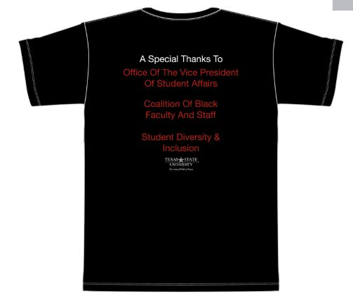
- All purchases must be made with a major debit/credit card.
- Submit forms to SDI
            - Email: osdi@txstate.edu
            - In-person: LBJ Student Center, Suite 5-2.1
- Shirts can be picked up Monday through Friday from 8:00 AM to 5:00 PM in the Office of Student Diversity & Inclusion (SDI).
- There will be NO mail orders (i.e. shirts will not be mailed or delivered).

T-Shirt Order Form

Please complete all fields below:

Purchaser Name:

Debit/Credit Card Number:

Card Expiration Date:

Billing Address:

Shirt Size: Small Medium Large Extra Large
Quantity:

Complete and return to:
Office of Student Diversity & Inclusion
600 Student Center Drive
LBJ Student Center, Suite 5-2.1
osdi@txstate.edu

