Graduate Minor in Women’s and Gender Studies Course Offerings Fall 2013
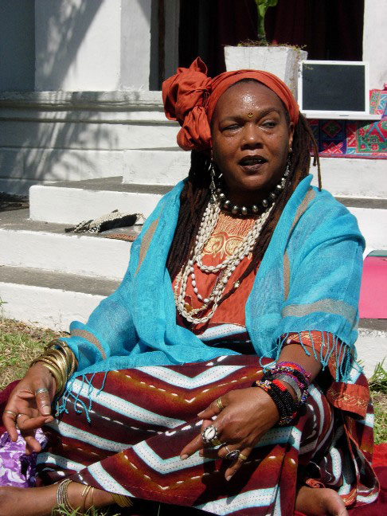

Required Available :
WS 5376
Approved Electives
ANTH 5324 Mexican American Culture
COMM 5325 Seminar in Human Communication
COMM 5342 Seminar in Human Communication
DVST 5310 Diversity Studies: Theories and Issues
ENG 5321 Contemporary Fiction
ENG 5332 Studies in American Prose
ENG 5364 Studies in the Romantic Movement
ENG 5368 Studies in Victorian Prose
ENG 5388 Studies in Literature for Children or Adolescents
ENG 5395 Problems in Language and Literature
PHIL 5301 Applied Philosophy
PHIL 5325 Philosophy of Sex and Love
PHIL 5388 Problems in Philosophy
SOCI 5350 Seminar on the Sociology of Gender
SPAN 5310 Studies in Spanish Culture, Language, or Literature (Independent Study)
WS 5388 Independent Research in Women and Gender Studies

