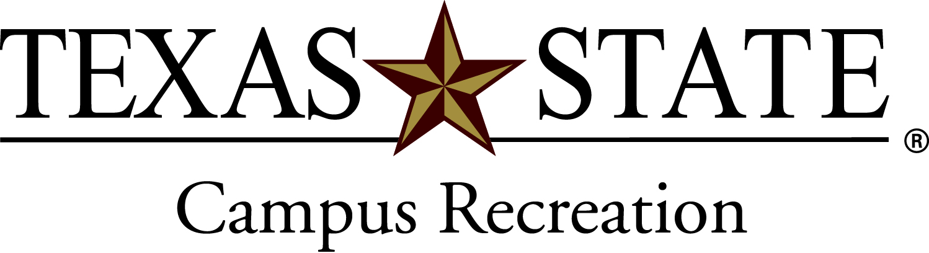
Texas State Sport Clubs
Budget Presentation

General Information
Each club will submit a budget for the current academic year and a budget for the upcoming academic year. Budget requests are submitted to the Sport Club Office and forwarded to the Sport Club Alliance (SCA) for their review. The SCA will review the information and forward their recommendation to Campus Recreation Administration. Allocations are finalized and awarded at the beginning of the fall academic semester.

Step by Step – all steps must be completed and on time to be granted any funding

- Budget Request Form (must be typed)
  - Each club must submit a budget request form no later than the Friday prior to the presentation to the Sport Club Office.
  - Along with the complete budget request form clubs must also submit justification documentation materials (detailed list of travel, fundraising, etc…)
    - Budget request totals will be compared to previous years expenditures
    - Rationale for expenses

- Budget Preparation Meeting
  - Set up meeting with the Assistant Director and/or the Graduate Assistant no later than the second Monday of April.
  - Final review of materials for presentation and budget

- Budget Presentation
Each club must present and defend their budget in front of the Sport Club Alliance during a scheduled 15 minute time slot in March after Spring Break
    - 10 minute maximum for presentation
    - 5 minute remainder for Q&A from Alliance

- Evaluation of Council
The budget request will be graded by the Alliance on the following criteria:
    - Presentation
      - Explanation of budget expenses (6-8 minutes)
      - Explanation of team purpose and goals (2 minutes)
      - Support materials and documentation
      - Visual aides
      - Presentation skills
      - Professionalism
      - Timeliness (time limit will be strictly enforced)

- Award Amount
  - The Sport Club Alliance will make a recommendation to the Campus Recreation Administration
  - Their recommendation is based upon their approval of the expenses you have set forth.
  - The Sport Club office will then total all teams approved funding and each club will get the adjusted percentage of the total.
  - Sport Club funding comes from student fee dollars, therefore the final amount allocated to each team can not be determined until enrollment figures are confirmed in August
  - Award letters will be given to each team at August Officer Training with their stated allocation amount, which is a combination of the Bobcat Scoreboard funding, and SCA recommendation.

