Intro to Diversity Studies
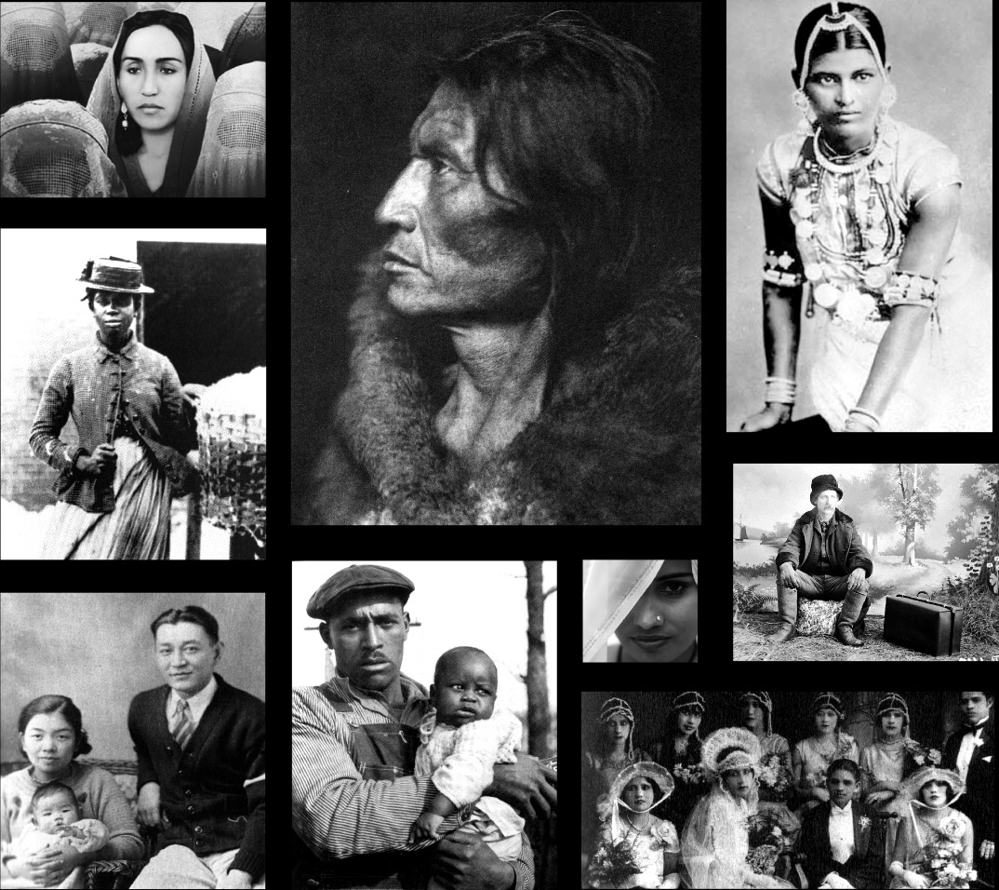

DVST 3301
Spring 2014
Instructor: Dr. Elvin Holt
Online Course

DVST 3301 Intro to Diversity Studies
Course Description:
- The course is a general, multi-disciplinary and comparative survey of U.S. diversity issues.
- It highlights the traditional minorities, such as African, Latino/a American, Native, and Asian Americans, as well as European American ethnic groups.
- It also explores issues related to religion, age, sexual orientation, gender identity, and physical ability/disability

