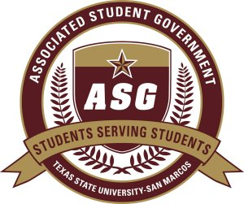

Author:
Senator Joseph Flores

Sponsors:
Senator Alec Hartmann
Senator Adam Brass
Senator Adam French
Senator Dominique Jackson
Senator Justin Solomon

S.S.R.F 2011-2012/2
Date of First Reading: October 10, 2011

“British Bobcats”

WHEREAS: Texas State University-San Marcos has a thriving international debate team; and
WHEREAS: Every year the Texas State Lyndon B. Johnson Debate Team hosts the International British Debate Team for workshops, training, and advancing Texas State’s own debate team; and
WHEREAS: Texas State University is home to many international students and guests; and
WHEREAS: The British Debate Team offers invaluable aid and support to the Texas State Debate Team through extensive training and teaching during their stay; Therefore
BE IT RESOLVED: that British International Debate Team member Ben Jasper and Richard Robinson be deemed ‘Honorary Bobcats’ by the chartered organization of the Associated Student Government; and
BE IT FURTHER RESOLVED: that this legislation be forwarded to ASG Advisor Kathy Weiser, Dean of Students Dr. Margarita Arellano, Vice President for Student Affairs Dr. Joanne Smith, Professor Wayne Kraemer and University President Dr. Denise Trauth upon passage.

