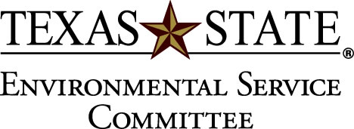

Date 10/19/2011

Attendance:
Committee members present:
- Stephanie Bledsoe
- Ignacio Gilbert
- AJ Perez
- Richard Medina
- Mark Carter
- Randy Simpson
- Laura Underhill
- Nancy Nusbaum
X voting members present: Quorum not met

- Call to order: 5:19
- First order of business Fashion Nation – Maria Gross
- A. asking $300 to fund Trashinshow. The trashinshow is a fashion show where Fashion Nation shows people how to upcycle old clothes and educate the public on textile pollution.
- Tabled- Quorum not met, will vote on project via email.
- Budget of ESC- 5:40
- Announcements- 5:45
  - Possible funding of bike path from campus masterplan
  - Committee Report from 2009-2010
- Adjourn 6:00
- Voting Via Email
  - Demoted Nicole Welday from voting position to non-voting position

