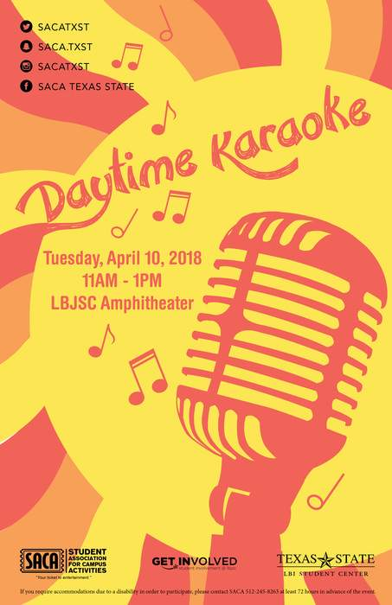
Event Flyer Example

Relevant Graphic
Contact Info
Name of Event

- Date
- Time
- Location

Hosting Organizations

Disability Notice
Required Flyer Content

- Name of Event

- Date & Time of Event

- Location of Event (if not yet determined: “TBD”)

- Short Description/Relevant Graphic that conveys the purpose and meaning of the event

- Name/Logo of student organizations hosting the event

- Office of International Affairs Logo (You will receive this after submitting the form, to be added after we recommend flyer edits)

- Disability Notice that says: “If you have questions concerning access, wish to request a Sign Language interpreter or disability-related accommodations please contact {INSERT name and contact information of the person submitting the funding request, including an e-mail}”

