Scenario 1: Connecting using a Windows computer using the web interface
Open a web browser to https://remote.txstate.edu and sign in with your NetID
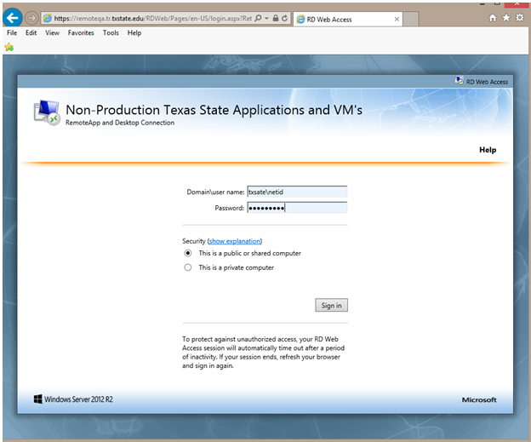
Select the desired program or virtual machine collection:
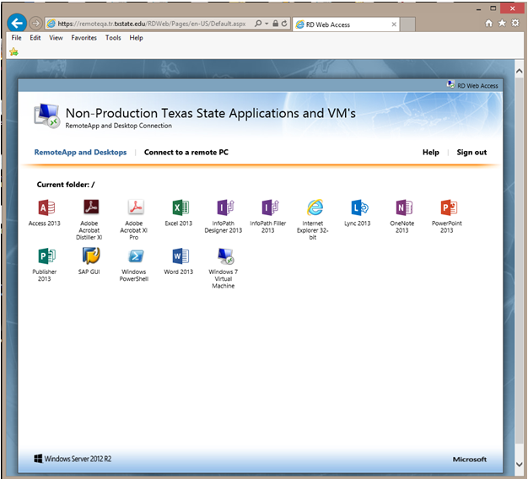

You may be prompted to sign in again after you've made your selection.

Scenario 2: To setup the connection to Remote to show all available software and virtual desktop connection in the start menu.
Go to the Control Panel and select “RemoteApp and Desktop Connections.”
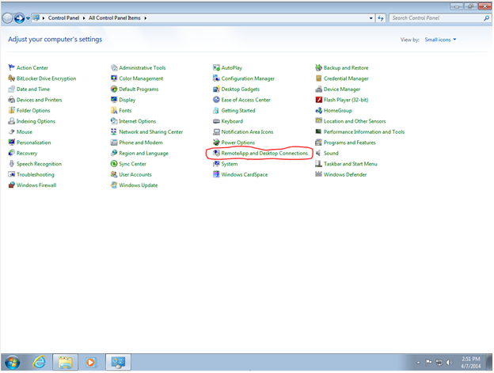

Now select “Set up a new connection with RemoteApp and Desktop Connections.”
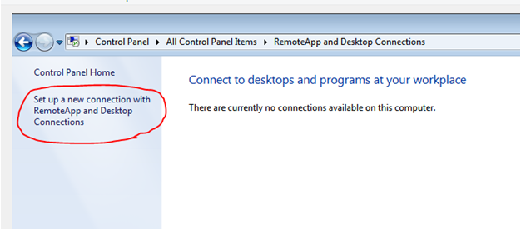

Now enter the connection URL https://remote.txstate.edu/rdweb/feed and click “Next.”

A successful connection will look like the following:
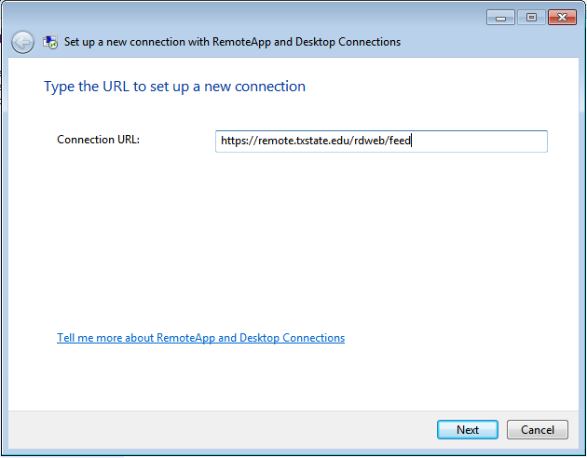
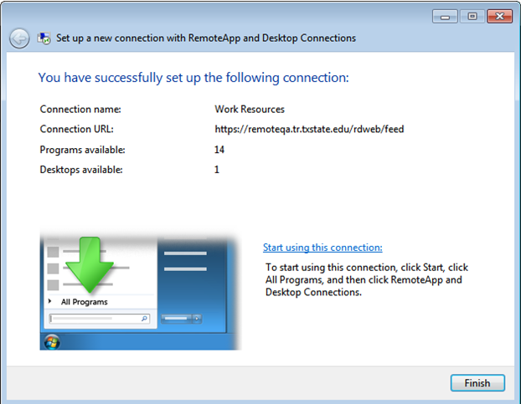

Now you can go into “All Programs” and select from the “Work Resources” folder your available programs or virtual desktops.

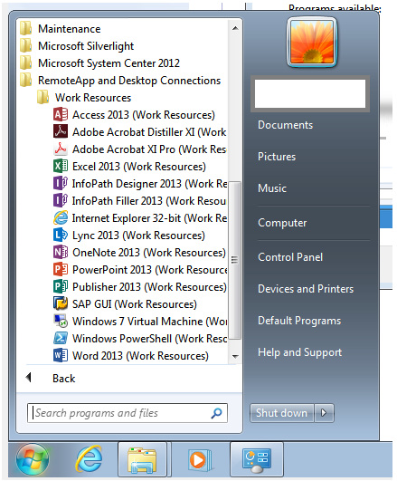

For connecting using a Mac, you will need to install “Microsoft Remote Desktop” from the App Store. This software is free.
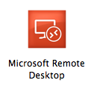
Scenario 3: Connecting using a Mac computer using the web interface.
Unfortunately, this scenario is unsupported due to security settings in place.

Scenario 4: Setup a connection as a "Remote Resource" on a Mac.
Install the "Microsoft Remote Desktop" application from the App Store and then setup the connection as below in "Remote Resources."
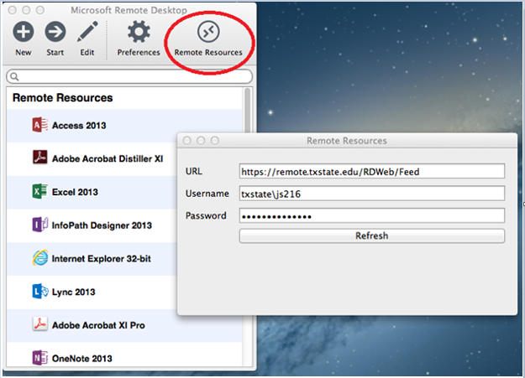
You will then have a list of available programs and virtual desktops every time you open "Microsoft Remote Desktop."

Scenario 5: Connecting on an Android or iOS device.
From the App Store, install "RD Client." This should be a free app.
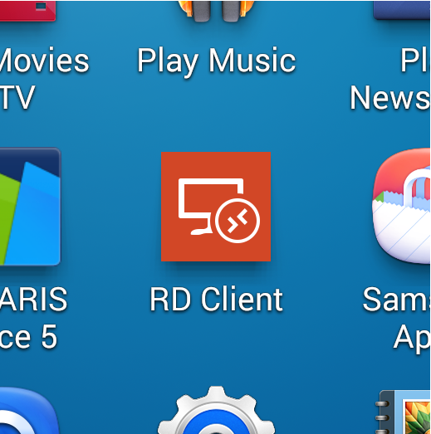

Select “Remote Resources” from the dropdown box, and then click the circle containing the two arrows to add a connection.

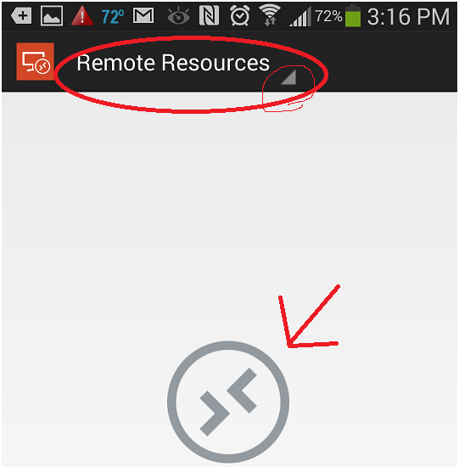

Now enter the connection information to https://remote.txstate.edu/rdweb/feed

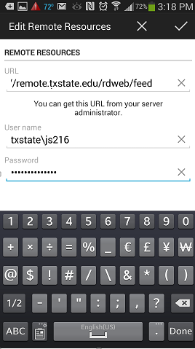
Click the checkmark in the upper right hand corner to save and connect. You will then see all software and virtual desktops available to you.
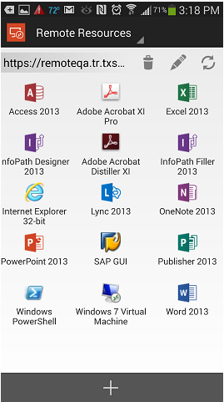

Enjoy!

