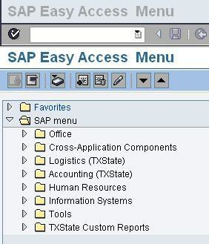C o m p l e t i o n o f Z H R P e o p l e S e a r c h a n d R e q u e s t f o r N e t I D P e o p l e S e a r c h f o r E m p l o y m e n t H i s t o r y

When to use Transaction ZHRPEOPLESEARCH
SAP transaction ZHRPEOPLESEARCH is available to assist our campus users who have the DEPARTMENT HEAD security role. This transaction will provide the PCR preparer with relevant employment history from 11/30/2004 to the present to determine if the employee to be hired is a current Texas State employee, a previous employee, or someone who will be a new hire to Texas State. Access to employment history will aid the preparer in the selection of the correct PCR form.

To use this transaction, follow the steps below:
- At the SAP Easy Menu enter transaction ZHRPEOPLESEARCH in the white text box and click the green check or press the Enter key on your keyboard.
1

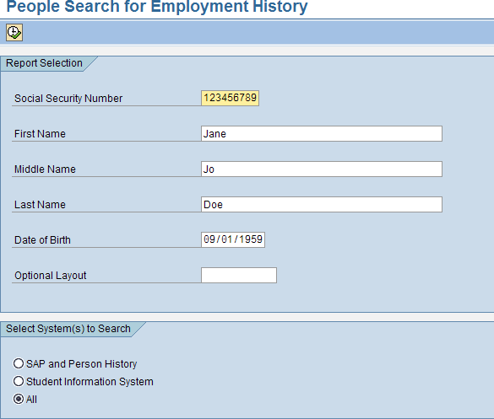
- The People Search for Employment History screen will load

- Enter the employee’s social security number, first name, middle name or initial, last name, and date of birth.
- Select the ALL option.
- Click to populate employment history.

- If a people record does exist, the following screen and information will appear.
Note the title of the record. If the title appears as **SAP History Found**, the individual does have either a current or previous work history record in SAP and the New Hire or Quick Hire PCR is not used to appoint the individual.

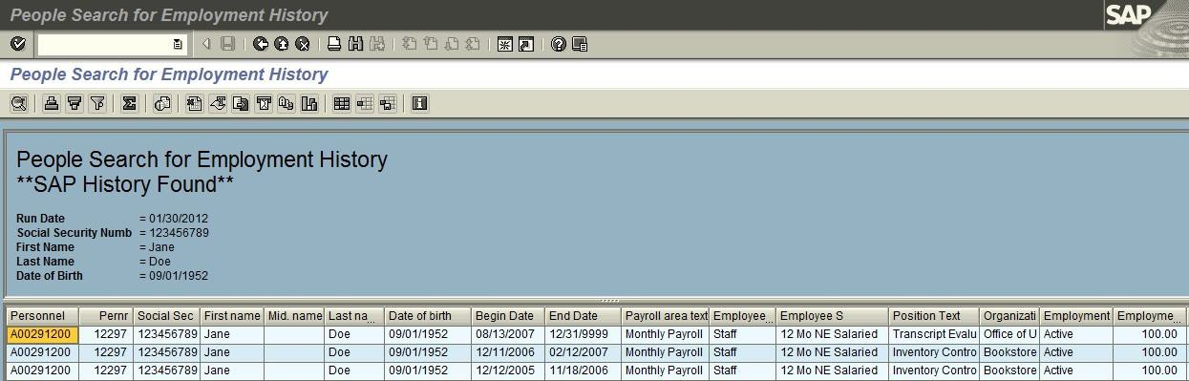

- The ‘SAP History Found’ screen indicates the employee’s:
  - Person ID to be used for PCR creation;
  - Any existing Personnel Assignment number(s);
  - Employee’s current name;
  - Date of Birth;
  - Record of employment history;
  - Employee subgroup (hourly or salaried); exempt/non-exempt status;
  - Position title and departments currently or previously employed by;
  - employment status
  - FTE
  - Net ID (if established)

In the example above, the employee was hired 12/12/2005 as a salaried staff employee and terminated 11/18/2006. She was rehired 12/11/06 and terminated 2/12/2007. She was rehired again on 8/13/2007 and is an active employee. If an employee is changing from a salaried position to an hourly position, a change in payroll area is not possible within the same pay period. The new appointment would be processed as an Additional Appointment with an effective date of the 1st of the following month.
Employees cannot hold a salaried position and an hourly position at the same time.

- If a **Person History Found** or **SIS History Found** record appears, the individual’s employment is treated as a new hire in SAP. A Person ID number will be displayed and Net ID (if existing)

- Record the Person ID number; you will use the number when the New Hire or Quick Hire PCR is selected.
- Make note of the assigned Net ID, if one exists. You will need to indicate this NET ID when requesting reactivation due to a Rehire or Quick Rehire action.
- If a Net ID does not exist, you will request one through the Net ID Request website. (https://tim.txstate.edu/netidrequest/)

If a Person ID and User ID appear but when creating the E-PCR you receive the message
“Employment record not validated”, you will need to request re-activation by accessing the Net ID Request website. (https://tim.txstate.edu/netidrequest/). Note the existing Person ID and User ID on your request under the Prior Affiliation.

If the message returned is “No History Found** the individual is new to Texas State. Creation of the New Hire or Quick Hire PCR will be required. Prior to the PCR creation, completion of the NET ID Request Process web application is required.

Net ID Request
This program is required:
- To create the Person ID (TEXAS STATE ID) and NetID for all new salaried staff, faculty, and non-regular, non- student staff (NSNR);
- To reactivate a previous NetID for an individual who is being rehired;

- To create a missing TEXAS STATE ID or NetID for an individual found in ZHRPEOPLE search; or

- To create a TEXAS STATE ID and NetID for an individual who needs access to university resources prior to the actual hire date.
Do not use this program if hiring a student employee. Student employees have an existing TEXAS STATE ID and Net ID in their student records.

* Upon completion of the NET ID request, the hiring department is responsible for providing the employee their Person ID (TEXAS STATE ID) and Net ID information.

Net ID Request Process
Prepare Before You Begin
- Decide if you will enter each name on the form individually or import a .CSV file with multiple names.
- If you import the multiple names, use the template on the site and be sure to follow the formatting and input instructions on the site: Download Import Instructions. Separate spreadsheets for each group are required if importing for a combination of faculty, staff or guest requests.
- If you are processing individual PCRs, you may wish to submit separate requests. Any errors in the request will result in the entire request not being approved.
- If your request is completed incorrectly or not approved, you will be required to submit a new request.
- Be accurate! Once requests are submitted, you cannot go back and edit the request details.

The Process
- NetID Request website: https://tim.txstate.edu/netidrequest
- Login with your NetID and password.
- Click Create a New Request.
- Complete the appropriate form fields.

- Click Review & Confirm.
- Click Submit Request.
- An e-mail with instructions will be sent to the Requestor and Sponsor when processing is complete.
Complete the Form Accurately and According to Instructions

Here are some helpful details!

TxState Guest | - Access to basic Texas State online authenticated services, minus Office365 (email)  - Set expiration date for the specific period of time access is required, limit 1 year
Faculty | - Intended for faculty only  - Access to basic Texas State online authenticated services, including Office365 (email) and faculty-specific resources  - Set expiration date to allow for PCR processing, maximum 45 days after start date  - Accounts without a valid PCR on expiration date will be disabled.
Staff | - Intended for staff only  - Access to basic Texas State online authenticated services, including Office365 (email) and staff-specific resources  - Set expiration date to allow for PCR processing, maximum 45 days after start date  - Accounts without a valid PCR on expiration date will be disabled.
Temp Agency Worker | - Limited to Texas State workers who:  - Are not otherwise considered an employee of the university, AND  - Are paid on a recurring basis with university funds through an intermediary as a result of their relationship with an agency, contract, or grant, AND  - Are fulfilling a role of similar capacity to a regular employee of Texas State 20 or more hours per week  - Office365 (email) access optional. Must be designated at the time of request  - Set expiration date for the specific period of time access is required, limit 1 year
Non-Paid Staff | - Access to basic Texas State online authenticated services for non-paid staff, minus Office365 (email)  - Full staff access is provisioned if/when PCR is processed (including Office365/email)  - Set expiration date as needed to allow for PCR processing
Figure 1. NetID Types

New Request Info Section
- You only see NetID types that you have been given access to request.
- Select official start date
- Select an expiration date. See Figure 1 (above) for expiration guidelines.
- Enter sponsorship reason
- Check the sponsorship agreement box

Supervising Sponsor Section
F. Select the supervisor from the dropdown menu
User’s Section
- There are two ways to add the new NetID names: (1) Enter individuals by selecting Add New User or (2) Use the template on the page (Download Import Template link) and import the CSV file.
- If you use the Import option, be sure to save it as this file type: .csv
Note: This is not a typical Excel file extension (.xls or .xlsx). The document template is already a .csv file.
G. If you use the template to import multiple names, your entries must exactly follow the guidelines set forth in the Download Import Instructions link on the screen.
Important Notes
H. Fill in the form completely and accurately. Use the person’s formal first and last name (no nicknames). Do not guess on any information. Incorrect data may lead to duplicate accounts, delay processing, and result in rejection. If your request is not approved, you will be required to start over with a new request.

SEE BELOW FOR ILLUSTRATION OF SCREEN

If you have questions about how to complete this form contact Human Resources by email at hr@txstate.edu or Faculty Records at 512.245.2786.

