Instructions for using Automated Asset Transfer Request

Getting Started

Go to transaction ZTRFASSET.
Choose the type of asset transfer request needed: 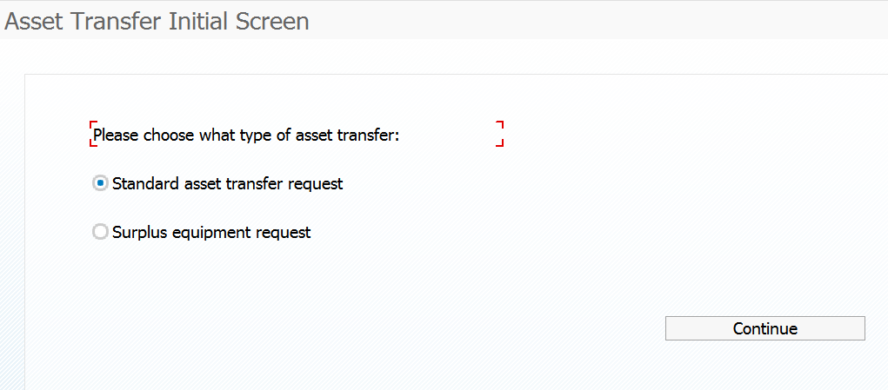
Click on CONTINUE once the appropriate transfer request path has been chosen.

Standard asset transfer request path:
Two ways to choose assets, by inventory number or by Responsible Cost Center. The Responsible Cost Center is the Cost Center the asset is listed under for performing the annual inventory. This is not necessarily the Cost Center used for purchasing the asset.
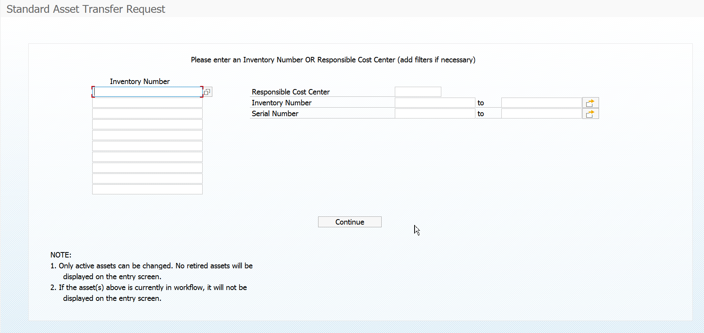

Inventory Number
This is the number located on the “State of Texas Property of Agency #754” barcode tag on the asset.
NOTE: Only active assets can be changed. If the asset has been retired in SAP, the asset will not show up on the entry. If you believe an asset should be listed on the entry screen, please contact Materials Management.
Inventory Number search function:
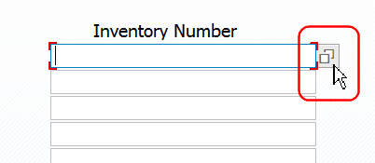

Search by wildcard using “*”
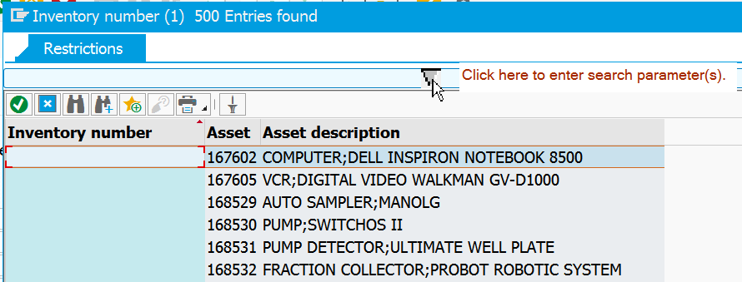
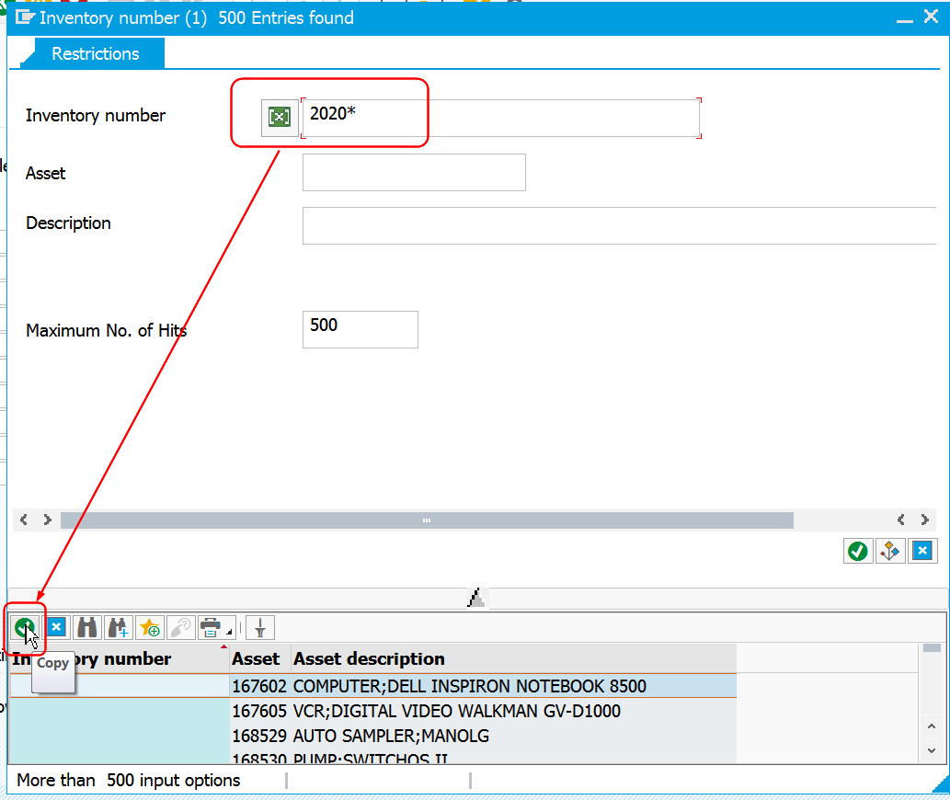
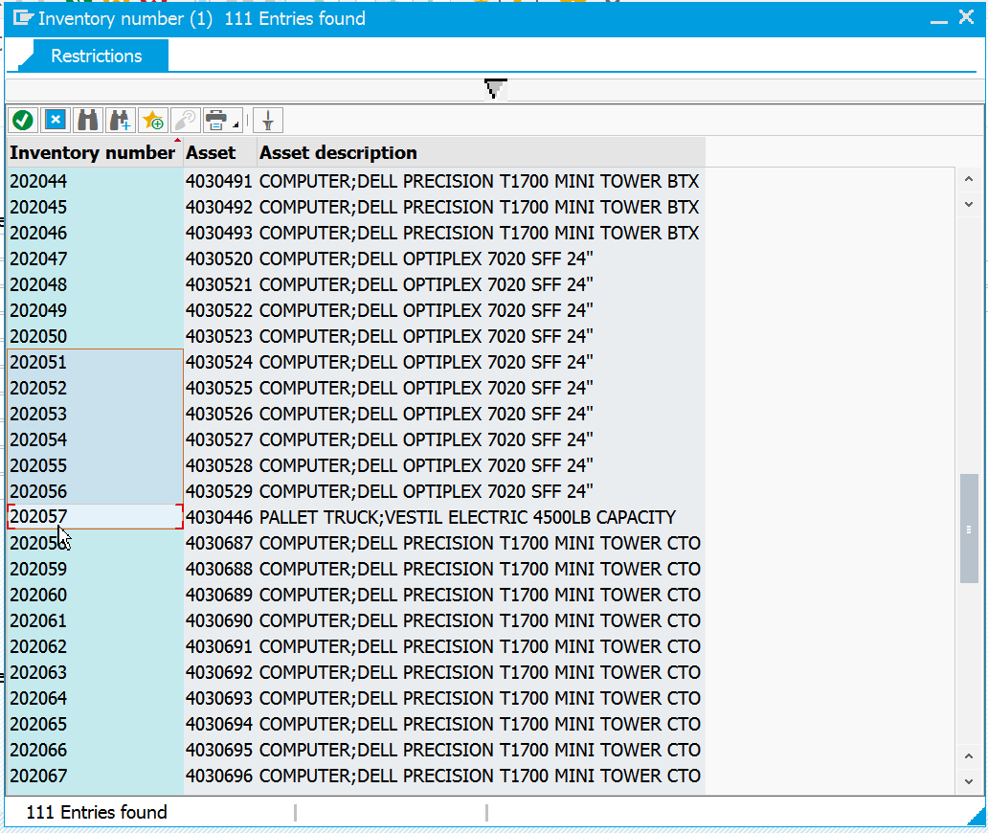
To choose, double click on the asset needed for the transfer. Up to 10 assets can be transferred at a time.
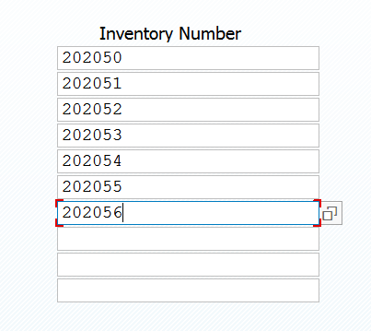
Click on CONTINUE to move to the next screen.

Asset Transfer Request Entry Screen
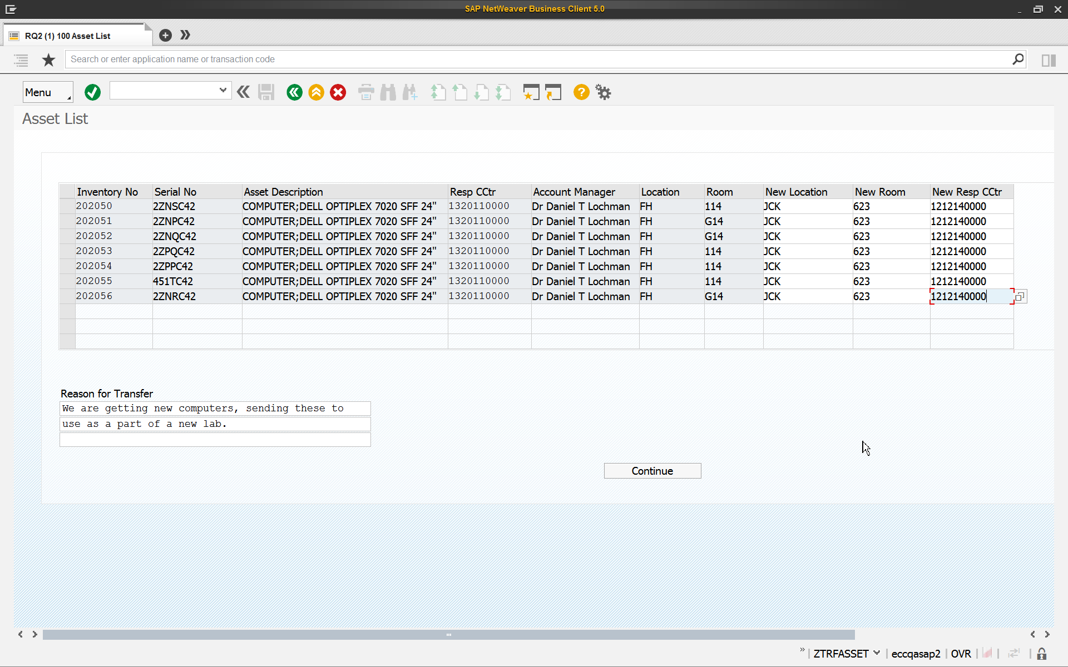
The Location (building) is pre-populated with the current building abbreviation. Anything in white can be changed on the request, Location, Room and/or Responsible Cost Center. Any fields in white that do not contain change entries (left blank) will keep the original location, room and/or responsible cost center.
*This will not result in any charges to the department, this is for inventory purposes only.
The Location, or building abbreviation, can only be chosen from a pre-existing list. Use the search icon 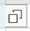 to see a listing of these abbreviations.
If an incorrect Location is used, the following error will be received:
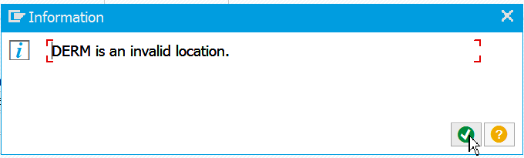
Responsible Cost Center also has a search function 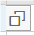and must be a valid cost center. If an invalid cost center is used, the following error will be received:
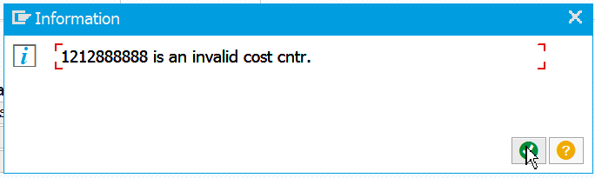
Business Purpose should be a description that will help the approvers determine if the change request is appropriate. This is a required field.
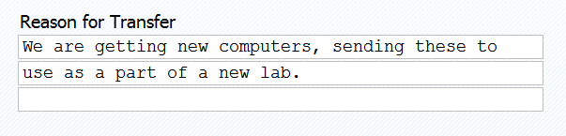

NOTE: An asset can only have one request per day or outside of workflow. If an asset was requested to be changed on day 1 and it is still in workflow on day 2, but a user enters a request for the same asset on day 1 or day 2, the user will get this message at the bottom of the screen:

Responsible Cost Center
This option will show the user all of the assets assigned to the entered cost center for inventory purposes. The user can either use the search feature to find a cost center or enter the cost center.
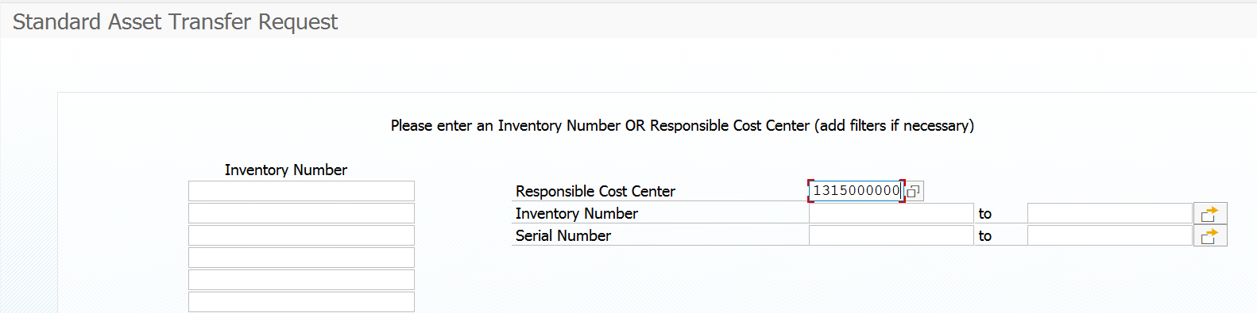
The user can also narrow down the selection by using inventory numbers or serial numbers. These filters work similar to report parameters in other SAP transactions. The user can narrow, use a wildcard or exclude items using the 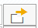.
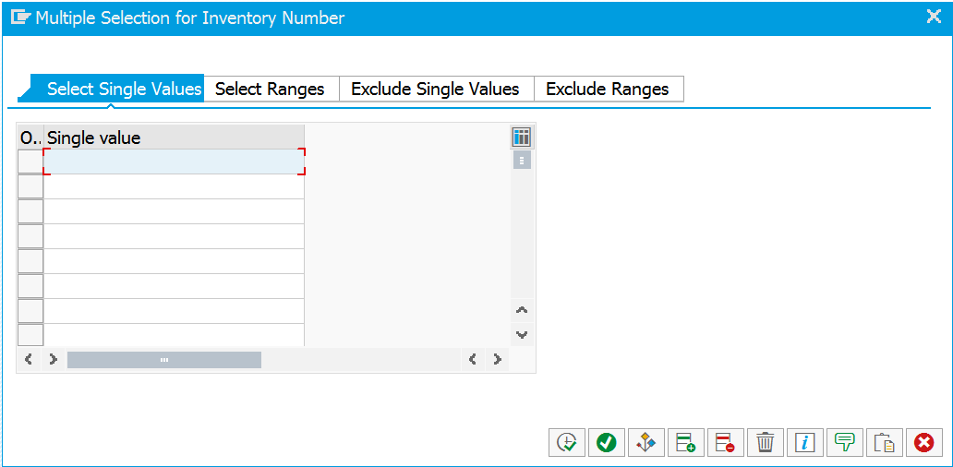
Click on CONTINUE to move to the next screen.

The next screen lists the assets assigned to the cost center entered on the previous screen.
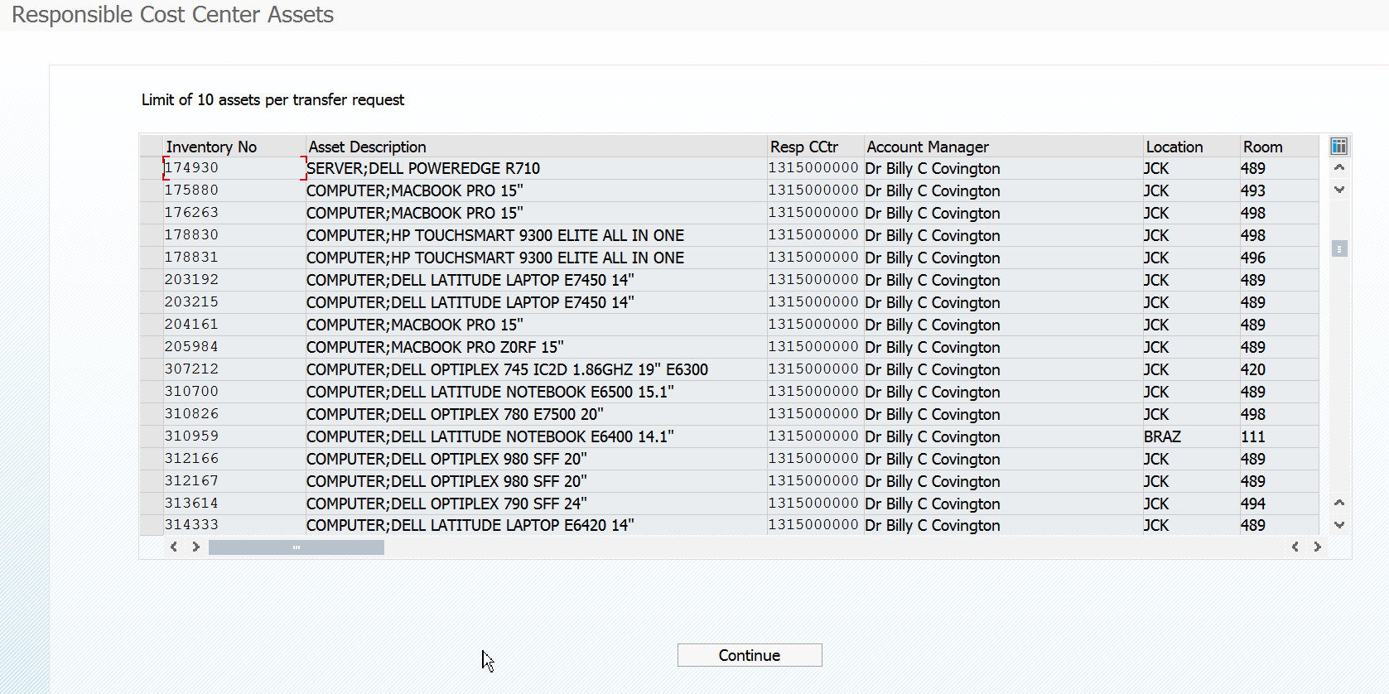
To select the assets, click on the raised box to the left of the inventory number. The line will highlight and it is selected. Keep in mind that the program will only allow for 10 assets at a time to be chosen. 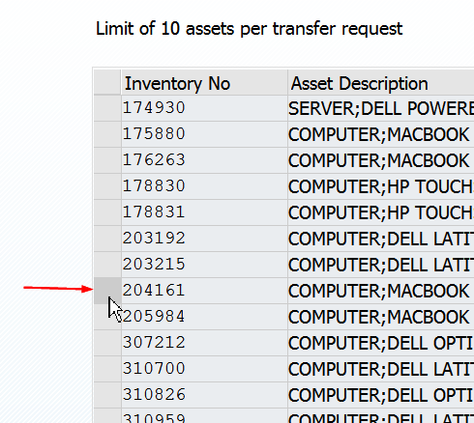
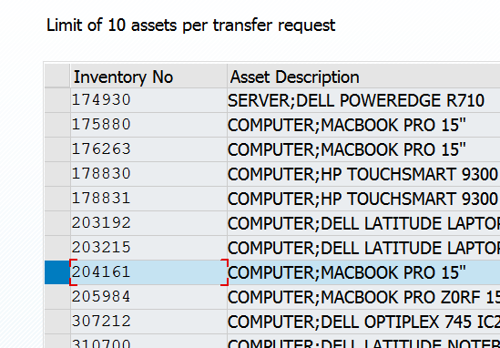
If an asset is already in workflow or it is retired, it will not show up on this list. If there is an asset that should be on this list, please contact Materials Management.
Click on CONTINUE to move to the next screen.
Make the necessary changes: 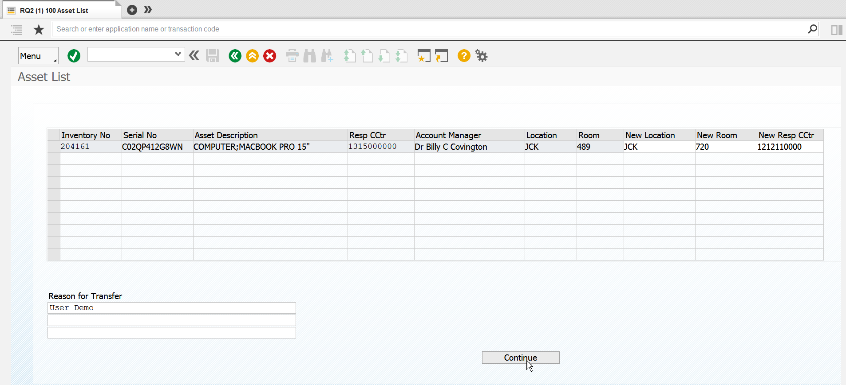
Click CONTINUE to move to the next screen.
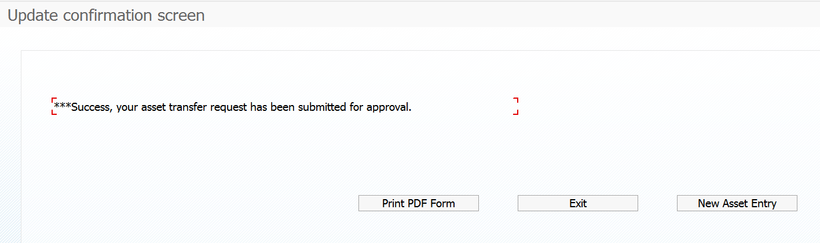

Surplus Equipment Request
Use this form to replace the form “Request Pickup of Surplus Equipment”.
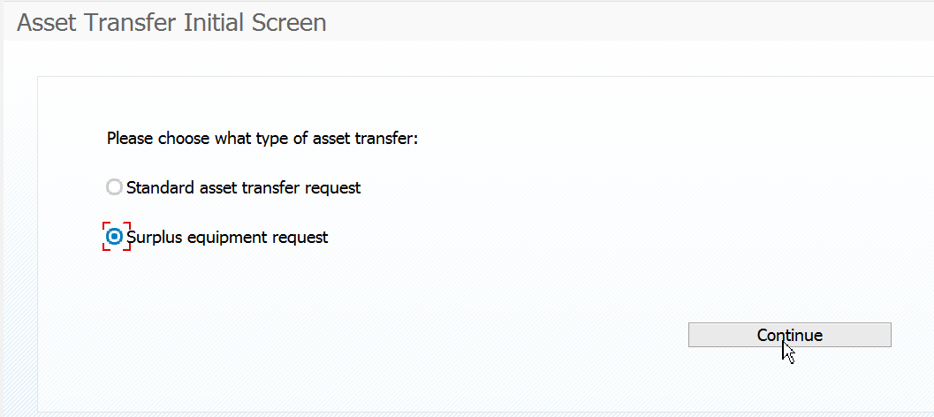
In this example, we want to send some items from responsible cost center 1212100000, which contains many assets. We want to narrow the list down to inventory numbers starting with 310* (you can use multiple wildcards using 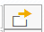)
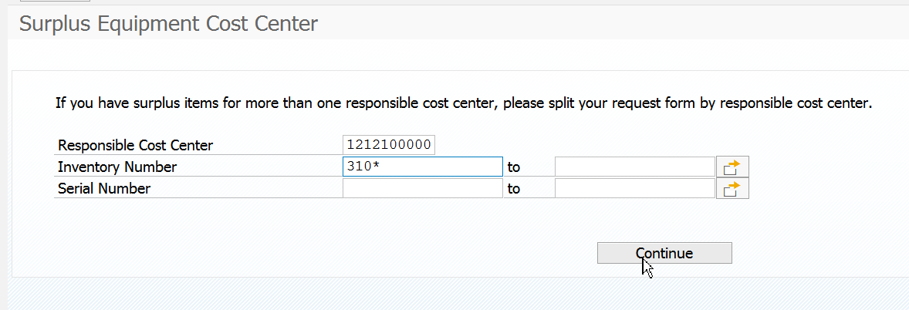
Choose the assets that need to be picked up from Materials Management by clicking on the box to the left of the inventory number:
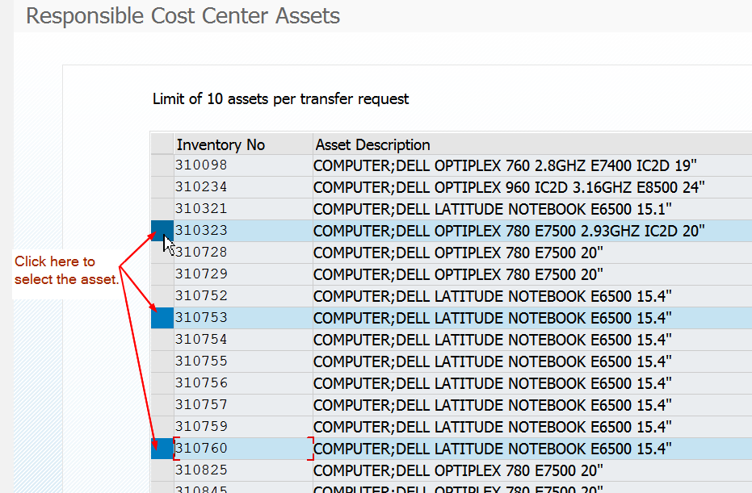
Click CONTINUE to move to the next screen.
The assets selected on the previous screen will appear with the University Distribution Center room 101 pre-entered and the new responsible cost center is 1410130099, which is what the final entry will be once the items have been picked up by Materials Management personnel.
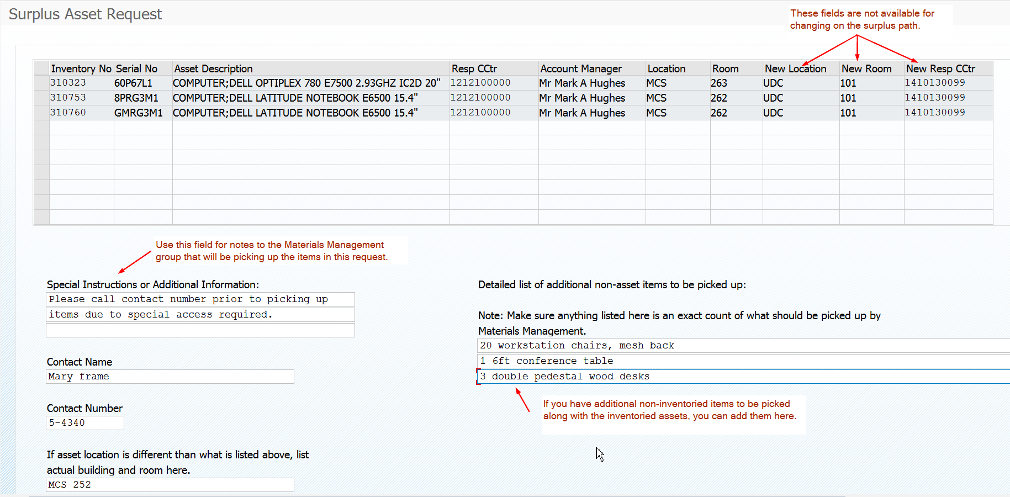
Click on CONTINUE to submit the request.
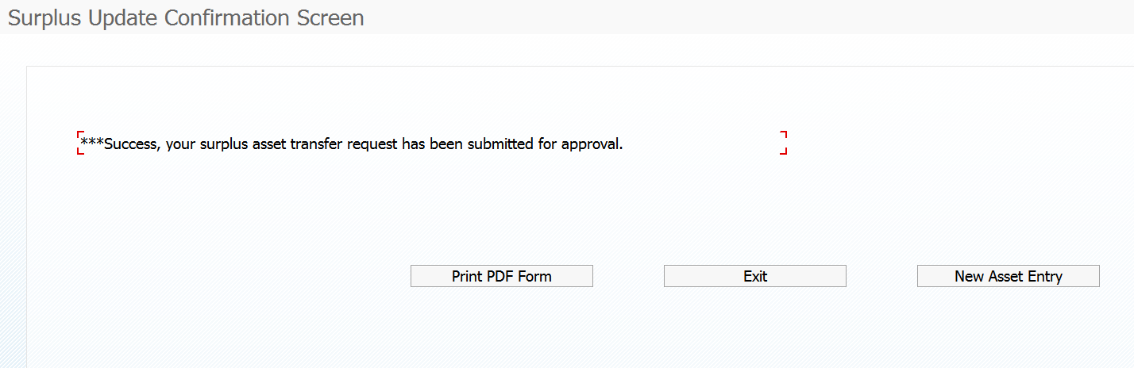

Print PDF Form
This form shows the request and the workflow path. This form can also be accessed from the monitor report, transaction ZASSETRPT2. These will remain viewable after the request has been posted.
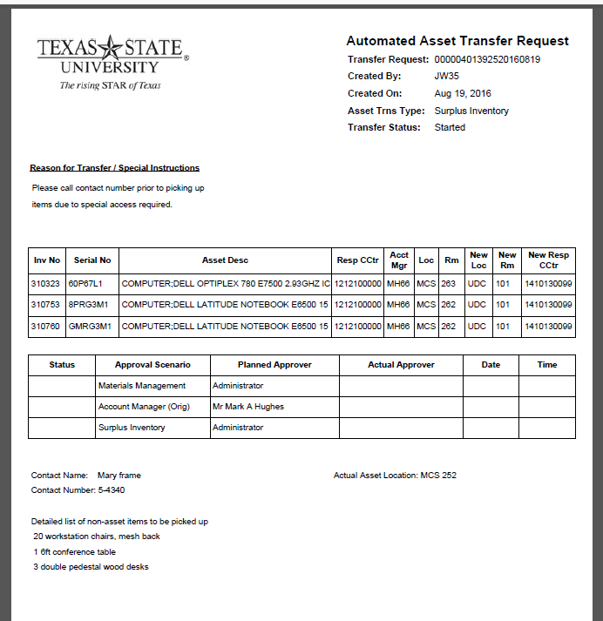
Workflow Configuration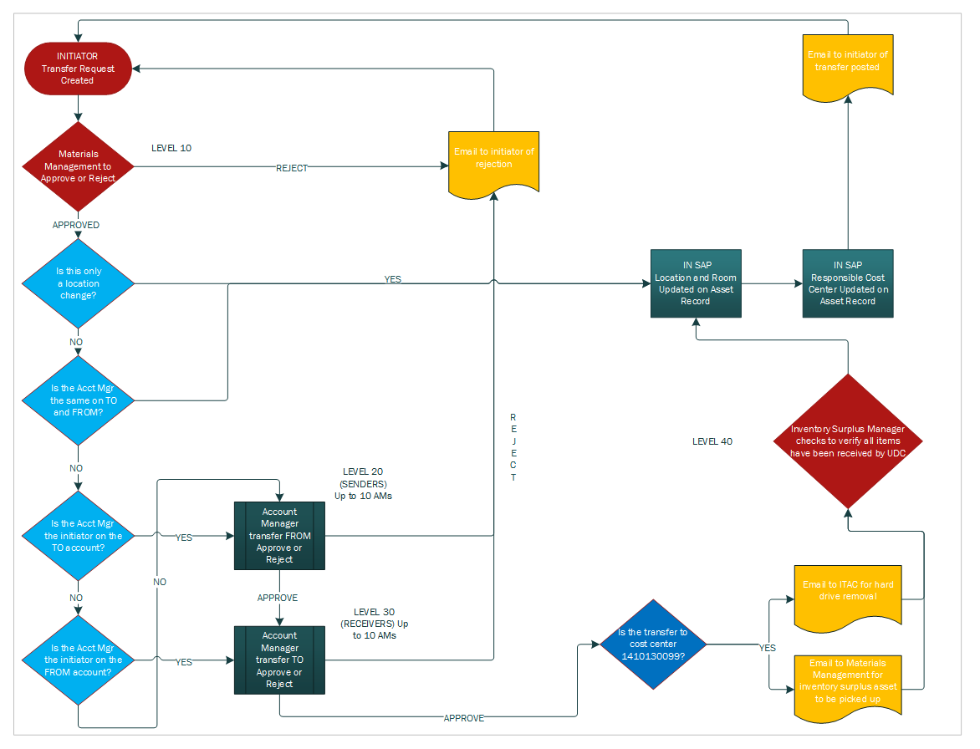

Monitor Report
Transaction code: ZASSETRPT2 (ZASSETRPT1 for Materials Management)
This transaction shows all asset transfers. The parameter screen allows the user to choose to view all or by status. If the user does not want to see the post transfers, choose to exclude the posted status.
The user can also run the report by date and/or inventory number. 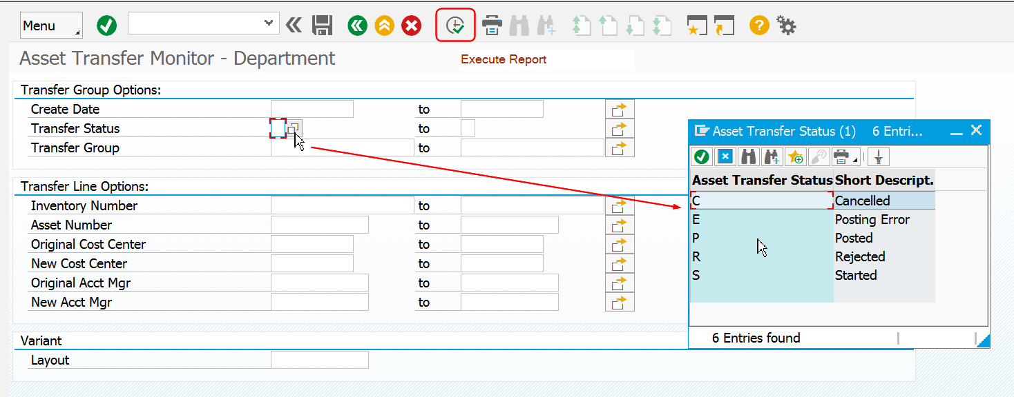
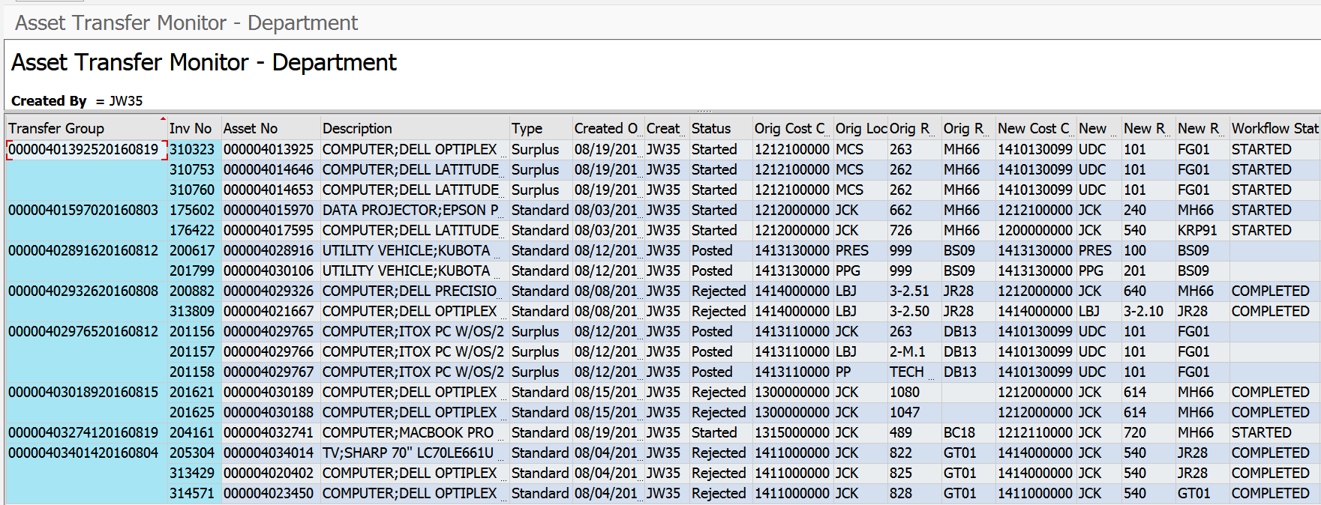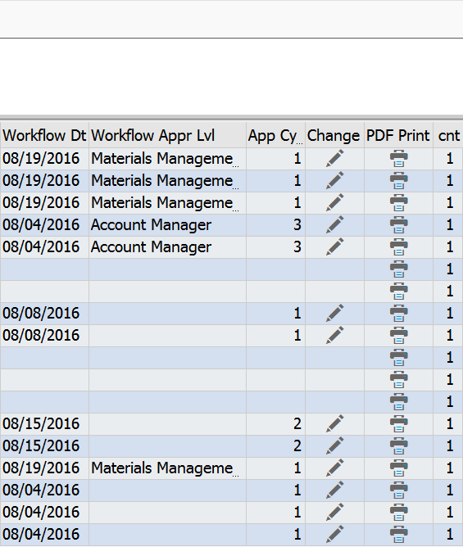

Transfer Group - this is similar to the document number. We had to create a table for this project and every table must have a way to group the items created together in order to keep the items together, we had to have a key. The key is made up of the first asset in the request and the date the request was submitted.
NOTE: If the user double-clicks on a line in this column, it will bring up AS03 for this asset. If you do not see the asset record when double-clicking, your security profile may need to have another role added.
Inventory Number - this is the tag number on the asset. It was used when creating the request. Double-click in this line item and AS03 appears.
Asset No. – This is the SAP assigned asset number, used when looking up assets in AS03. Double-click in this line item and AS03 appears.
Type – This will either be standard or surplus. This is the path used when the request was created.
Created On – This is when the request was created.
Created By – This is who created the request. The requests on ZASSETRPT2 will be by the user in this column.
Status – Shows what status the workflow is currently in for the request. If an item is rejected, the workflow has stopped, but will show completed on the report. In order to restart workflow, either use the toolbox or make a change to the document and save it.
Original Responsible Cost Center, Location and Room – this is where the asset current resides in SAP, AS03.
New Responsible Cost Center, Location and Room – this is where the request will post and change the AS03 record.
Workflow Status – Shows if the workflow has started, completed or stopped. Double-click into this column and the workflow log is shown: 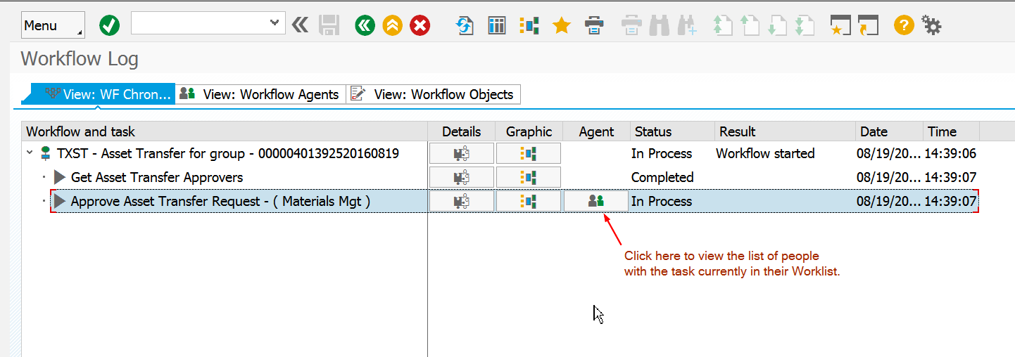
If the workflow show In Process, click on the Agents and see who has the task reserved. If someone has looked at the request and chose “Exit without Action” they have now reserved the task. You can tell who the task reserved by looking at the Agents and the one with the inbox symbol next to their name is the one who has reserved the task. They either need to approve it, reject or replace the item.
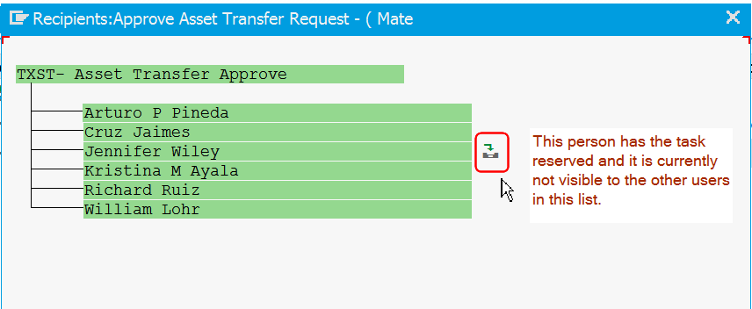

Workflow Date – this is the date that workflow moved into the level shown in the next column
Workflow Level – this is the current level that is awaiting approval. Drill into this line item to see the workflow log and show the users.
App Cycle – This shows how many times the asset was involved in a change request within this program process.
Tools (only on ZASSETRPT1) – Double-click on this and you will be able to start and/or stop workflow. Use this if there is ever a glitch.
Change – This is for users to make limited changes or delete the entire request.
NOTE: On surplus requests, the user is limited to text changes, not room, cost center or location changes. Once the workflow reaches the Surplus Group, the user is no longer able to make changes. The user must notify Materials Management of a change to the request.
PDF Print – this is the print form showing the request details and workflow planned/approval path. This will continue to remain viewable even after the request has posted.

Workflow Log Settings

If your log does not look like the screenshot above, follow these instructions to change the setting.
From the menu path, choose GOTO, then PERSONAL WORKFLOW SETTINGS.
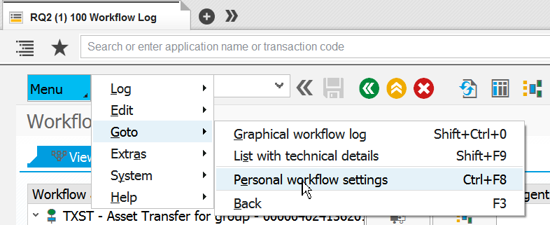
Make the WORK ITEM DISPLAY and WORKFLOW LOG set as USER VIEW

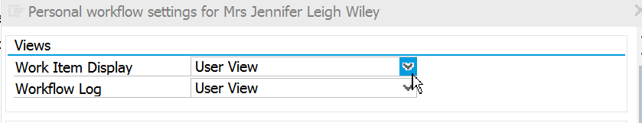

Workflow Approval Screens
Using the Portal, the items to approve will appear in the worklist. This is similar to approval for time, travel, requisitions, e-IDT and e-NPO. 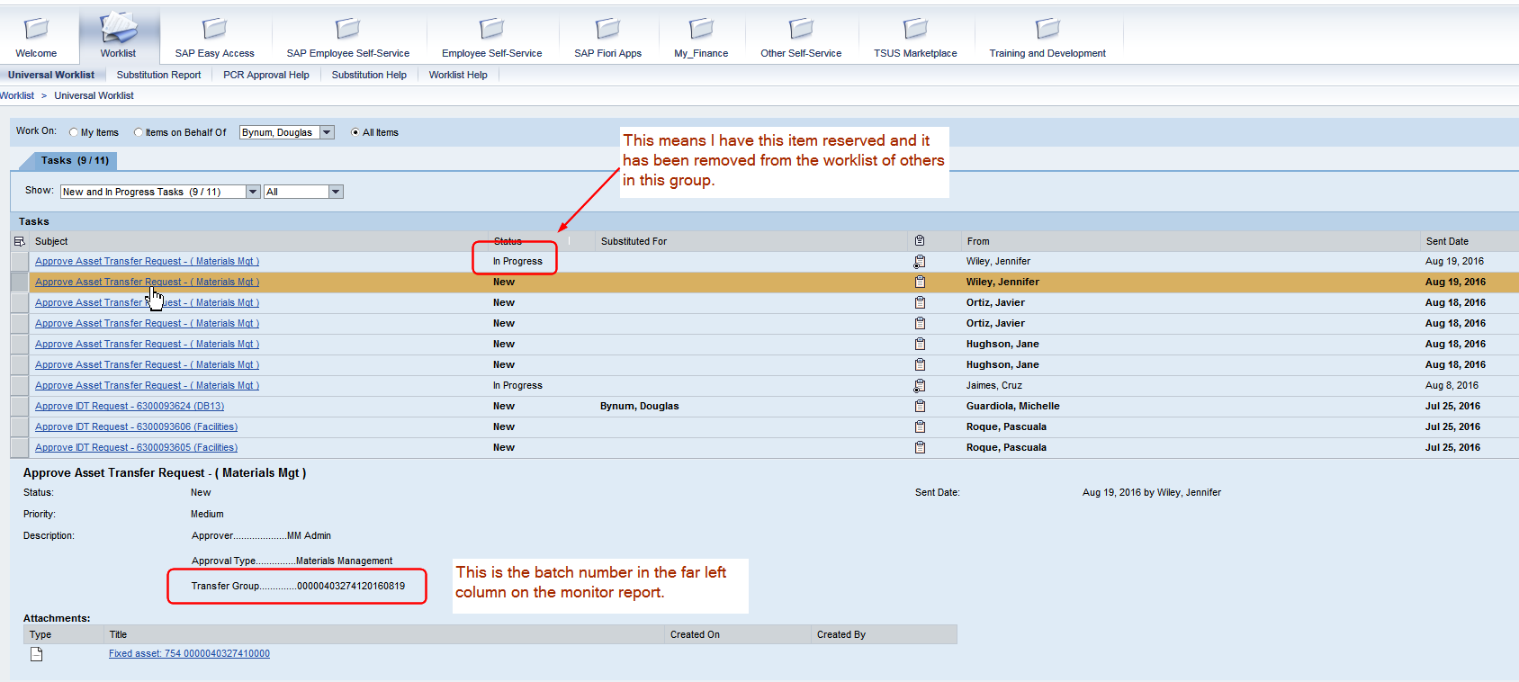
Click on the item to view it for approval, rejection or exit without action. If EXIT WITHOUT ACTION is chosen, this reserves the item and it will not appear in the other worklists of users in this group. If it is an account manager and the substitute views the item, the account manager will no longer see the item in their worklist. The item can be replaced using the worklist inbox from the GUI.
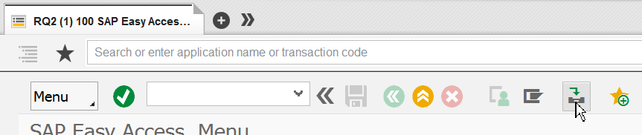
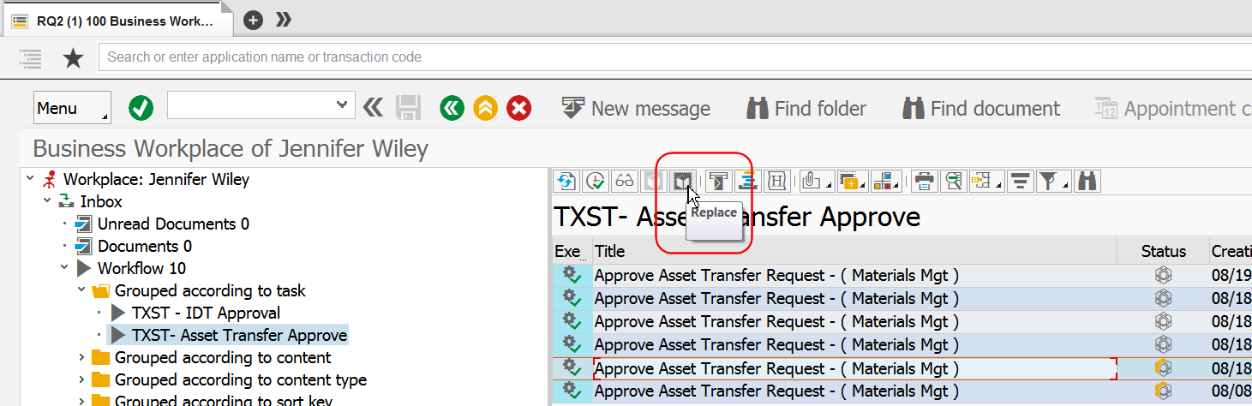
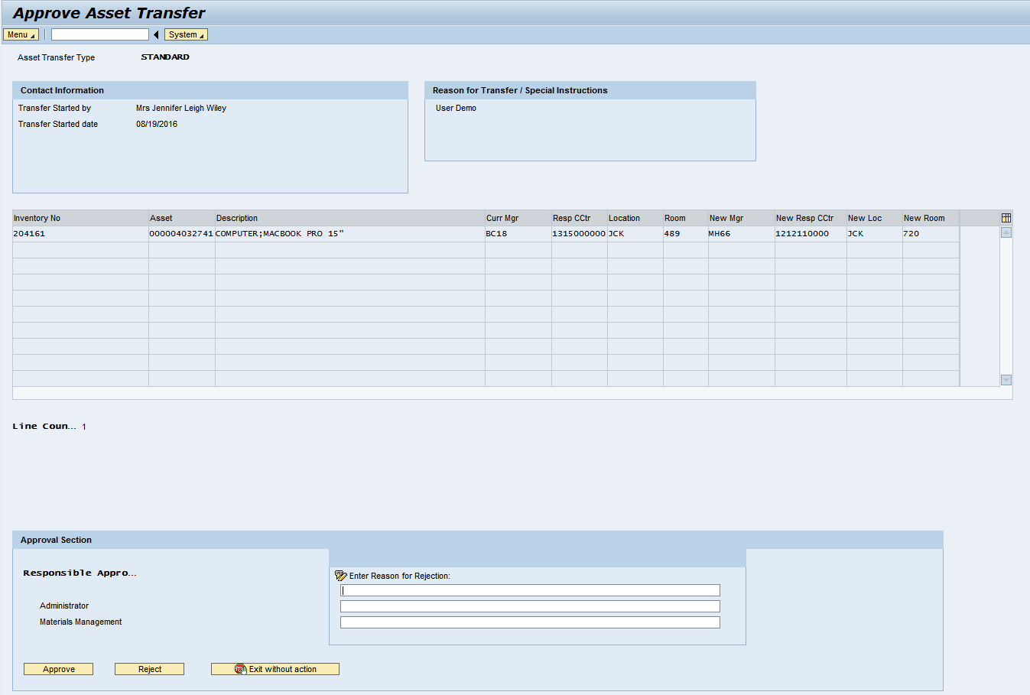
If REJECT is chosen, a reason must be given for the rejection. An email will be sent to the initiator containing the details of the request, who rejected it and the rejection reason.
Monitor Report prior to rejection:
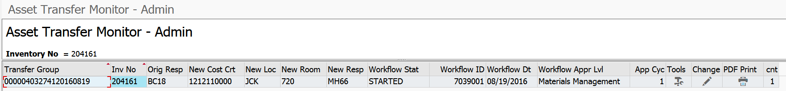
After Rejection:
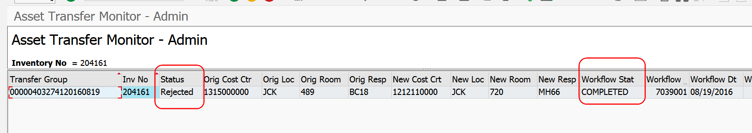
Print Form after rejection: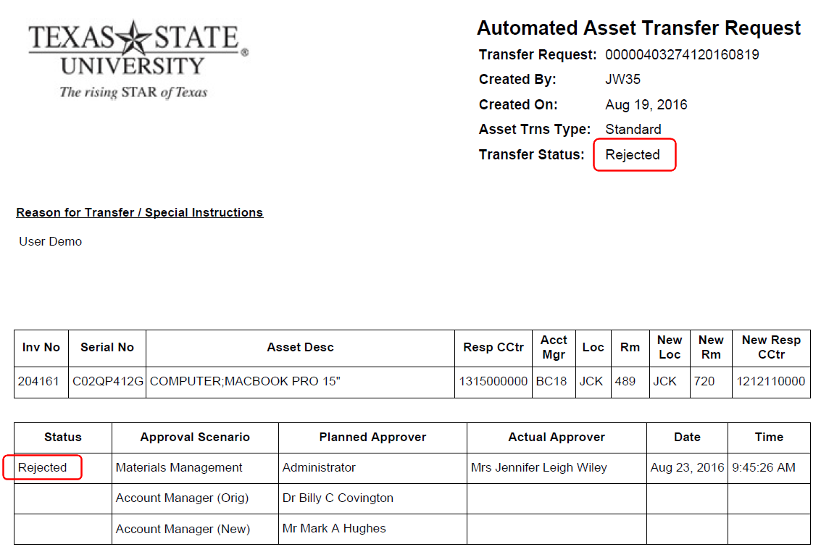

Administrator Workflow Level

This level is seen when master data on the cost center is blank. If this level appears on a worklist for someone who is an approver at that level, reject the document and enter in the rejection reason:
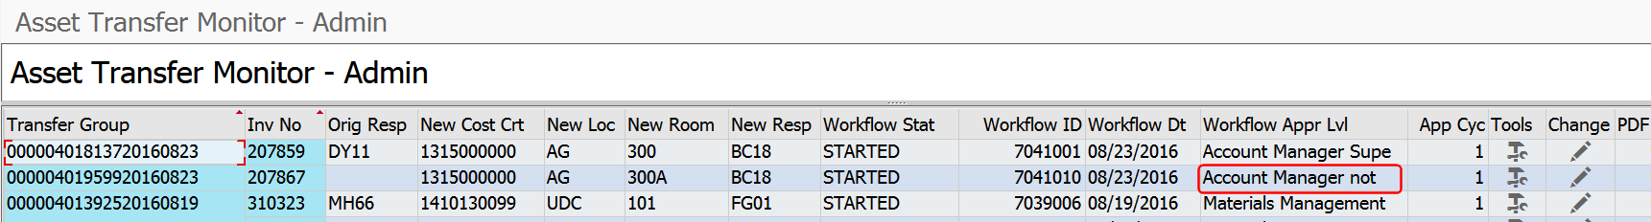
Master data for the cost center is incorrect.
Please contact Financial Reporting to update.
Once updated, select change and save document to restart.

Withdrawn Employees on Cost Center Master Data

If a cost center has not been updated after an employee has left the University, the workflow will determine that the employee is in withdrawn status and route the request to that position’s supervisor. 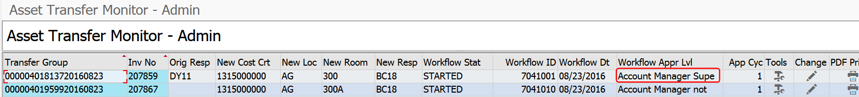
No action needed by Materials Management on this scenario.

Sample Emails

POSTED, sent to initiator
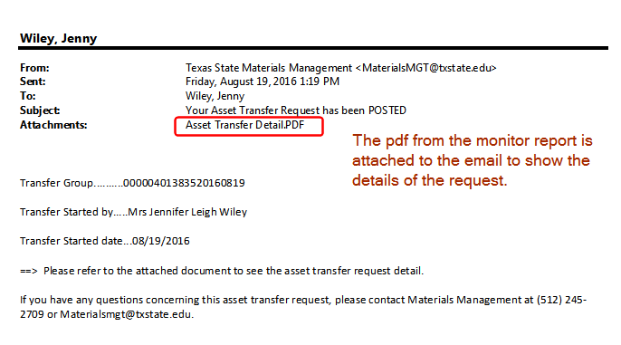

REJECT Email
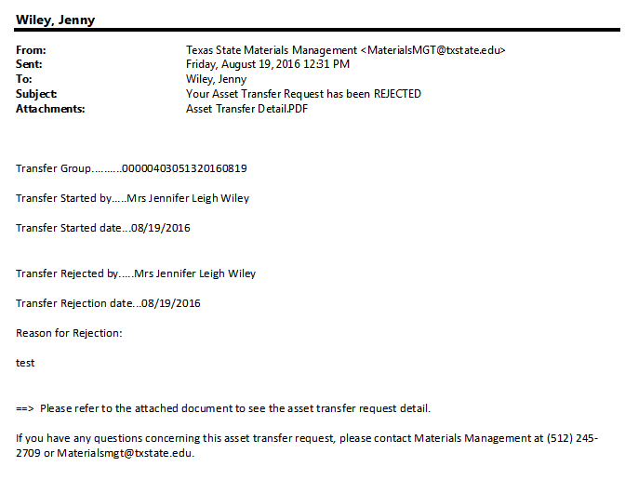
SURPLUS INVENTORY to Materials Management and ITAC 