Summer 1 2018 PSY 1300 Research Experience*: Participant Guidelines

This information applies to these sections of PSY 1300 and PSY 2101 for Summer 1 2018:
PSY 1300 MTWRF, 8:00-9:40 Sec 501 (CRN 50494) - Instructor: Dr. Amy Meeks
PSY 2101 MWF, 10:00-11:50 Sec 501 (CRN 51004) – Instructor: Angela Johnson
PSY 2102 MWF, 2:00-3:50 Sec 502 (CRN 51005) – Instructor: Marin Cordivin

*Note: Please direct any questions regarding the research experience requirement to the Research Experience Coordinator at Psy-Research@txstate.edu.

Psychologists conduct much of this research with human participants in psychology laboratories at universities such as Texas State University. To enhance your understanding of the nature of psychological research, it is important that you get some first-hand experience with research. For that reason, students are required to have direct experience with psychological research.

All research with human participants must be carried out in an ethical manner. For example, you cannot be required to participate in experiments against your wishes. Therefore, you have two options to fulfill the research experience requirement: one option involves participation in research studies whereas the other does not. Both options have been designed to take the same amount of effort. You are free to choose either option or a combination of both for a total credit balance of 4 credits.

If you fail to complete the research experience requirement (either Option 1 or 2 below, or a combination), then your final course grade will be reduced by approximately one-half of a letter grade (i.e., 5%).

The due date to complete your research requirement is:
Thursday, July 5, 2018 by 11:59pm

No late submissions will be accepted.

Option 1. Research Participation
If you are 18 years of age or older, you are eligible to participate in research studies (the age restriction is due to federal policy). Your participation in these studies will give you a chance to have direct contact with research. Participation in psychology research studies at Texas State University that require 30 minutes or less are worth 1 credit; studies that take between 30-60 minutes are worth 2 credits; studies that take between 60-90 minutes are worth 3 credits; studies that take between 90-120 minutes are worth 4 credits. Laboratory studies (those that you have to participate in-person at a predefined location) are worth an additional bonus credit above what the time commitment dictates. Online studies are credited just based on the time commitments listed above.

The number of credits will be noted in the study description that you see when you sign up. Only studies listed at http://txstate.sona-systems.com qualify for credit. In addition, paid studies cannot be used to satisfy the Research Requirement.

To sign up for a study, follow the steps below:
- Go to the website http://txstate.sona-systems.com on or after the start date: Friday, June 8, 2018 at 12 pm.

2. Log in with the following credentials:
- User ID: Your Texas State net ID email (ex: abc1234@txstate.edu)
- Password: 123456 (You may change your password after logging in)

After you log in, you can sign up for studies, view your accumulated credits, and edit your profile, including your password as shown in the screen shot below.
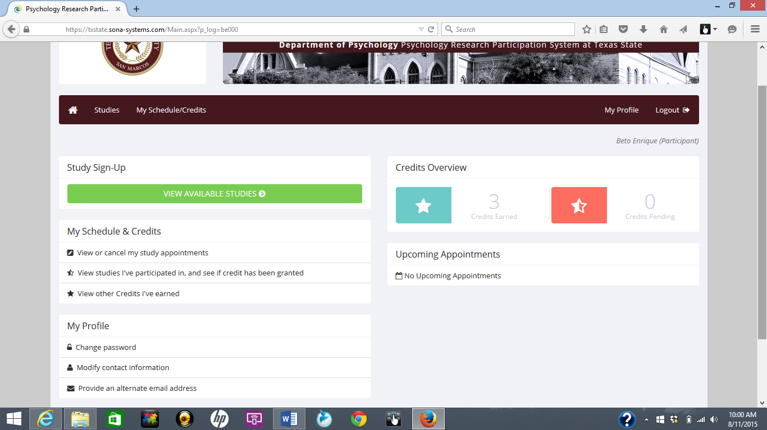
Your name here

Credit Distribution

Length of Study | (In-person studies: add 1 additional credit)
1-30 minutes | 1 credit
31-60 minutes | 2 credits
61-90 minutes | 3 credits
91+ minutes | 4 credits
Research Article Summary | 2 credits

Option 2. Research Article Summary
You may also demonstrate direct contact with research by submitting a written summary of a research article published during 2015-2016 in Psi Chi Journal of Undergraduate Research. Credit will not be given for summaries of articles published in any other year or any other journal. Each written summary is worth 2 credits. To earn credits in this way, follow the steps below:

- Visit the following web site: http://libproxy.txstate.edu/login?url=http://search.ebscohost.com/login.aspx?direct=true&db=a9h&jid=FKUB&site=ehost-live. (works best with Mozilla Firefox) Expand the 2015/2016 list on the right side of the page, and choose one the articles listed. The article(s) you summarize must be from 2015 or 2016. All articles can be accessed for free through the Texas State Library.

- Read the article and then type (in 12-point font, single spaced) a 1-page paper in which you answer the following 4 questions.

- (A) What question(s) did this research try to answer or what hypotheses did it test?
(B) What methods were used to answer the question(s) or test the hypotheses?
(C) What were the major findings of the research?
(D) What conclusions did the researchers draw based on the findings?

- Please respond in your own words and avoid direct quotes. If plagiarism is detected in your article summary, you will lose the opportunity to earn that credit through article submission. You might then (a) do a study to replace it or (b) lose the credit.

- Submit your summary via email to: Psy-Research@txstate.edu

Monitoring your Credits
Research Experience is worth 5% of your course grade. Research credits for both options can be tracked by logging into http://txstate.sona-systems.com/ as described above. In addition, your credits earned will be updated in a column in your TRACS Gradebook at the end of each week. Additional details, including frequently asked questions, can be found at: http://www.psych.txstate.edu/research/PSY1300/. Please direct any questions regarding the research experience requirement to the Research Experience Coordinator at Psy-Research@txstate.edu.

