Texas State University
Course Review Flow Chart
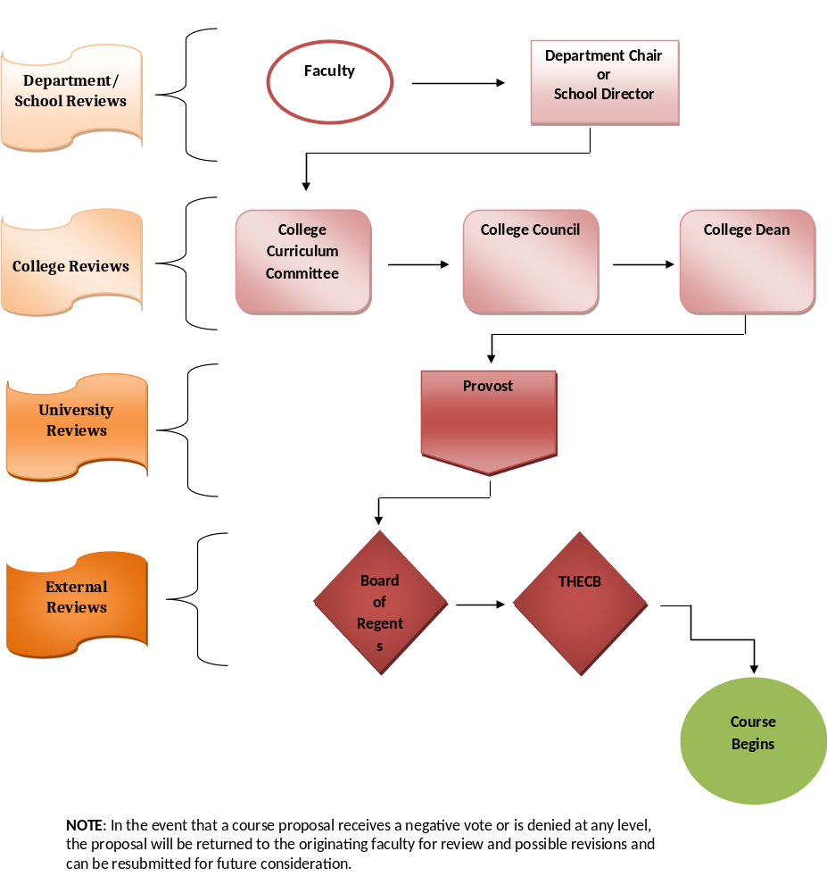For Course Changes Effective Fall

Month | Review Group | Action

December | Curriculum Coordinator | Distributes Fall course change instructions and due dates to College Deans
January | Faculty | Submit course change proposals to Department Chairs/Program Directors/School Directors
 | Department Chairs/Program Directors/School Directors | Review course change proposals and submit to College Deans
 | Deans' Staff | Prepare CCC Summary of course change proposals for CCC
February | College Curriculum Committees | Review course change proposals and CCC Summaries
February | College Councils | Review course change proposals and CCC Summaries
February | College Deans | Review course change proposals and CCC Summaries
February | Deans' Staff | Submit course change proposals and summaries to the Curriculum Coordinator
February | Curriculum Coordinator | Reviews course change proposals and summaries
February | Curriculum Coordinator | Combines all CCC summaries and submits to the Dean of the Graduate College, AVPAA, and Provost
February | Dean of The Graduate College | Reviews the CCC Summary and proposals
February | AVPAA and Provost | Reviews the CCC Summary
 | Undergraduate Academic Advisors | Advising for fall semester begins
March | Curriculum Coordinator | Submits course change board order to VPFSS
 | Curriculum Coordinator | Enters course changes into the SIS course catalog
 | Students | Registration for fall semester begins, with revised courses available
May | Board of Regents | Reviews course changes
May | Curriculum Coordinator | Notifies Deans of BOR approvals
May | Curriculum Coordinator | Submits course changes to the Office of Institutional Research
May | Institutional Research | Submits course changes in CBM003 to the Coordinating Board

June | Curriculum Coordinator | Review addition and deletion proposals with final CBM003

Texas State University
Course Review Flow Chart
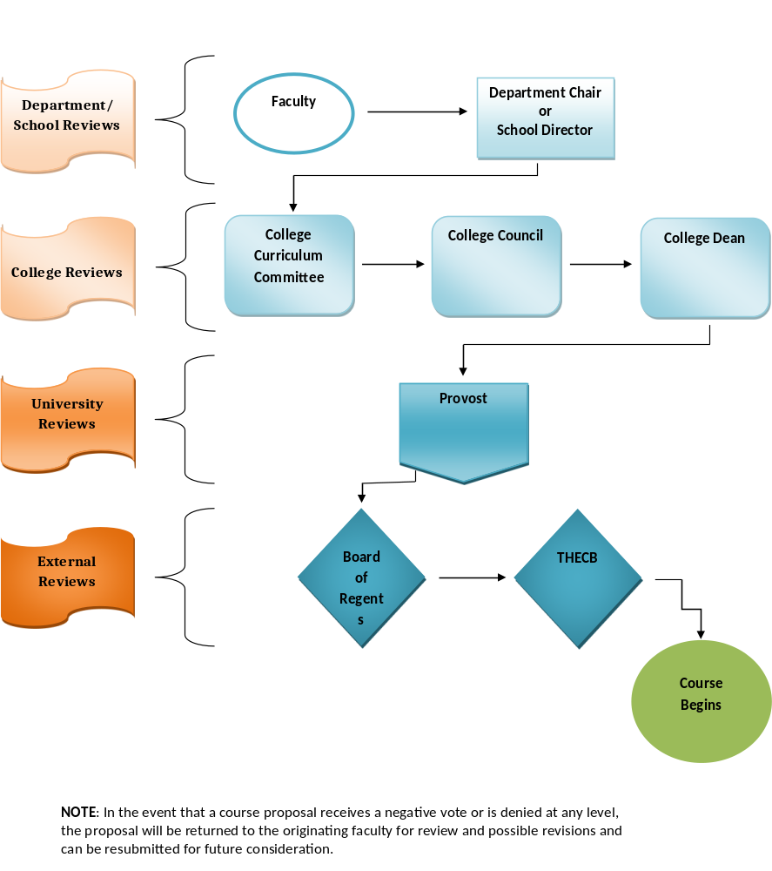For Course Changes Effective Spring

Month | Review Group | Action
May | Curriculum Coordinator | Distributes Spring course change instructions and due dates to College Deans
August | Curriculum Coordinator | Distribute a reminder of the Spring course change instructions and due dates to College Deans
September | Faculty | Submit course change proposals to Department Chairs/Program Directors/School Directors
September | Department Chairs/Program Directors/School Directors | Review course change proposals and submit to College Deans
September | Deans' Staff | Prepare CCC Summary of course change proposals for CCC
September | College Curriculum Committees | Review course change proposals and CCC Summaries
September | College Councils | Review course change proposals and CCC Summaries
September | College Deans | Review course change proposals and CCC Summaries
September | Deans' Staff | Submit course change proposals and summaries to the Curriculum Coordinator
September | Curriculum Coordinator | Reviews course change proposals and summaries
September | Curriculum Coordinator | Combines all CCC Summaries and submits to the Dean of the Graduate College, the AVPAA, and Provost
September | Dean of The Graduate College | Reviews the CCC Summary and proposals
September | AVPAA and Provost | Reviews the CCC Summary
September | Undergraduate Academic Advisors | Advising for spring semester begins
October | Curriculum Coordinator | Submits course change board order to VPFSS
 | Curriculum Coordinator | Enters course changes into the SIS course catalog
 | Students | Registration for spring semester begins, with revised courses available
November | Board of Regents | Reviews course changes
November | Curriculum Coordinator | Notifies Deans of BOR approvals
November | Curriculum Coordinator | Submits course changes to the Office of Institutional Research
November | Institutional Research | Submits course changes in CBM003 to the Coordinating Board

