Modular Polymer Processing System
Model: HAAKE PolyLab OS RheoDrive4 Extruder
Location of Machine: Composites Lab, RFM 1218
Location of SOP and Machine Operating & Safety Manual: Composites Lab website under resources; Composites Lab TRACS site; and Hardcopy near machine.
Emergency Contact:
- Call 911
- Call EHS & Risk Management at 512-245-3616
- Call Head Lab Technician, Dr. Ray Cook (office 512-245-2050)
- Call Dr. Jitendra S Tate (office 512-245-4872)

Before using this machine:
- You must have permission from Dr. Tate.
- You must have received formal training from technician or, trained research student (designated by Dr. Tate) related to machine safety and operation.
- You must read and understand SOP and Machine Operating & Safety Manual.
- You must use this machine under direct supervision of Dr. Tate or, Dr. Cook or, trained research student (designated by Dr. Tate).
- You must have signed “Lab Rules” document with Dr. Tate. This document must be signed every semester fall, spring, and summer (as applicable).
- If you do NOT follow above instructions you will be held responsible for your own safety and damages.
Safety Precautions:
Protective Equipment: Prior to performing this procedure, the following personal protective equipment must be obtained and ready for use: Gloves, Safety Goggles, Lab Coat.
Important Safeguards:
- Before you start the screw in the software please make sure that the temperature of three zones rise till where it melts the plastic, otherwise you break the screw. Always before logging out please write in the log book the plastic used and the temperature needed to melt the plastic.
- Make sure to leave material in extruder after purging the machine. When starting machine, add dyed material into extruder and wait for it to start exiting. Once the dyed material begins to exit, add your desired material. When the color changes from the dyed material to clear (or desired test material color) then you know the material being extruded is your desired material. Do this again at the end of your experiment, add die and wait for the color of the extruded material to change to the dyed material. Then load LDPE into the machine and wait for the extrueded material to turn back clear. Once it starts to exit clear again stop the machine. We want to leave this low Tmelt material in the machine for next use to ensure that the screw does not break.
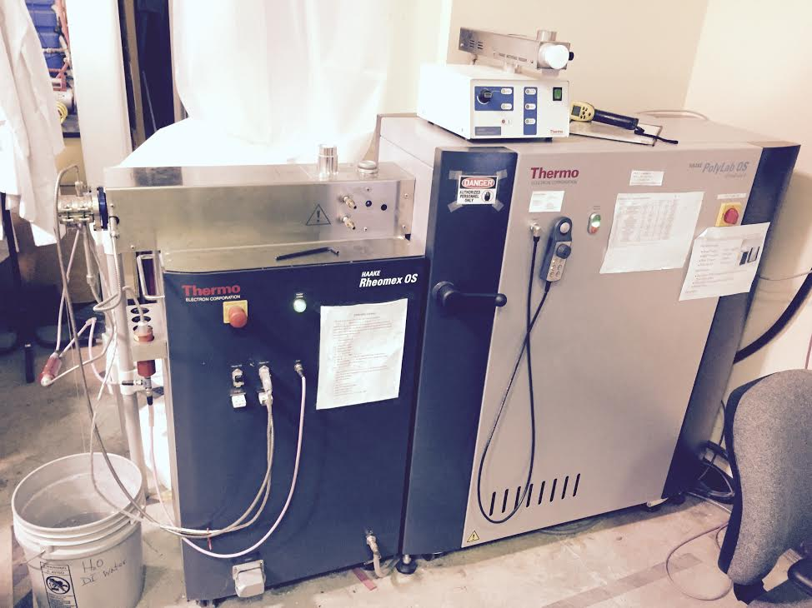
Stackable HAAKE Metering Feeders
& Traditional Feeder

RheoDrive 4 kW System
PolyLab OS- Remote Control

Screw with 3 Temp Control Zones

Pressure Sensor

Extruder system
**Cool Water Bath**
General information
Screw plastification is the most common method of processing plastics, rubber, food stuffs and ceramic materials. Rheomex controls data administration and communication with master unit. Mobile measuring sensors avoid necessity of handling heavy and hot parts. Integrated heating, cooling circuits reduce number of plug connections thus reduces danger of making incorrect connections. Several peripheral units such as feeding and post-extrusion units are computer controllable thus meaning better reproducibility, documentation. Simplifies handling in laboratory and enables secure operation. Extruder tool enables analysis of rheological and processing characteristics of many materials.
Specifications:
- Single screw Extruder
  - Make :Thermo Electron Corporation
  - Model : Haake polylab OS Rheodrive 4: Haake Rheomix OS
  - Screw Diameter : 19.05 mm (3/4")
  - L/D ratio : 25
  - Speed Range : 250 1/min
  - Max. Torque : 160 N.m
  - No. of Heating zones : 3
  - Pressure : 700 bar
  - Max. Temp. : 450 degree centigrade (842 °F)
  - No. of Die's : 2 and their diameters are 1 mm and 3 mm
  - Rheological tests for Standard Thermoplastic Materials

Turning and preparing the Extruder for instrumented operation
Behind Instron:
- Turn ON Compressed air
On the extruder:  - Locate the Red circular switch and turn it on.(Polylab OS)  - Locate and press the Green/Red button to enable motor.  - Locate and press the green button to enable heater. | 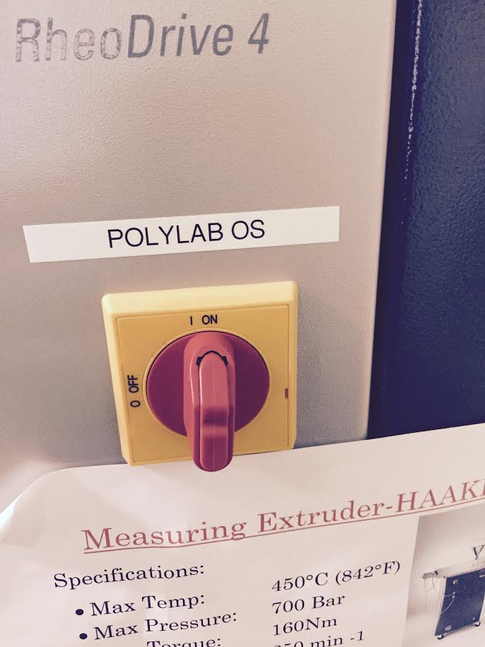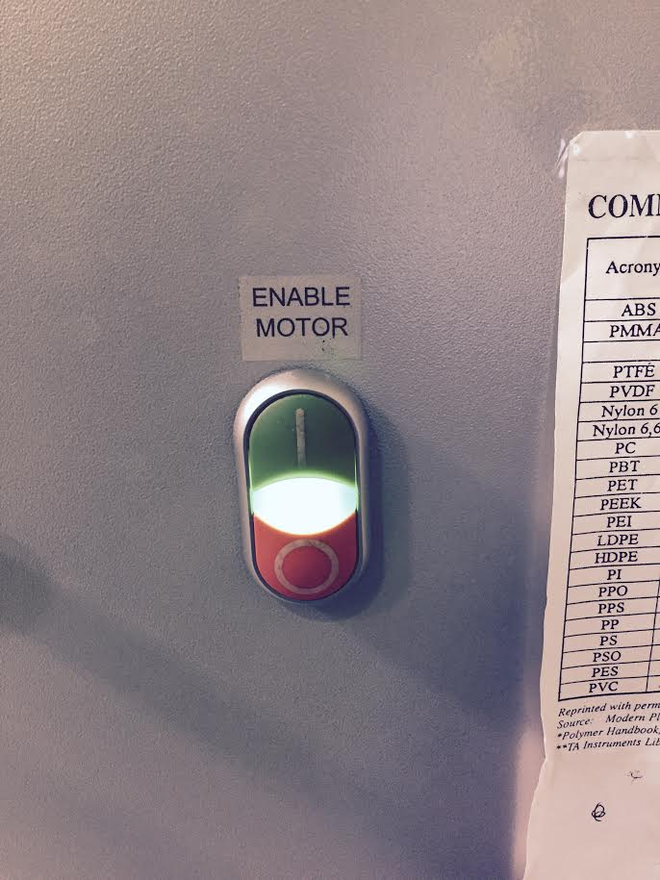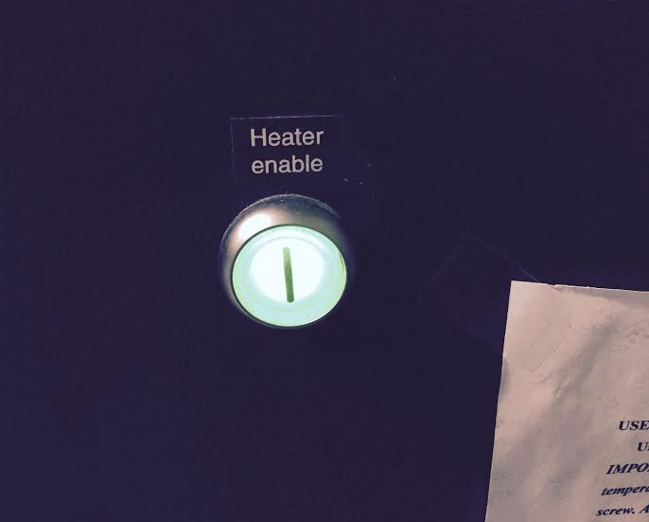
- If needed to control feed:  - Turn ON metering feeder. | 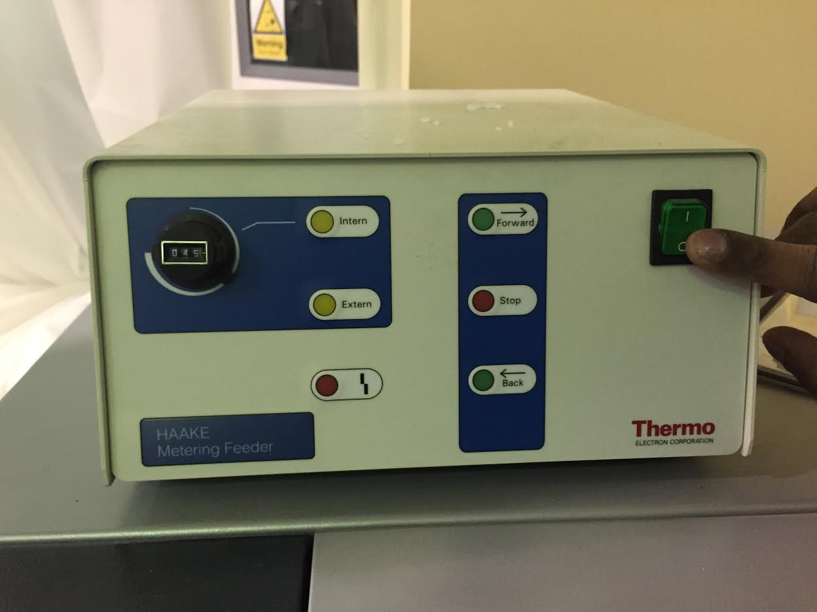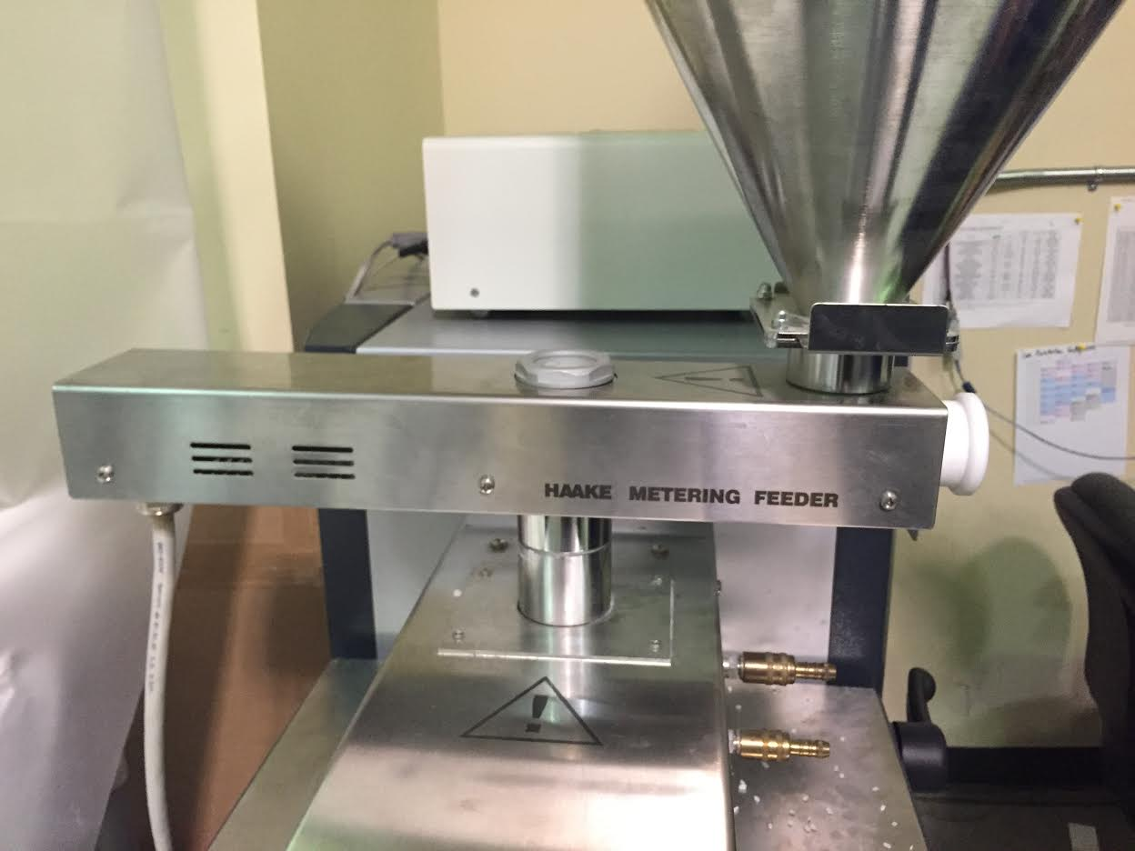
- Otherwise hopper is directly attached. | 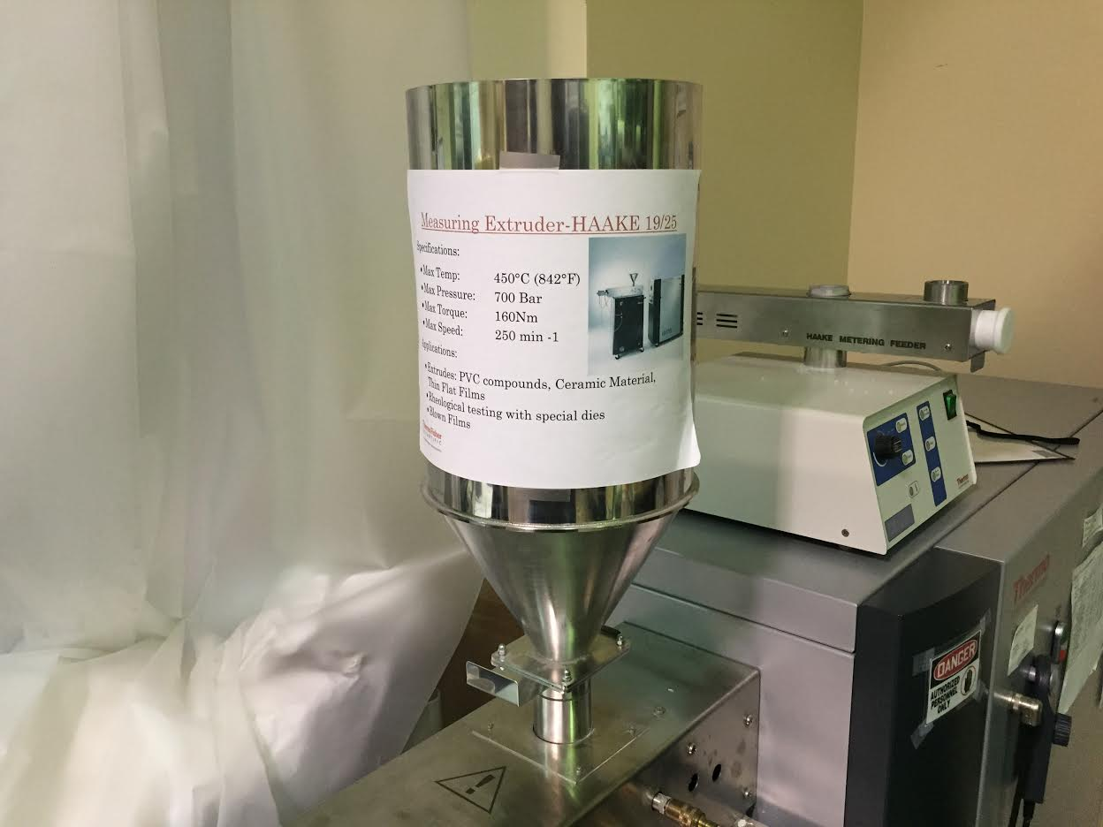
On the computer:  - Locate “Polysoft Monitor” icon on desktop and double click on it. | 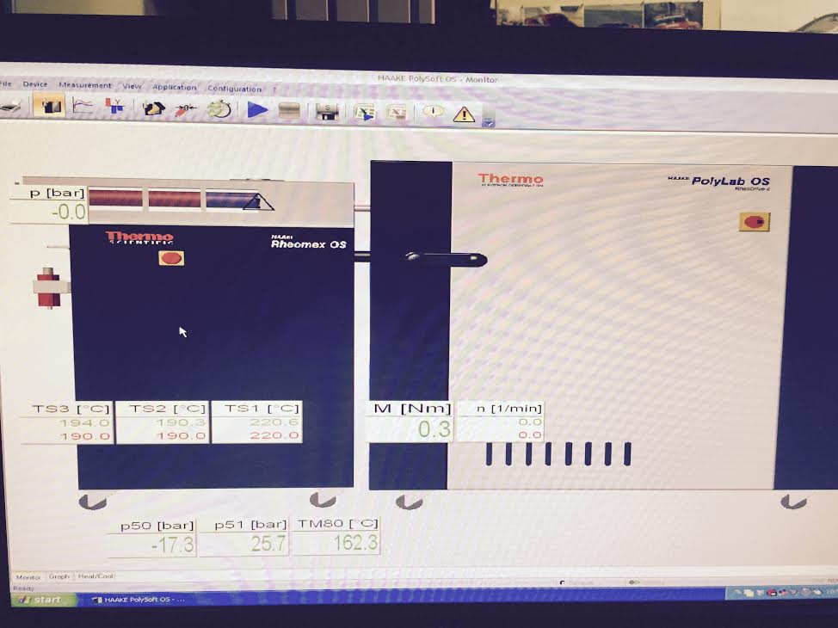
- Your screen should look like the following:
- Rise Temperature of three zones BEFORE turning the screw.
- According to material requirements (melt)
- Green – Actual Temp
- Red – Desired Temp
- Ensure manual control is on  Adjust the speed of the screw using the controller.  - Clockwise = + positive  - C-Clockwise = - reduce | 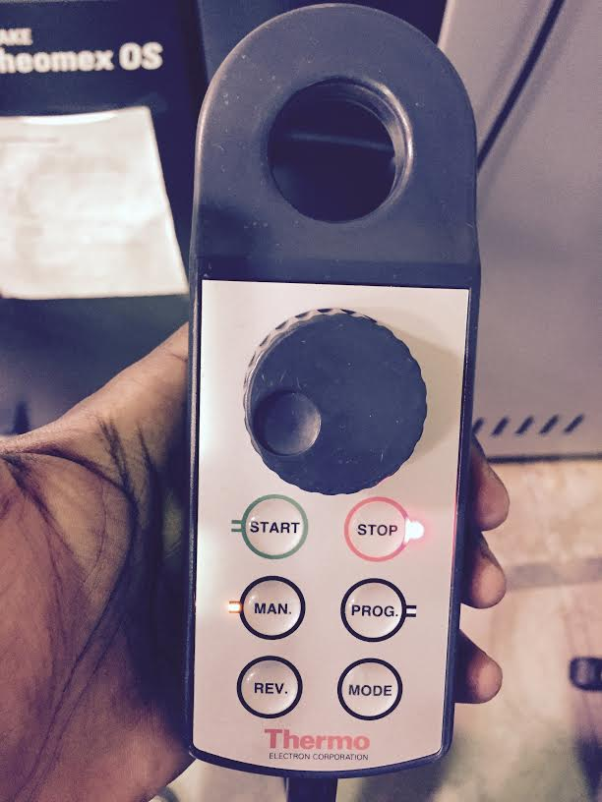  Manual Control  Lights  Green = Turning  Red = Stopped
- Always watch the pressure developed on the screw.  - Stop screw if alarm turns ON. | 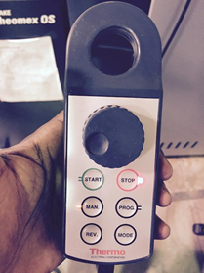
Turning off the machine:  - Leaving material in extruder  - Be sure to leave material in extruder. ESPECIALLY materials such as Nylon due to its high glass transition temperature. | You can check to see if there is still material in after purging the machine. That is, putting colored material in the extruder after you’ve used all your experimental material and waiting for the colored material to begin to exit the machine. Then put LDPE in the extruder until its starts to exit. After clear(LDPE) begans to come out again stop rotation. Leave this low Tmelt material inside until next use.
- Turing Sofware Off:  - Lower the three temperatures so the material can solidify(Far below Tmelt) | 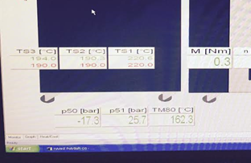
- Quit the software | 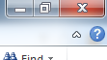
Turning Instrument Off:  - *If feed controller used:  - Put the feeder power switch to OFF position | 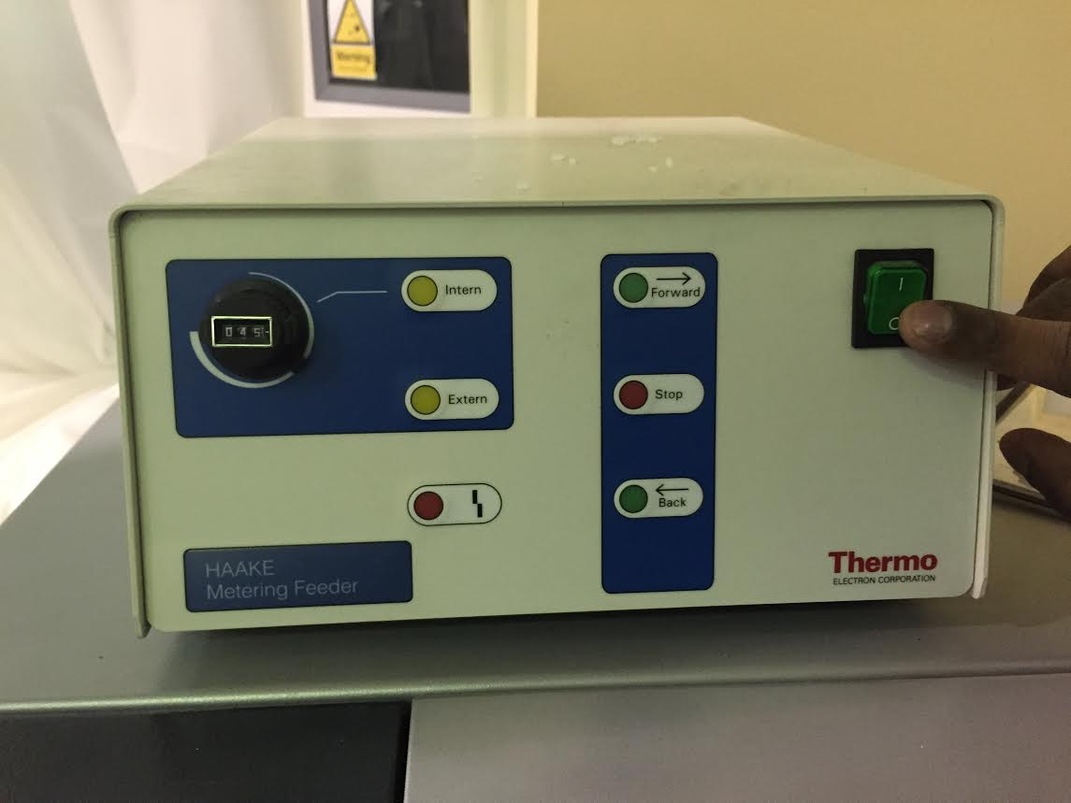
- Turn off Machine switches
- Turn Heater Enable OFF
- Turn Enable motor OFF
- Turn PolyLab OS OFF

