How to Approach A Literature Review
This handout describes the basic steps, which are based on a textbook by Creswell and Creswell (2018):
- Identify your topic/refine your research question
- Conduct the literature review
- Prepare a written report.
In addition, there are resources to facilitate completion of literature reviews.
PHASE 1. Identify your topic/Refine your research question
Questions and tips from Ch. 2 (Creswell & Creswell, 2018).
- Ask questions.
  - Is it practical and useful?
  - Does it contribute to the existing literature by filling gaps in information, extending research, or recreating a study with new variations?
- Draft a simple title before beginning research to maintain focus and direction. It may help to form the title as a question or simple description.
  - Ex. “My study is about dog owners and their life expectancy” or “How does transcranial magnetic stimulation compare to SSRIs for the treatment of depression?”
- Apply the PICO [Population, Intervention (or Exposure), Comparison, Outcome] approach to refine your topic and research question, as well as identify key words for advanced database searches.
  - Evidence Based Medicine: PICO Model https://researchguides.uic.edu/c.php?g=252338&p=3954402
  - PubMed/MEDLINE: Search a PICO Question https://www.youtube.com/watch?v=_pVxRw-y8-M
  - More on PICO approach in the PRISMA statement:
www.prisma-statement.org

Example of PICO table
Research Question: Is transcranial magnetic stimulation a comparable treatment for depression as SSRIs (Selective serotonin reuptake inhibitors)?
Parameter | Inclusion Criteria | Exclusion Criteria
Population  (P) | Adults (aged 18-60 years) with depressive disorder | Elderly adults, individuals who use drugs, individuals with co-existing mental illness
Intervention  (I) | Transcranial magnet stimulation | Transcranial magnet stimulation in conjunction with anti-depressant medication, other novel depression treatments (e.g. ketamine).
Control  (C) | SSRIs | none
Outcome  (O) | Reduction of symptoms associated with depression | none
Study Design | Experimental studies | Observational studies

You may also want to create a table to layout key words, related concepts and MeSH terms (e.g., MeSH terms for PubMed/MEDLINE).
Example of Concept Map table
Research question: What effect does a 6-week behavioral nutrition intervention have on dietary intake of fruits and vegetables for Mexican American families?
Concept | Keyword | MeSH
Behavioral nutrition intervention | Behavioral intervention or behavioral program or  health promotion intervention or  health promotion program | “Behavioral Medicine”[mesh] OR “Health Promotion”[mesh] OR “Health Behavior”[mesh] OR “Health Education”[mesh]
Mexican Americans | Mexican American or Mexican or Mexicano or Mexican heritage or Mexican origin | “Hispanic Americans”[mesh] OR “Mexican Americans” [mesh]
Fruit and vegetable intake | Dietary intake of fruits and vegetables or  fruits and vegetables intake or  fruit and vegetable consumption | “Fruit”[mesh] OR “Vegetables”[mesh] AND “Diet”[mesh] OR “Eating”[mesh] OR “Feeding Behavior”[mesh]

PHASE 2. Conduct the Literature Review
Questions and tips from Ch. 2 (Creswell & Creswell, 2018).
- Identify key words.
  - How Library Stuff Works: How to Choose Keywords https://www.youtube.com/watch?v=BoujP8KoK7E

- Search databases using your key words. Commonly used databases in nutrition include PubMed/MEDLINE, CINAHL, and ISI Web of Science.
  - Library Databases
(https://catalog.library.txstate.edu/search/y)
  - PubMed: Search a PICO Question
PICO, MeSH Terms, and PubMed Searches
  - How Library Stuff Works: Boolean Operators (AND OR NOT) https://www.youtube.com/watch?v=bCAULDuMcso
  - 5 Tips for Searching PubMed
https://www.youtube.com/watch?v=6wWeeCBBlk4

- Attempt to locate articles or books related to your topic. Per Creswell and Creswell (2018), the goal is to identify about 50 references on your topic. But for class assignments, you may want to identify about 15-25 references (mostly journal articles and original research articles) depending on your assignment.
  - If the full text version (PDF) is not available online for free, utilize the ILL (InterLibrary Library service) https://www.library.txstate.edu/about/departments/ill.html or the GrADS (Graduate Article Delivery Service) /https://www.library.txstate.edu/about/departments/ill/grads.html to request the PDF.

- Skim through the initial set of references to determine relevance to your topic.
  - Start removing articles with titles obviously not related to your topic
  - Then read through remaining abstracts to determine relevancy.

- Design a literature map to group articles and illustrate how your research will add to the existing literature.
  - Place topic in box at the top of the hierarchy.
  - Organize studies into broad subtopics, linking to your topic
  - Within each box, label the nature or outcome of the studies, as well as a brief reference.
  - Reference maps can go further from subtopics to sub-subtopics
  - Example of literature map (Creswell & Creswell, 2018)
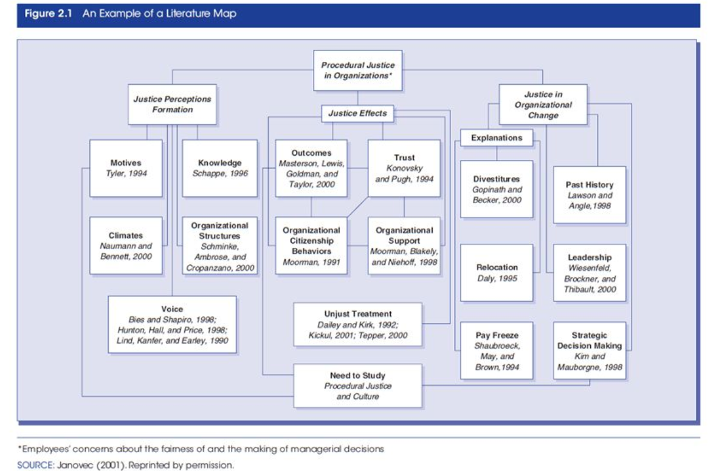
- Draft article summaries. Article summaries may provide an overview, discuss the article critically or evaluate the article, or describe the purpose of the article in this literature review. Creswell & Creswell (2018) suggest that article summaries include:
  - Issue or problem being addressed
  - Central purpose or focus of study
  - Sample, population, or subjects
  - Key results that relate to your study

For advice on preparing article summaries or annotated bibliographies, please visit the Purdue OWL (Online Writing Lab). https://owl.purdue.edu/owl/general_writing/common_writing_assignments/annotated_bibliographies/annotated_bibliography_samples.html

- Consider preparing a literature matrix. For one approach to organizing the study characteristics, methods, results, and discussion points of research studies, please see Garrard’s textbook on the matrix method for literature reviews in health sciences (2017). The TXST Library has an e-book version available here: https://catalog.library.txstate.edu/record=b4377381~S1a. Use an e-reader app called Browzine for this e-book. Learn more about Browzine here: http://guides.library.txstate.edu/c.php?g=184817&p=1218802

Examples of literature matrices can be found in published systematic literature reviews, such as Johnson et al. (2018) available here: https://www.ncbi.nlm.nih.gov/pmc/articles/PMC6240001/
PHASE 3. Write up the literature review.
- Chapter 4 provides tips on the writing process (Creswell & Creswell, 2018).
- Review additional books for writing advice (Elbow, 1998; Galvan, 1999).
References
Creswell, J. W., & Creswell, J. D. (2018) Research design: Qualitative, quantitative, and mixed methods approaches. Thousand Oaks, CA: Sage Publications.
Elbow, Peter. (1998). Writing with power: Techniques for mastering the writing process. New York: Oxford University Press.
Galvan, Jose. (2017) Writing literature reviews: A guide for students of the social and behavioral sciences (7th ed). New York: Routledge
Garrard, J. (2017). Health sciences literature review made easy: The matrix method. Sudbury, Mass: Jones and Bartlett Publishers.
Johnson, C. M., Sharkey, J. S., Lackey, M. J., Adair, L. S., Aiello, A. E., Bowen, S. K., Fang, W., Flax, V. L, & Ammerman, A. S. (2018) Relationship of food insecurity to women’s dietary outcomes: A systematic review. Nutrition Reviews, 76(12), 910-928.
Purdue Online Writing Lab. (n.d.). Annotated Bibliography Samples. Retrieved from https://owl.purdue.edu/owl/general_writing/common_writing_assignments/annotated_bibliographies/annotated_bibliography_samples.html
NLM (National Library of Medicine) Resources
- Medline Plus https://medlineplus.gov/
  - Use to learn about unfamiliar medical and health terms
- PubMed/MEDLINE
https://www-ncbi-nlm-nih-gov.libproxy.txstate.edu/pubmed?db=PubMed&otool=txsusmalib

TXST (Texas State University) Resources and Software
- Graduate Student Services at Alkek Library https://www.library.txstate.edu/services/graduate.html

- LibGuides by Alkek Library https://guides.library.txstate.edu/?b=o

Search for topics to obtain resources like:
  - Writing & Citation Style Guides: Home http://guides.library.txstate.edu/friendly.php?s=writing-citation-style-guide
    - Learn about American Medical Association (AMA) and American Psychological Association (APA) styles

  - Citation Management Tools: Home http://guides.library.txstate.edu/c.php?g=450962&p=3079005
    - Learn about software applications like EndNote

  - EndNote http://guides.library.txstate.edu/citationmanagement/EndNote
    - Learn how to use EndNote (TXST Librarian 1-hour video tutorial) https://youtu.be/bljwiSHwIek/
    - How to transfer research articles form PubMed to Endnote https://www.youtube.com/watch?v=8KTDSl9OGgE
    - How to use groups to manage my EndNote library https://www.youtube.com/watch?v=etgofjkFLC8
    - How to add citation to Microsoft Word from EndNote https://www.youtube.com/watch?v=P3A_by6H3vA
    - How to share your Endnote library https://www.youtube.com/watch?v=z2WhHJBQeFc

  - Graduate Student Research Survival Skills http://guides.library.txstate.edu/gradstudentsurvivalskills

- Link to YouTube video collection published by Alkek Library https://www.youtube.com/user/alkeklibrary/videos

- FCS 5310: Research Methods Course Guide https://guides.library.txstate.edu/fcs5310-johnson-smith
This online course guide has quick links to:
  - Connect with librarian
  - Request records through interlibrary loan (ILL) (or Graduate Article Delivery Service)
  - Nutrition encyclopedias to learn about unfamiliar terms in nutrition
  - Electronic databases to identify journal articles (e.g., PubMed/MEDLINE)
  - Tools to help identify scholarly records (e.g., Ulrich’s web http://ulrichsweb.serialssolutions.com/login)
  - Library catalog to identify books
  - Resources for citing your sources
  - Tutorials and handouts and more

- Software (Available for free)
  - Adobe Acrobat Pro (to edit PDFs)
  - EndNote to organize references and cite references while you write
  - Microsoft® Word with EndNote Cite While You Write plug-in

Problems with software at TXST?
Contact ITAC (IT Assistance Center) https://itac.txstate.edu/contact.html
Phone: 512.245.ITAC (4822)
Email: itac@txstate.edu
LiveChat: https://livechat.itac.txstate.edu

