Proposed Service via Social Media by an Order for Substituted Service

Requests to deliver civil process via social media are generally made with an order for alternate service by the Court. The orders should give you a specific way to identify that you are sending the process to the correct person.

Service on Facebook
- The Court/plaintiff will provide a specific account number or a photo of the main profile page that allows the officer to positively identify the correct account.
- The office/ Agency will create an account on Facebook to be able to access
- The officer will then scan the document to be attached.
- Send the document to the respondent to the account provided through the “message” tab on the respondent’s page.
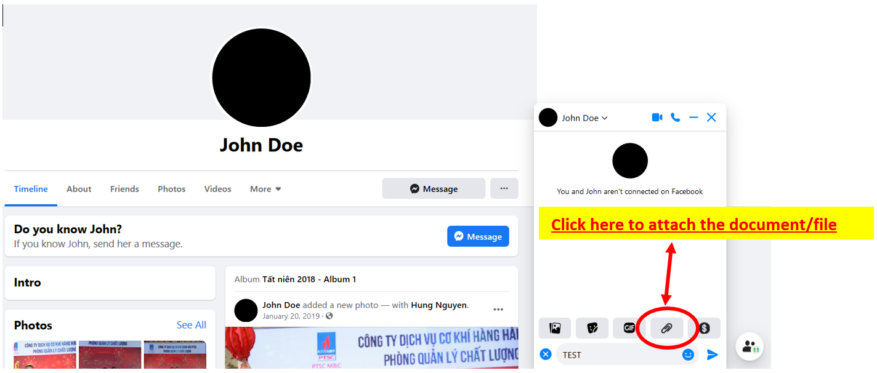
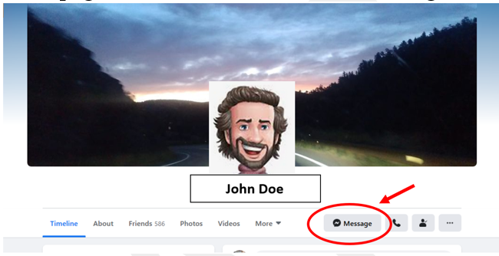

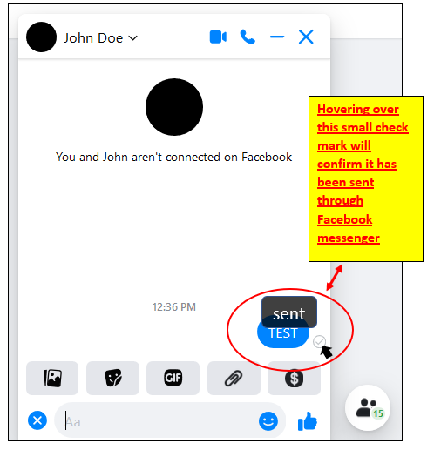
- The officer may request confirmation, although it is not required to complete the return unless directed by the court.
- The officer will use the time/date information from the
electronic platform as the date of service for the officer’s
return. If requested will also attach a screen shot of this
information and response, if any, to the return.

Service by Email
- The Court/plaintiff will provide a specific email address for the subject being served.
- Send a scanned copy of the process to be served to provided email address.
- Request response through email provider “message received” and “message read”
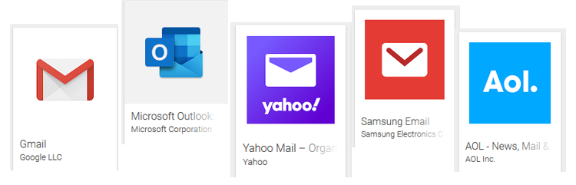
- The date/time information from the “outbox” in your email program is used as the date/time of service on the officer’s return. If requested attach a screen shot of this information and response to the return.

Service on “What’s App” (or sending via text message)
- The Court/plaintiff will provide a specific phone number for the subject being served.
- Once the correct account/phone number is received and confirmed, send the process scan a copy of the process to be served and
- attach it to a message for the respondent.
- The officer may request confirmation, although it is not required to complete the return unless directed by the court.
- The time/date information from the electronic platform will be used as the date of service for the officer’s return. If requested attach a screen shot of this information and response, if any, to the return.

Additional Social Media Platforms that have direct messenger applications:
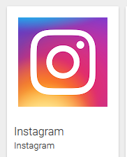
- Instagram
- Twitter
- LinkedIn

NOTE:
Adequate Service of process will be determined by the Court. In many cases the officer may not be able to confirm receipt of these deliveries via social media since there may not be any feedback from the different platforms. An actual response from the respondent would be a positive confirmation that someone at that end received the notice.

