Texas EMS & Trauma Registries
Data Entry Hints & Tips for Justices of the Peace

Once you have been able to log into the Texas EMS & Trauma Registries, the new user training slides will provide basic instructions for navigating the system. The following hints are provided to assist you with entering the records into the Registry system. This documents assumes that you have logged into the Registry and have selected “Create a New Record.”
CREATE RECORD – PERSON INFORMATION
For Record Type, you will select Patient Record – Submersion or Patient Record TBI/SCI. For this discussion, we will address entering a submersion record.
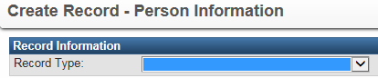
Click the down arrow. A drop down list will show all records available. Select Patient Record – Submersion (If you wish to enter TBI/SCI in the future, follow this same process.)
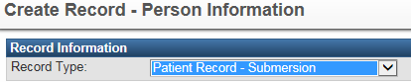
Enter the person information. When completed, click Save at the bottom.
This will take you to the Record Summary. You now want to complete the question packages. At the bottom, you will see the following:
Click the down arrow and select Submersion Required Data Elements. Click View Wizard. The wizards are slow to load, so this will take some time.
The Individual information should be populated from the first page where you entered the person’s demographics. If not, on the upper right tool bar is an option to “Jump To…”. Click on that and select Edit person.
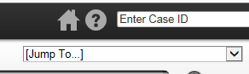
COMPLETE ALL QUESTIONS WITH AN ASTERISK (*) TO THE LEFT OF THE QUESTION. THIS ARE ALL REQUIRED QUESTIONS.
Provider Name: This is where you enter your assigned DSHS Id number.
Click on the magnifying glass and search for your entity name.
This will bring up the Search Event page.
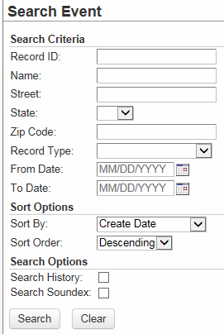
On Record Type: Click down arrow and select Justice of the Peace
On Name: Enter your entity name followed by an asterisk
When you enter your entity name, include an asterisk (*) following the name. This is a wildcard symbol that must be included.
You may enter only a portion of your entity name (.e.g. County name).
Click Search at the bottom. It will bring up all JP entities with the entered criteria.
See following example:

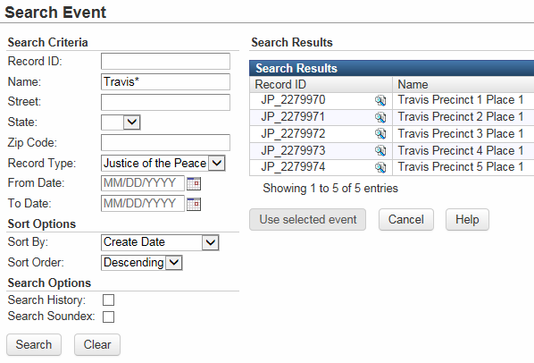
Double click on your entity name. It will populate in the Provider Name field and populate the DSHS Id number on the right side of the screen.
Hospital Arrival/Discharge section - Skip this section. (That is for hospitals to complete since they also use this same record to report.)
JP/ME Section: Complete Date of Death
If Date of Death is grayed out, go to the Jump To box in the top tool bar and select Edit Person from the drop down. Return here to complete the record.
ICD-10 underlying cause of death code: This is an optional field- You may select a null value – Not Known/Not Recorded. We know that JPs do not work with ICD-10 codes. We are considering converting this to a narrative field.
Event Section: Complete required questions (*) or provide null value listed on right side of record. Optional questions do not have to be answered. You may opt to answer any pertinent questions you have information on. (e.g. Witness, drug/alcohol use, supervision, lifeguard, etc.) You may enter a narrative in the last box labeled “Enter any circumstances no previously entered…..”
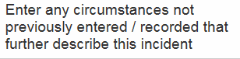
When all information completed, click Save. You should be done.
If you have any questions or need assistance, please feel free to email us at injury.web@dshs.texas.gov

Rev. 11/8/2018

