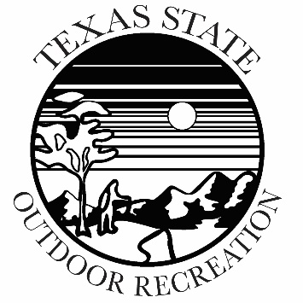

Texas State Outdoor Recreation
Trip Staff Training Program (TSTP)
Application

CANDIDATE DEMOGRAPHICS
LAST NAME |  | FIRST NAME
LOCAL PHONE # | TXST A Number |  | TXST Email Address
LOCAL ADDRESS
MAJOR/MINOR COURSE OF STUDY | CLASS STANDING (fresh., sopho., junior, senior |  | ANTICIPATED GRADUATION SEMESTER

CANDIDATE QUESTIONAIRRE
Why are you interested in the Trip Staff Training Program?
What outdoor activities do you currently participate in and at what level (novice/intermediate/advanced):
What outdoor activities do you not engage in currently, or are not proficient in, that you want to work towards?
List all relevant and current certifications you hold and their expiration date (CPR/First Aid, WFA, WFR, paddling/climbing certifications, Leave No Trace, interpretive guide, etc):
Describe any leadership opportunities you have had (do not have to be outdoor-specific):
Tell us something about yourself that will help us to get to know you better:

Outdoor Related or First Aid Certifications Held:  Outdoor Related or First Aid certifications registered for: (Course and date) | Recreation Administration or Leadership Courses Taken:
Organized Outdoor Courses in which you have participated, such as NOLS, Outward Bound, etc.): (organization, length, location, activities) | Outdoor Work Experiences:
Personal Outdoor Activities in which you participate and at what level: | Texas State Outdoor Recreation trips or courses in which you have participated:

