Formlabs Standard Operating Procedure

Purpose
- To describe the startup, operation, and shut down processes required to use the Formlabs.
- Describe relevant background information.

Scope
- This SOP is intended for students, staff, faculty, and non-university individuals.

Prerequisites
- The equipment coordinator (Dr. Asiabanpour) and his appointees are responsible for conducting the training.
Emergency Contact:
- Call 911
- Call EHS & Risk Management at 512-245-3616
- Call Head Lab Technician, Dr. Ray Cook (office 512-245-2050)
- Call Dr. Asiabanpour (office 512-245-3059)

Before using this machine:
- You must have permission from Dr. Asiabanpour.
- You must have received formal training from equipment coordinator, technician or, trained research student (designated by Dr. Asiabanpour) related to machine safety and operation.
- You must read and understand SOP.
- You must use this machine under direct supervision of Dr. Asiabanpour or, Dr. Cook or, trained research student (designated by Dr. Asiabanpour).

Responsibilities
- The lab manager and their appointees are responsible for conducting the training.

Procedure
- Preparation Procedure
  - Verify that power cable and USB/Ethernet cable are properly connected
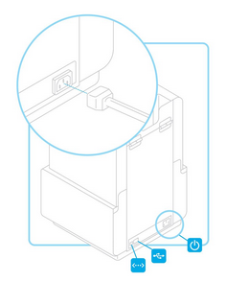
Figure 1.1 Cable placement of Formlabs

  - Verify that the printer is properly leveled
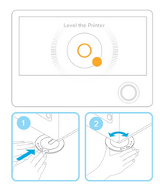
Figure 1.2 Leveling of Formlabs
  - Insert Resin Tank into Formlabs
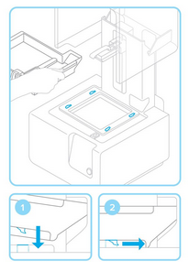
Figure: 1.3 Alignment of tank into corresponding holes
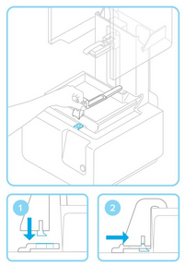
  - Insert Wiper into Formlabs
Figure 1.4 Alignment of wiper into corresponding hole
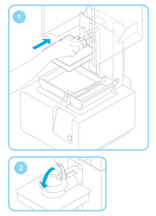
  - Insert Build Platform into Formlabs
Figure 1.5 Inserting build platform onto platform carrier and lock

  - Insert Resin Cartridge into Formlabs
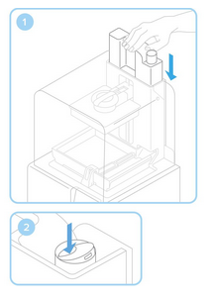
Figure 1.6 Inserting resin cartridge and opening valve for printing

- Printing Procedure
  - Make sure PreForm software is downloaded
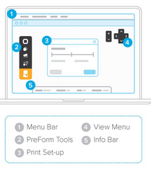
Figure 2.1 PreForm software
  - Prepare .STL or .OBJ file for print
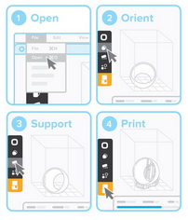
Figure 2.2 Opening, Orientation, Support, and Print of model

  - Pre-Print Checks
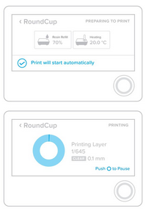
Figure 2.3 Heating(35 degrees Celsius) and Tank filling of resin tank

- Finishing Procedure
  - Remove Build Platform
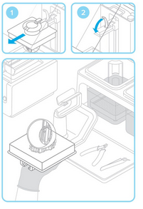
Figure 3.1 Remove build platform by releasing lock

  - Remove Print
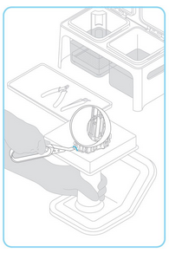
Figure 3.2 Attach build platform to jig and use removal tools to release the part

  - Wash Print
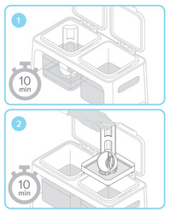
Figure 3.3 Place part into rinse buckets filled with isopropyl alcohol (IPA) and leave for at least 10 minutes in each bucket
  - Finish and Completion of Print
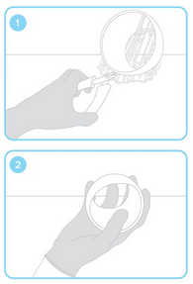
Figure 3.4 Use flush cutters to remove any extra support from part

- Maintaining/Cleaning Resin Tank
  - Inspect the empty tank
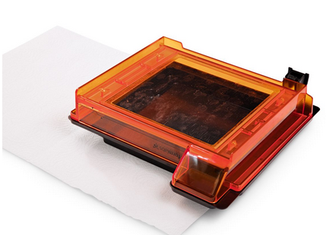
Figure 4.1 When the tank is empty, use the glare from an outside light source to check the bottom surface of each tank.
  - Clean the tank
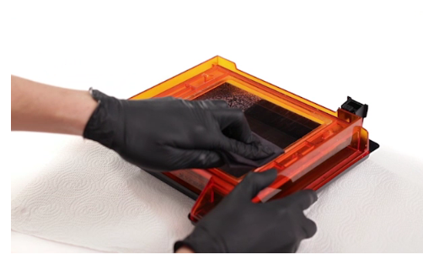
Figure 4.2 Clean the tank’s clear acrylic with Novus 1 acrylic cleaner and a clean microfiber cloth.

  - Reinspect the tank
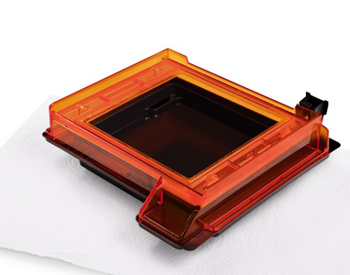
Figure 4.3 Keep the sides of the tank clean, so that the lid does not stick to the acrylic material and to keep it from cracking. When removing the lid, if you lift it only from the front (which seems like the natural way to remove), it can put excessive stress on the pour spout and can cause the tank to crack. It is recommended to use the tabs on the sides of the lid to lift it with two hands straight off the tank.

  - Protect the ID Chip
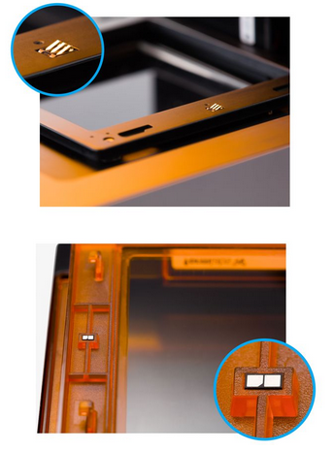
Figure 4.4 Each resin tank has its own ID chip that the Form 2 uses to detect, track, and match the resin type with the proper resin cartridge. Uncured resin on the ID chip or tank carrier may cure with exposure to nominal electric current; cured resin will block the Form 2 from properly reading an inserted tank. Watch for the small ID chip on the underside when handling a tank and resin.

- Maintaining/Cleaning Glass Optical Window
  - Disengage the wiper
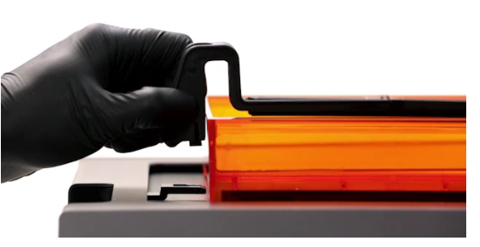
Figure 5.1 Pull the wiper toward the front of the printer to release the wiper's foot from the mount. Set the wiper aside, resting on the far right edge of the resin tank. Manually slide the wiper mount to the center before removing a resin tank.

  - Cover resin tank
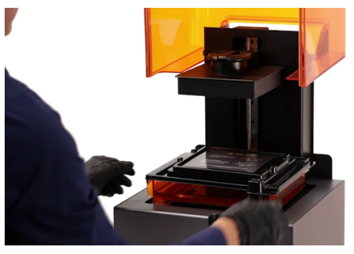
Figure 5.2 Wear gloves and hold the tank by the front tabs, sides, or rim, to avoid getting fingerprints on the internal and external surfaces of the window.
Do not rub or scratch and do not allow resin on the underside of the tank.
  - Remove build platform and resin tank
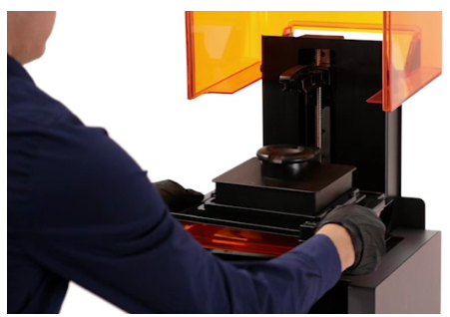
Figure 5.3 Always remove the build platform before removing the resin tank to avoid dripping leftover material onto the optical window.

  - Dry Wipe
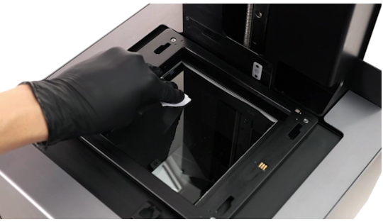
Figure 5.4 Use a lint-free cloth or paper towel, such as a microfiber cloth or PEC*PAD, to remove dust from the window.

  - Wet Wipe
Figure 5.5 Proceed with a wet wipe if the dry wipe does not clean the glass completely. Only use IPA to clean the glass surface as any cleaning solution may degrade the anti-reflective coating. If resin has dripped onto the window, use a small amount of IPA with the cloth or paper towel. Wipe slowly, pulling the cloth toward you moving from the left to the right side of the optical window until you have cleaned the entire surface.
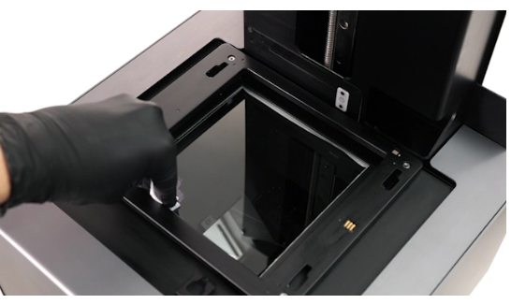
After cleaning with a wet solution, wipe the glass surface again with a dry wipe to remove any streaks. Avoid using cleaners or materials that could scratch or leave residue on the glass surface of the optical window.

References
- Formlabs Support Website

Definitions
- N/A

