PROFESSIONAL DEVELOPMENT INTEGRATING PRACTICING AND PROSPECTIVE TEACHERS: SHARED Resources from a community of practice
Christina Koehne Katty Zied
Texas State University Texas State University
crz7@txstate.edu kattyzied@txstate.edu

Hiroko K. Warshauer Cody Patterson
Texas State University University of Texas -San Antonio
hw02@txstate.edu cody.patterson@utsa.edu
This study examines a professional development that integrated practicing and prospective teachers to decompose observed practices in a class associated with a summer math camp for elementary and middle school students. An embedded case study was used to analyze the data from 54 episodes from two discussion groups over a two-week period. We report preliminary results regarding participants' observations of three types: noticing of students; noticing of teacher; noticing of enactments. We find most of the discussion focused on collaboratively finding ways to support the students in their classes. The decomposition of practice during the reflection sessions benefited from various resources contributed by the participants in the forms of knowledge of mathematical content, materials, and practices in teaching.

Keywords: Teacher Knowledge; Professional Development; Community of Practice
Introduction
Research suggests that professional development (PD) focused on practice provides prospective and practicing teachers’ opportunities to learn and examine the real work of teaching (Ball & Forzani, 2009; Grossman, Compton, et al, 2009; Silver et al., 2007). Representations of practice (Grossman et al., 2009) captured in video episodes, student work, transcripts, and teachers’ narratives are often used by researchers as effective tools to help unpack and decompose practice (e.g. Sherin & van Es, 2005; Kazemi & Franke, 2004; Silver et al., 2007; Oslund, 2016). Lacking, however, is the opportunity to interact or be present within the dynamics of the teaching context. PD opportunities such as lesson study (Lewis, Perry, & Hurd, 2009) provide direct access to the classroom with demonstration lessons that serve as representations of practice followed by opportunities for the decomposition of practice. These PD experiences have provided opportunities for teachers to reflect, analyze, and decompose practices and have been effective in developing teacher knowledge, teacher-learning resources, and professional community in various settings in the US and internationally (Cajkler, Wood, Norton, & Pedder, 2014).
Additionally, Little (2003) posits that improvement of teaching and learning is strengthened when teachers collectively and collaboratively examine practice and engage in analysis of their work. Representations of practice that are contextualized in a common work environment become resources for professional community and teacher learning (Little, 2003). Practices and observations can then be made visible in the interactions among the members of the professional community. The skill of professional noticing of significant features of classroom activities becomes an important component of what is attended to and how it is interpreted (Jacobs, Lamb, & Philipp, 2011; Schoenfeld, 2011; Star & Strickland, 2008). Researchers have noted differences in what expert, beginning, and novice teachers monitor, perceive, and understand of classroom events (Sabers, Cushing, & Berliner, 1991; Berliner, 2001). Informed by these studies, our work aims to examine how a PD intended to enhance professional noticing, professional community, equitable teaching, and practice-based pedagogy along the teaching continuum from prospective to practicing teachers can contribute to participants’ understanding of their mathematics and teaching practices. This paper will focus on discussions in which PD participants decomposed teaching practices observed in the camp, analyzing the mixture of resources that participants brought to bear on their analysis of a shared teaching and learning context.
Background
Our study examines a PD where practicing and prospective teachers observed or taught in a summer camp for children in the mornings and engaged in afternoon discussion sessions about practices and mathematics content observed during the morning camp sessions. This work is done within the context of practice-based professional education (Ball & Cohen, 1999) in that we structured experiences for practicing teachers’ professional development and preservice teacher preparation, that are “centered in practice.” Grossman and colleagues (2009) identified three practice-based pedagogies: representation, decomposition, and approximation. Our PD work centers on these three elements of practice by having participants view representations of practice (the morning camp), learn to break down practice into its constituent parts (the afternoon sessions), and implement approximations of practice (subsequent days in the morning camp).
The afternoon sessions focused on the practice of decomposing the practices observed in the morning camp portion. It is during these nine sessions that we collected data to answer the following research questions:
- What observations of a camp classroom do the participants bring up during their daily reflection sessions that relate to teaching and/or supporting students’ mathematical learning?
- What resources does the mix of practicing and prospective teacher participants offer for the productive decomposition of practice?
Methodology
Our study is an embedded case study with conversational episodes as units of study within the two cases described below (Yin, 2009). We used open coding and categorical aggregation (Creswell & Poth, 2018) to examine episode transcripts in detail to describe the interactions among participants regarding their class observations. We then analyzed the types of resources contributed by participants in the episodes using Little’s (2003) classifications of intellectual, social, or material resources. Because the participants were reflecting in discussion, we re-defined Little’s resources as follows: intellectual resources are statements that contextualized observations or actions in experiences such as PDs, coursework, teaching, or working with children; material resources are knowledgeable statements regarding benefits, implementations, or difficulties with models, manipulatives, or materials; and social resources are rationalized statements informed from a conversation the participant had with another person.
Additionally, we used the same process to create descriptive resource types that fit within our structure of Little’s classifications. Similarly, we also describe these resources as internal or external to the camp. Internal resources include resources such as camp curriculum or teaching experiences in previous camp classes. External resources include teaching experiences in the teachers’ own schools, mathematical content or pedagogical knowledge from university courses or other professional development attendance, and pedagogical tools (See table 1).
Participants and Data Collection
Our study included 16 participants who attended a PD associated with a two-week half-day math camp for students in grades 3-8. The participants consisted of three lead teachers (LT) who taught the morning camp classes, five practicing teachers seeking professional development hours (PDT), five prospective teachers (PST), and three undergraduate “fellows” not on any teacher certification track (F) who observed and assisted with the camp classes. Each participant was assigned a specific class to teach or observe for the duration of the two-week camp; each class had a LT and a mix of PDT, PST, and F. Participants wrote individual prompted reflections of their classes immediately after the morning camp and lunch. Examples of prompts included, writing about instances when students struggled or instances when the teacher used techniques of questioning. They then met for approximately 40 minutes with participants from the same class or class level to discuss their observations. These discussions were semi-structured around, though not restricted to, the reflection prompts and were informally guided by two of the LTs. These discussions provide insight into the resources that participants from different backgrounds (LT, PDT, PST, F) contributed to the groups’ analysis of their observations and practices.
Data Analysis
We define an episode to be part of a discussion with a focus on an observation discussed by the group. An episode ends when a new observation is introduced that is taken up by the group. We found that 120 of the 200 episodes discussed observations regarding teaching and/or supporting students’ mathematical learning. We further explored these episodes for rich episodes to address our research questions. By rich episodes, we mean episodes in which at least two participants engage in a discussion and decomposition of observations from the morning camp classroom sessions. This eliminated episodes in which a participant stated an observation that was not taken up or discussed by the group. Two researchers examined the 120 episodes independently to identify the rich episodes; any disagreements were resolved through discussion. This process identified 54 rich episodes. We further explored these rich episodes through open coding for discussion topics (research question 1) and resources offered by participants related to those topics (research question 2). After the researchers independently open coded for discussion topics and resources, the researchers aggregated the codes to arrive at agreed upon discussion topic categories and resource subcategories that fit into our existing resource framework. The data was then recoded with the agreed upon categories.
Findings
We identified the following discussion topics in the rich episodes: students’ mathematical connections (between and within concepts), participant questioning, noticing students’ understanding, students’ multiple methods and strategies, student disengagement, participant’s teaching moves, lesson trajectory, and student confusion (analysis is based on conversation density) (see Table 1). After analyzing the data, we found that the resources brought to these eight discussion topics could be described in terms of internal or external resources. This distinction became important as it showed which experiences from this camp and PD the participants most often decomposed and discussed, as well as which outside experiences the participants found similar in nature and made connections to.
Concepts typically had a predominant resource; however, two concepts used an approximately equal mix. Predominance was determined by a 10% difference between the categories; percentage reflects the density of the resources within each concept (see Figure 1). For the purposes of this paper we will only focus on the predominant classifications.
Topics that focused on students’ multiple methods and strategies, questioning, noticing students’ understanding, and confusion used the predominantly internal resources. Among the internal resources, use of camp visual models was mentioned most frequently. Other frequently used resources included knowledge of students and teaching experiences. Knowledge of students was most apparent in both the concepts of questioning and noticing student’s understanding, while teaching experience was commonly utilized in both students’ multiple methods and strategies and student confusion. Interestingly, knowledge of students was not used as a resource when discussing students’ multiple methods and strategies or student confusion. Similarly, teaching experiences were not present in the other topics except for a brief use in terms of questioning discussions. (See Figure 2.)
This pattern of sharing common resources does not extend to the predominantly external topics, student disengagement and lesson trajectory. The topics of student disengagement fostered a conversation that lent itself to teaching experience and using external activities to re-engage the students. In conversations about lesson trajectory, future plans were discussed that would benefit the students learning based on that day’s lesson. Thus, a mixture of resources were included in formulating the lesson trajectory for the following day (See Figure 3.)
Next, we look at the topics that were approximately equal in their use of internal and external resources, teaching moves and students’ mathematical connections. Due to the nature of this breakdown, we combined the internal and external subcategories. The topic of teaching moves elicited resources that primarily reflected teaching experience and purposeful decisions. Although various other resources were brought into the conversation, none were as prevalent as these two resources which were both present in the internal and external resources. When discussing supporting students’ mathematical connections, participants most often used internal resources related to knowledge of students and curricular knowledge, and material resources regarding visual models. Additionally, participants tended to focus on their current students’ knowledge and their knowledge of students of that age when trying to orchestrate mathematical connections. Similarly, participants had to anticipate learning trajectories in the camp curriculum and students’ prior and upcoming experiences in school to start creating a pathway for these connections to occur (See Figure 4).
Lastly, we added a seeking resource component that was neither internal nor external, but an attempt to elicit a resource from another participant. This category, which appeared in all eight of our primary concepts, were initiated by a PST, F, of PDT. These discussions provide not only an environment where participants shared their observations and resources but were able to exchange resources and reflect on new resources they did not have access to before.

Conclusion
This camp aims to provide teacher participants with opportunities to learn and develop tools for engaging all students in exploring mathematical ideas. Our preliminary findings show that participants draw from various internal and external resources when discussing and analyzing a shared context in teaching. This shared environment of the camp classroom and the group discussions appear to contribute to creating a community of practice that analyzes with greater specificity their common experiences and those observed practices that relate to teaching and learning of mathematics. The resources that participants share can serve to enhance the perspectives and understanding of classroom activities, interactions, and instructional practices for all participants. Future research will focus on what resources each participant classification contributed, and who brought up the topic of focus.
References
Ball, D., & Cohen, D. (1999). Toward a practice-based theory of professional education.
Teaching as the Learning Profession San Francisco: Jossey-Bass.
Ball, D. L., & Forzani, F. M. (2009). The work of teaching and the challenge for teacher
education. Journal of Teacher Education, 60(5), 497-511.
Berliner, D. (2001). Who is teaching our children? Educational Leadership, 58(8), 6-10.
Cajkler, W., Wood, P., Norton, J., & Pedder, D. (2014). Lesson study as a vehicle for collaborative teacher learning in a secondary school. Professional Development in Education, 40(4), 511-529. doi: 10.1080/19415257.2013.866975
Creswell, J. W. & Poth, C. N. (2018). Qualitative inquiry & research design: choosing among five approaches. Los Angeles: Sage.
Grossman, P., Compton, C., Igra, D., Ronfeldt, M., Shahan, E., & Williamson, P. (2009).
Teaching practice: A cross-professional perspective. The Teachers College Record, 111(9), 2055-2100.
Jacobs, V. R., Lamb, L. L., & Philipp, R. A. (2010). Professional noticing of children’s mathematical thinking. Journal for Research in Mathematics Education, 41(2), 169-202.
Kazemi, E., & Franke, M. L. (2004). Teacher learning in mathematics: Using student work to promote collective inquiry Journal of Mathematics Teacher Education, 7(3), 203-235.
Lewis, C., Perry, R., & Hurd, J. (2009). Improving mathematics instruction through lesson study: a theoretical model and North American case. Journal of Mathematics Teacher Education, 12(4), 285-304.
Little, J. W. (2003). Inside teacher community: Representations of classroom practice. Teachers college record, 2013(6), 913-945.
Oslund, J. A. (2016). After the elementary mathematics teacher workshop. Elementary School Journal, 116(3), 437-458.
Sabers, D., Cushing, K. S., & Berliner, D. C. (1991). Differences among teachers in a task characterized by simultaneity, multidimensionality, and immediacy. American Educational Research Journal, 28, 63-88.
Schoenfeld, A. (201. Noticing matters, a lot. Now what? In M. Sherin, V. Jacobs & R Philipp (Eds.) Mathematics Teacher Noticing: Seeing through teachers’ eyes. (pp. 223-238)
Sherin, M. G. & van Es, E. A. (2005). Using video to support teachers; ability to notice classroom interactions. Journal of Technology & Teacher Education, 13(3), 475-491.
Silver, E. A., Clark, L. M., Ghousseini, H. N., Charalambous, C. Y., & Sealy, J. T. (2007). Where is the mathematics? Examining teachers’ mathematical learning opportunities in practice-based professional learning tasks. Journal of Mathematics Teacher Education, 10(4-6), 261-277. doi: 10.1007/s10857-007-9039-7
Star, J. & Strickland, S. K. (2008). Learning to Observe: Using videos to improve preservice mathematics teachers’ ability to notice. Journal of Mathematics Teacher Education, 11, 107-125.
Yin, R. K. (2009). Case Study Research Design and Methods (Fourth ed. Vol. 5). Thousand
Oaks, CA: Sage Publications.

Table 1

Discussion Topics
Students’ Mathematical Connections | Participant observed a student, or students, trying to create a deeper understanding by making connections between and within a concept area.
Questioning | Participant’s explain or discuss questions they asked students, as well as why they asked a certain question.
Noticing Student’s Understanding | Noticing the difference between the students who understand and those who need more practice or time. Noticing students’ prior knowledge.  Claims by the participant that portrays an assumption regarding some aspect of student(s) understanding.
Student’s Multiple Methods and Strategies | Participants discuss students using different methods/approaches/ strategies to solve a single problem.
Student Disengagement | Participants discuss actions taken when students become unwilling to work or unproductive.
Teaching Moves | Participants discuss and justify actions they took to help students
Lesson Trajectory | Participants discuss plans for future lessons, and why these plans will help the students.
Student Confusion | Participants discuss students being unable to make connections or understand a mathematical concept.

Resources
Internal | Knowledge participants elicit in conversations that are influenced by the camp.
External | Knowledge participants elicit in conversations that are transferred into camp situations but are influenced by outside sources.
Intellectual | Resources that stem from knowledge gained through experiences such as PDs, coursework, teaching, or working with children
Purposeful Decision | Participant justifies why they responded in a particular manner.
Coursework or PD | Participant relates the conversation to PD or coursework.
Curriculum Knowledge | Participant relates the conversation to future lessons or grade level knowledge.
Knowledge of Students | Participant uses what they know about students, or student thinking, to further a conversation or justify their actions.
Teaching Experience | Participants use their own teaching experience to enhance a conversation or justify their actions.
Material | Resources that stem from the discussion regarding the use of physical object and manipulatives.
Activity | Participants discuss the benefits or difficulties with an activity. Activity meaning a game or problem that uses materials that are not visual models (e.g. flash cards, card games, online games such as Kahoot or KenKen)
Visual Model | Participants discuss the benefits, usage, or difficulties or visual models, such as the number line, chip model, or multiplication charts.
Social | Resources gained from participants discussing information that stemmed from a conversation they had with another person.

Figure 1
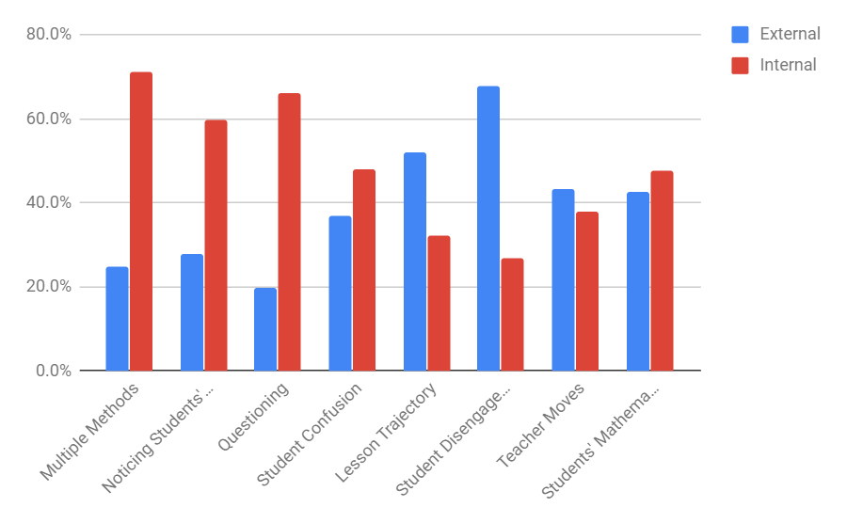

Figure 2
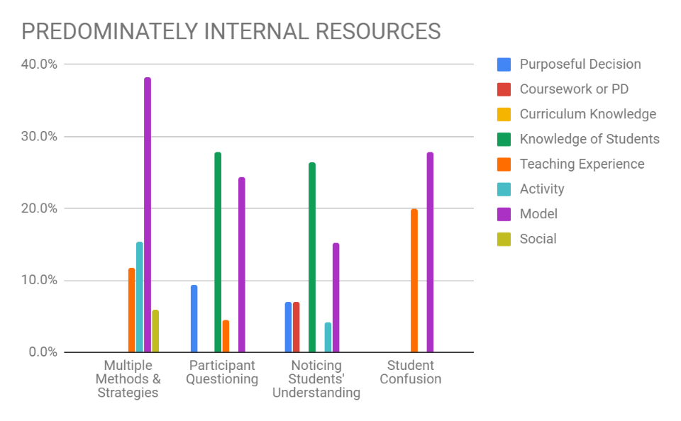

Figure 3
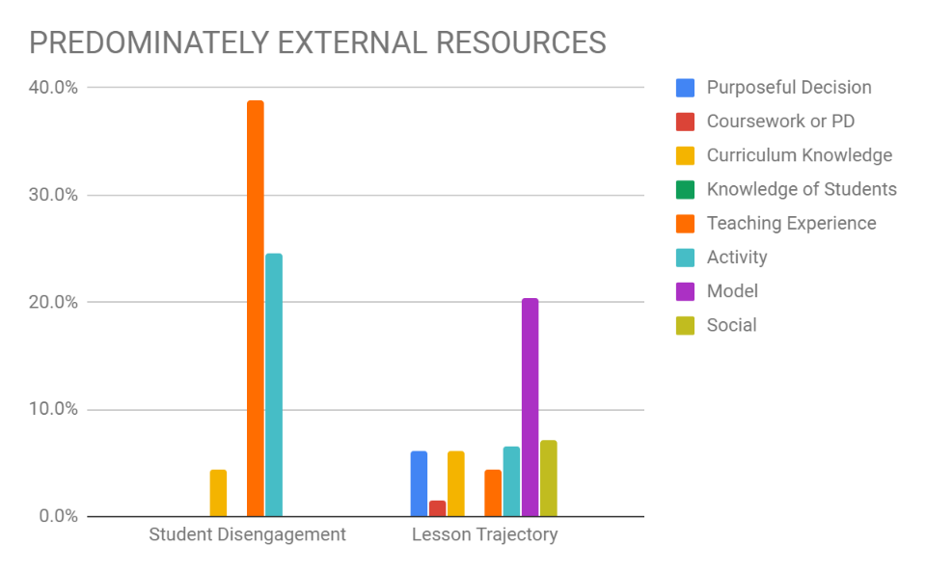

Figure 4
