Texas State International Piano Festival:

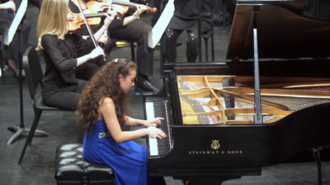
Introduction: Texas State’s International Piano Festival exposes young, future professional pianists to a performance career. After seven successful years, we are eagerly preparing for the 8th annual festival June 3-11, 2017. This year we have received an overwhelming number of applications from very talented young artists of low income families locally and around the world. We are inviting individuals and organizations to sponsor scholarships for these extraordinary, yet disadvantaged students. For every $700, one student will be awarded a full-tuition scholarship. For every $350, one student will be awarded a half-tuition scholarship. The sponsor will receive a photo of the student’s final performance with a personal thank you letter.
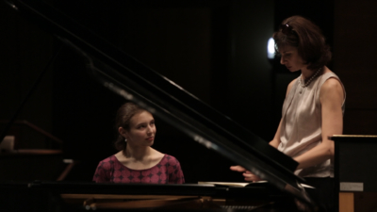
The Need: Developing pianists often feel secluded and isolated, and it’s difficult for serious budding performers to find experienced mentors who can guide and connect them to the professional world. This is especially difficult for disadvantaged students. Lots of summer camps exist for young pianists to learn basic skills and technique, but Texas State’s International Piano Festival is the only festival in the region teaching youth higher level piano skills while exposing artists to world class performances, connecting them with potential mentors, and teaching advanced career skills, like how to interview for a job.
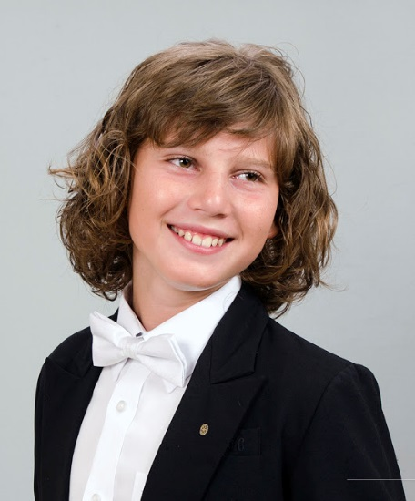
For example, Nikolai Marinov is a fantastically talented student from Plodiv, Bulgaria. At the age of 15 he applied to attend the festival, but could not afford the cost of attendance. With the drastically different exchange rate between the US and Bulgaria, a high monthly salary was around $400 USD. Nikolai’s family would have had to spend the equivalent of a few months of their salary to send him. Yet because of generous sponsors, he was able to attend. Nikolai’s reaction to the festival was priceless! Not only did he fulfill some of his dreams, like play for faculty members from Juilliard and Peabody, but he also got to perform a concerto in the US for the first time. You can see a video here: https://youtu.be/YVi-5buPp_A. Because of this experience, Nikolai finally felt at home as a pianist. This was the first time in his life he was surrounded by other fantastically talented kids his age. The festival allowed Nikolai to open his eyes to a whole new approach and make a ton of new friends. He is very grateful to his sponsor and constantly in touch with many from the festival.
Nikolai Marinov
Former Participant, Bulgaria
Festival Description: The annual International Piano Festival is an intensive one-week summer residency for aspiring young pianists worldwide to study with a stellar array of faculty. Most of the festival’s preparation each year is done by dedicated faculty volunteers who care about these students dearly, and love to witness how the festival positively changes so many young lives. Participants usually range from the age of eleven through university level, and are selected through a highly competitive audition process. Participants are artists with phenomenal skills who are passionate about making music and are seeking advanced guidance for how to become professional pianists. This is truly a once in a lifetime opportunity that changes the lives of each student who participates.
MISSION:
Discovering and exposing future professional pianists to a performance career.
SCHEDULE
INCLUDES:
Guest Artist Recitals
Solo Recitals
Rising Stars Recital
Concerto Performances
Master Classes
Presentations
TESTIMONY:
“I have been to many festivals and master classes, but this one left something special in my heart. Everything was amazing- from the master classes and concerts to all of the very talented young people that I met there. It is great that professors like Jason Kwak, Julian Martin, Boris Slutsky, Enrico Elisi, and others, can pass to us, the younger generation, their experience, their flames and their knowledge.”
-Nikolai Marinov, age 15

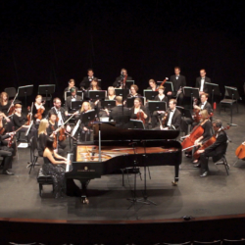
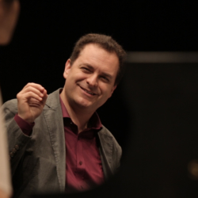
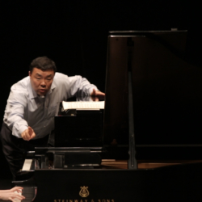
Led by international concert artist Jason Kwak, the festival is truly global in its makeup, both in terms of faculty and participants. During the festival, guest artists and faculty provide master classes and recitals. Students learn advanced skills and techniques and are inspired by concerts performed by professionals, rising stars currently studying at prestigious music schools (such as Peabody Institute and Julliard), and young finalists in the festival’s own piano competition. Festival faculty currently teach at some of the finest music schools around the country, including: the Julliard School, Peabody Conservatory, Eastman School of Music, and Cincinnati Conservatory of Music. Faculty offer a wealth of knowledge, experience, and networking connections to these promising artists. Often natural mentoring relationships develop to assist the students in achieving their artistic, educational, and future career goals. Beginning two years ago, the festival instituted the Festival Concerto Competition, where students are accompanied by a full professional symphony (Round Rock Symphony) and compete. In the 4th festival we brought the famed NPR show “From the Top” where they recorded an episode featuring many of our participants in front of a sold out theatre. The seventh year’s Dickinson competition finalists had the opportunity to compete for a very special prize—to record with one of the largest independent classical music labels in America, Centaur Records.
Please join us in helping talented, disadvantaged young pianists experience this life changing festival by sponsoring a $700 or a $350 scholarship. To donate, contact Dr. Kwak or donate online. Provide an address and add “International Piano Festival Scholarship” in the comments section to be mailed a tax deductible receipt. Donate at: https://donate.txstate.edu.

