FunKey Piano Project

SPRING 2021

Parent/Student Handbook

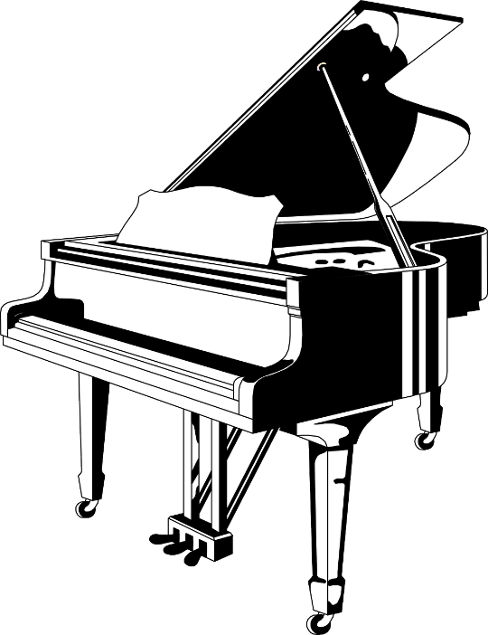

Table of Contents

Overview ……………………………………………… 3
Tuition …………………………………………………4
Calendar ………………………………………………..4
Music Stores ……………………………………………5
Location ………………………………………………..5
Lesson Policy ………………………………………….. 6
Performance Policy ……………………………………. 6
Absence Policy ………………………………………….7

Texas State FunKey Piano Project
Overview
FunKey Project was founded in 2018 by Dr. Daria Rabotkina for the local community. Piano lessons are open to students in grades K-12.
The presence of COVID-19 has forced changes on every level of our daily lives, yet it could not STOP the music for our children. FunKey Piano Project will be continued throughout the spring semester. All lessons and activities will be offered ONLINE via Zoom platform unless otherwise instructed by the university.
Lessons are scheduled individually with the assigned private teacher. Weekly lessons are taught by the members of keyboard faculty and piano majors at Texas State. The students are matched with a piano teacher by their level and personality. Piano majors are supervised by the Texas State faculty members and are eager to share their enthusiasm and love for piano education with the students of FunKey Piano Project.
FunKey Piano Project concludes each semester with an evaluation and a formal performance, where all families are welcome to celebrate music and their child’s efforts! This spring these activities will be held via Zoom.

Dr. Daria Rabotkina, Founder
School of Music
Texas State University
601 University Drive
San Marcos, TX 78666

Website: www.funkey.music.txstate.edu
Email: dsr51@txstate.edu

Frequently Asked Questions

Tuition
For remote instruction in Spring 2021 only: a 25% discount will be applied to the spring tuition charges.
Ten, 30-minute lessons are offered for $112.
Payment is due in full by the last day of the registration.
Online payment link:
https://secure.touchnet.com/C24322_ustores/web/store_main.jsp?STOREID=369&SINGLESTORE=true

When in-person lessons resume, FunKey Piano Project will offer twenty, 30-minute lessons at $300 per year, or ten lessons at $150 per semester. This includes private lessons, performances, and evaluation. Additional lessons can be negotiated with your teacher, at their personal pay rate. 60-minute lessons are available upon request.

Calendar 2020-2021
Fall 2020
Tuesday, August 25 |  | Online Registration Begins  Online Payment Portal Opens
Wednesday, September 2 |  | Fall Registration Ends
Tuesday, September 8 |  | First Day of Lessons
Friday, November 13 |  | Last Day of Lessons
Sunday, November 15 | 2pm | FunKey Virtual Fall Concert
Wednesday, November 18 | 6pm | FunKey Virtual Fall Evaluation

Spring 2021
Wednesday, January 20 |  | Online Spring Registration and Payment due
Monday, January 25 |  | First Day of Lessons
March 14-21 | Spring Break | No Lessons
Friday, April 9 |  | Last Day of Lessons
Sunday, April 11 | 2pm | FunKey Virtual Spring Concert
Wednesday, April 14 | 6pm | FunKey Virtual Spring Evaluation

Music Stores
Families are responsible for buying music for the student. Options for piano purchases/rentals music scores:
Online: amazon.com, alfred.com, sheetmusicplus.com
Austin: Strait Music Company (2428 W. Ben White Blvd, Austin, TX 78704)
San Antonio: Alamo Music (425 N. Main Avenue, San Antonio, TX 78205) and RBC Pepper Sheet Music (4415 Centerview Drive, San Antonio, TX 78228)
Examples of the sheet music for the beginners: John W. Schaum Piano Pre-A: The Green Book, The Russian School of Piano Playing, Book 1, Part II.

Lesson, Performance and Absence Policy

Lesson Policy
- For Zoom instruction, parents/caregivers MUST remain in the room with the child at all times during the lesson. Cellphones can be used for recording a lesson only, with the permission of your teacher. Writing down the instructions and homework is highly encouraged.
- By the end of the registration period, a student must have an instrument with a full keyboard of 88 keys at home. Lessons will not be given unless a student has an instrument available for daily practicing. Options include renting/buying a piano or a keyboard. An upright or a grand piano is more encouraged for successful practicing than a keyboard.
- The student would need to purchase music scores which will be used in class.
- Please be on time. Have your music ready and any additional supplies requested by your teacher.
- Students are expected to practice daily and to come to lessons fully prepared.

Performance Policy
Concerts and evaluations are all mandatory FunKey Piano Project events. Missing one of these events without a prior written permission of Dr. Rabotkina will result in the removal from the project.
All repertoire and technical exercises are to be performed by memory.
Performances and evaluations require formal attire.
Minimum requirements for the concert:
Two pieces performed without mistakes, in a steady tempo and with the understanding of dynamics, articulation and character,
Minimum requirements for the evaluation:
30-minute lessons - two major and/or minor scales and arpeggios
60-minute lessons – four major and/or minor scales and arpeggios

Absence Policy
With the exception of a sudden illness, always let the teacher know ahead of time that you will not be at the lesson.
Two (2) missed lessons are allowed during each semester with a valid excuse (see below). Lessons missed by a student are not expected to be made up by the teachers. A third missed lesson will put a student on probation and potentially result in the student’s missing the end of the semester’s concert.
A missed make up lesson will not be rescheduled.
Lessons missed by a teacher will always be made up before the end of the semester.
Valid Excuses:
- Illness
- Death in the family
- Mandatory school activity
- Religious holidays
- Natural disaster

