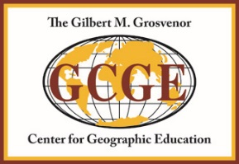

Subscription Form

Research in Geographic Education is an international peer-reviewed journal published in the Spring and Fall, emphasizing research in geographic education and spatial learning. Articles, commentary, and reviews of the following subjects are addressed in this journal: spatial cognition, map learning, learning theory, curriculum, gender issues, distance learning, non-traditional learning, environmental psychology, environmental education, cross-cultural spatial learning, and teaching methodologies.

Subscription (One Year)
Within North America: Individual- $30/Institution- $50
Outside of North America: Individual- $40/Institution- $60
Universities may subscribe using EBSCO subscription services.

Orders/Inquiries
Grosvenor Center for Geographic Education
Texas State University-San Marcos
601 University Drive
San Marcos, Texas 78666-4616
Tel: (+1) 512-245-1823; Fax: (+1) 512-245-1653
E-mail: j_z37@txstate.edu

Name: ______________________________________________________________________
Affiliation: ____________________________________________________________________
Mailing Address: _______________________________________________________________
_____________________________________________________________________________
City: ___________________________ State: ______ Zip: __________Country: _____________
Phone: __________________________ E-mail: ______________________________________
Subscription Year: ______________________

Payment

Cash: __Check: __ Make checks payable to: Grosvenor Center for Geographic Education

P.O. # (enclose copy): ___________________________________________________________

CreditCard/#:_______________________________________________________ ExpDate:__/__

Signature (required): ____________________________________________________________

