Encumbrance Overview

The end of the University’s fiscal year is August 31. You should review your open travel encumbrances quarterly and monthly during the last quarter to release funds back to your account(s).

Close any travel encumbrances that are no longer needed. If the trip is complete and all the expenses have been paid or the trip was not taken, this will release any remaining funds back to their funding source.

This is an important step in the year end process and can have some substantial benefits for your available budget if funds are released.

The SAP GUI Transaction Code to run this report is ZOPEN_ENCUMBRANCE. This report will display all open encumbrances if the specific travel general ledger number range is not entered.

Close Travel Encumbrance Instructions

- Log on to the SAP GUI using your Net ID and Password.

- Open the transaction code ZOPEN_ENCUMBRANCE.

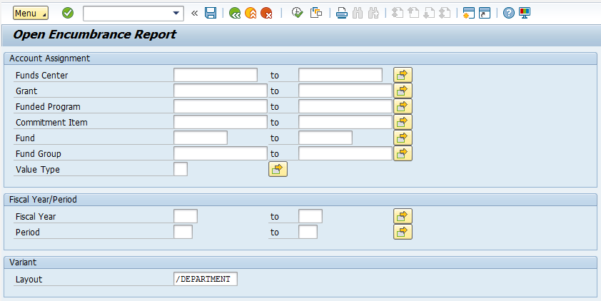

- Enter the “Funds Center”, “Grant”, “Funded Program” and/or “Fund” account combinations you have encumbered money with and select the “Execute” icon.

Note: You may choose to not enter any general ledger numbers and run the report “wide open” to see what you have currently encumbered for all general ledger numbers.

- If you only want to see what travel encumbrances are open, enter travel General Ledger (GL) numbers in the “Commitment Item” field. View the travel general ledger matrix at this link http://www.txstate.edu/gao/ap/travel/procedures/Travel-GL-Matrix.html.

- Select the yellow arrow to the right of the “Commitment Item” fields.

- Choose the “Select Ranges” tab. Enter the GL ranges 710096 - 719800 and 725100 – 725100.

- Select the “Execute” Icon.
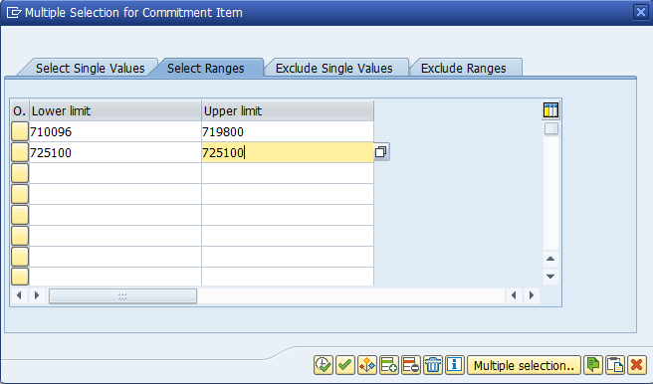

- You will be brought back to the main screen. Select the “Execute” icon and wait for the report to populate the data.
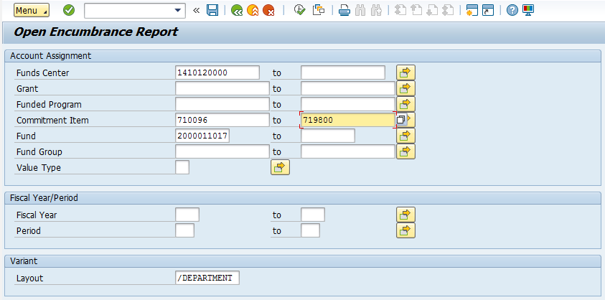
- Review the open encumbrances on your report. The report may have several different types of documents that require certain actions to close the encumbrance. All the document numbers are 10 digits long.

- Documents that start with 45 or 31 are Purchase Orders (PO). Email the Purchasing Department at purchasing@txstate.edu and request the PO be closed. Make sure all of the invoice(s) applied to that PO have been posted before closure.

- Documents that start with 2014 are Travel Funds Commitments (FC). Email the Travel Office at travel@txstate.edu and request the FC be closed. If applicable, make sure all of the Company Paid Airfare, Car and/or Lodging applied to this FC is posted and has consumed the funds before closure.

- Documents that start with 73 are TRAVELTracks Travel Requests and Expense Reports. There is one document number per trip.

- If the trip was not taken, email the Travel Office at travel@txstate.edu and request the Travel Request be canceled.

Note: If Company Paid Airfare (CBA) was purchased on a trip which was not taken, an Expense Report processing the CBA must be submitted by the Travel Assistant. The CBA should have been canceled and the residual value (credit) should be available for future travel by the employee.

- If the trip was taken, process the Expense Report and have the traveler submit into the workflow for audit and reimbursement. After the Expense Report is processed by the Travel Office, any unused encumbered funds will be released back to your account(s).

Note: The Travel Assistant may process and submit a zero-dollar expense report on behalf of the employee.

- e-NPO documents that start with 16 will not be on your Open Encumbrance Report.

- Check your e-NPO Monitor Report with the SAP GUI transaction code ZNOPO2. Verify the status of these documents and ensure they are moving through the workflow.

- Make sure the e-NPO is in the workflow early enough so all approvals are obtained by August 29th so the document can be audited and posted by August 31st.

