How to Submit Returned Contract Requests

The Contract Manager/Specialist will return any contract that:
- Is currently “Under Review” and
- has a request for additional documentation from that has not been received for seven (7) calendar days.
Step-by-Step
The Contract Manager will add notes in the Discussions Tab indicating what additional information is needed before returning the Contract Request to the requestor.
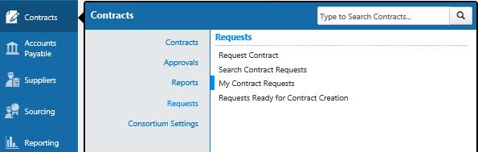
- Navigate to Contracts > Requests > My Contract Requests
- Select Filter Contract Requests (In the Upper Left Corner)
- Check the “Under Review” Box
- Click Apply
- Click on the Contract Request Name in Blue that was returned
- Select the Discussion Tab
- Read the comments left by the Contract Specialist for actions to be taken.
- Click threw the Tabs on the side and update any attachments or questions that are requested by the contract specialist
- Select Review and Complete
- Select Complete Request
- This will put the contract request at the end of the que.

