AUTHORS
Director of Finance Richardson, Brittlin
SPONSORS
Senator Rollins, Hunter
Senator Moloney, Patrick
Director of Programming Torpey, Kelly
Senator Haynes, KeAirra
S.R.2019.2020.15
Date of First Reading: March 30, 2020
A Bill-
A bill entitled “Free Menstrual Hygiene Replenish Act” which amends the Budget Authorization Act of 2019 to direct $2,250 from the Student Government funds from the fiscal year 2019 to purchase free menstrual hygiene products available for student use on-campus.
WHEREAS: The Student Government initiative entitled the Menstrual Hygiene Accessibility Act in S.G.C. Title IX Chapter 113 is a valuable and necessary service to increase accessibility to menstrual hygiene products for students on-campus; and
WHEREAS: Numerous buildings on-campus house and provide menstrual hygiene products through this initiative including Jowers Center, Jerome & Catherine Supple Science, Commons Dining Hall, Harris Dining Hall, Emmett & Miriam McCoy Hall, and Lampasas; and
WHEREAS: When menstrual hygiene products are purchased by Student Government through Aunt Flow, they are distributed to the partnered buildings and restocked as needed until Student Government is notified that more products are needed; and
WHEREAS: Student Government’s budget is an allocation from the Student Service Fee, a mandatory fee for all students, which operates under the State of Texas’ fiscal year calendar rules, beginning on September 1st of one year and ending on August 31st of the following year; and
WHEREAS: The allocation of funds by the Student Service Fee for the Student Government is not considered a “rollover” account, meaning any leftover or otherwise unutilized funds by Student Government will be absorbed by the Student Service Fee reserve fund balance and will not be available for use by Student Government in the upcoming fiscal year; and
WHEREAS: The facilities housing these products have notified Student Government that more menstrual hygiene products are needed, indicating the projected year allotment has been exceeded and the initiative is extremely valuable to the student body and should be maintained; and
WHEREAS: Aunt Flow has provided an invoice for the restocking of menstrual hygiene products on the Texas State University campus, totaling $2,250 and can be found in Exhibit A; therefore
BE IT ENACTED: The S.G.C. Title VIII §101 – “Budget Authorization
Act of 2019” be amended by inserting a Section 3 with the following provision:
ARTICLE II. PURCHASE OF MENSTURAL HYGEINE PRODUCTS
§3 PURCHASE OF MENSTRUAL HYGEINE PRODUCTS. For Fiscal Year 2019 the President shall, on or before August 25, 2020, authorize the purchase of menstrual hygiene products such as pads and tampons through the vendor Aunt Flow as outlined in S.G.C. Title IX Chapter 113 Article II §1(b) totaling $2,250 of the Student Service Fee funds and distribute those products to the partnered on-campus facilities such as, but not limited to, Jowers Center, Jerome & Catherine Supple Science, Commons Dining Hall, Harris Dining Hall, Emmett & Miriam McCoy Hall, and Lampasas.
- This purchase under this act shall only occur if Student Service Fee funds for Student Government remain to be at least $2,250 on or before August 25, 2020, and the purchase would not occur in an overdraft of the account.
- The Director of Finance is directed to make a written report to the Senate on or before September 1, 2020 reporting the status of the purchase and the funds utilized.
- If no purchase has occurred or is not completed by August 25, 2020, the Director of Finance will provide a written justification to the Senate on or before September 5, 2020.
- If no acting or confirmed Director of Finance is in place by the dates identified in this Act, the President or President’s designee shall assume all responsibilities under this Act.

Exhibit A
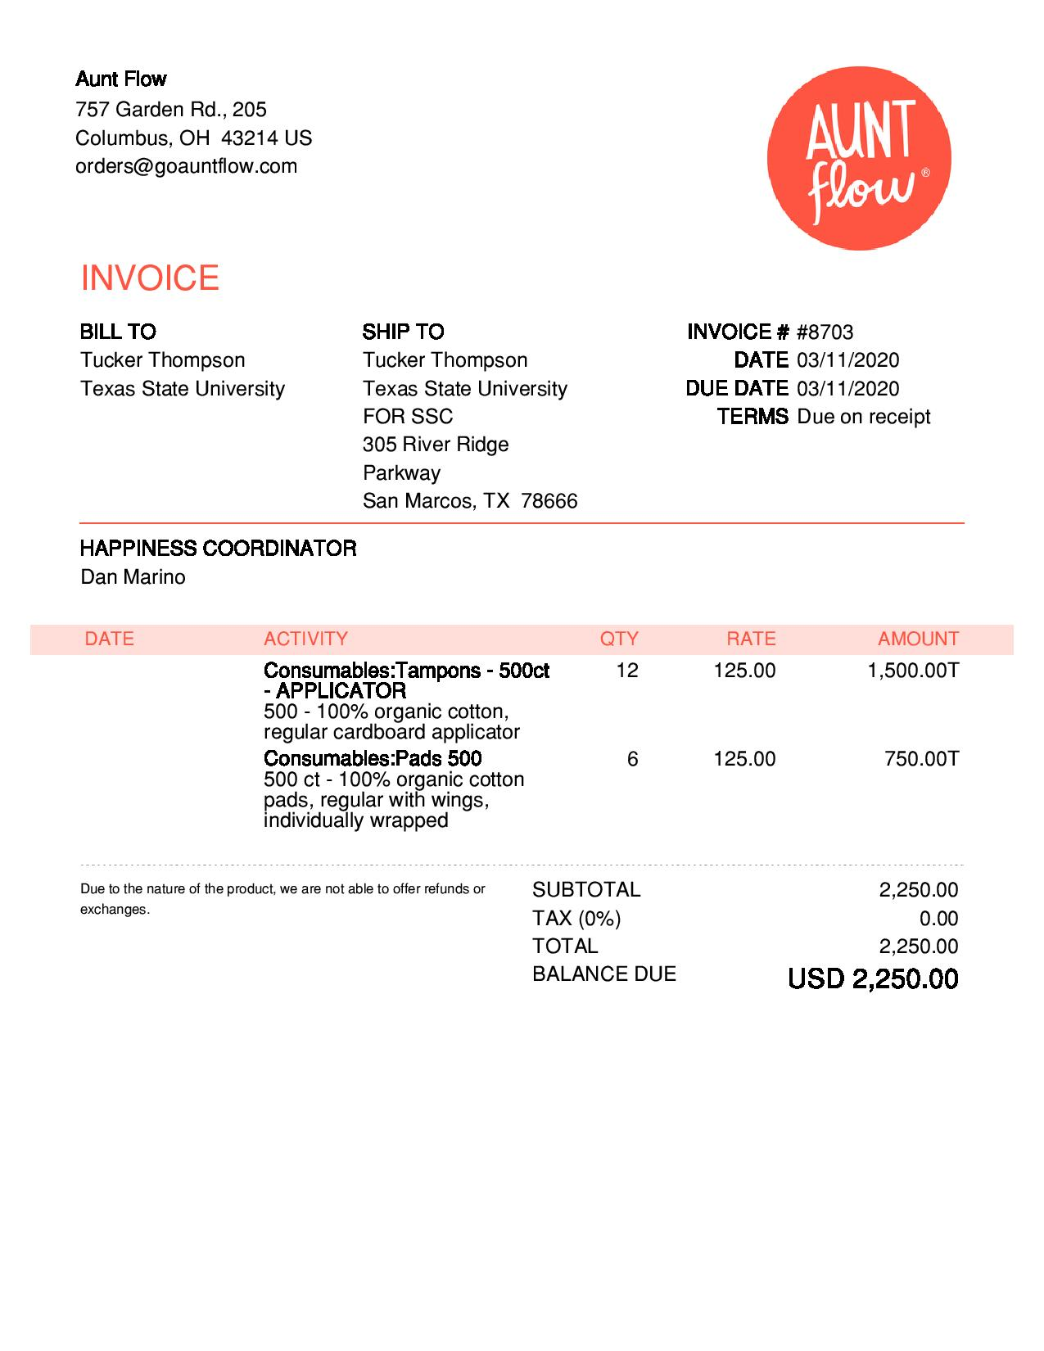
End of Exhibit A

