Environmental Service Committee Monthly Meeting

Date:2/17/2022 Time: 5:15 Location: Via Zoom

Meeting called by Chair: Mitchel Sabourin
Type of meeting: ESC Presentations and introductions for new voting members Facilitator: Mitchel Sabourin and Emma Parsley
Meeting Minutes: Quincey Pugh

Attendance:
Tres Allen Emma Parsley
Priscilla Hernandez Mitchel Sabourin Quincey Pugh Christi Townsend Wren Vogel
Josie Boehm Nicole Wagner

Absences:

Earth Day Event
-should the ESC apply funds again if the rewarded funds in 2020 have not been used
-Haley Taker didn’t have Miranda make another proposal in 2021, however the 2021 EDF was canceled as well
-Miranda wait already has all the funds they have been promised
-should they be able to use the funds for 2022 EDF
-we well allocate the money from the fund to Miranda wait for 2022

Blackland Pocket Prairie
Presenter: Mitchel Sabourin
-San Marcos ecoregion
-Hays County Edwards Plateau
-rich soils
-500 native fauna
-less than 1% of Blackland Prairie original vegetation left

Pocket prairie is a small urban planter featuring native plants
-located in between Alkek and the Math building
-235 sq ft
-little blue stem
-inland sea oats
-side oats

-blue gramma
-blanket flower
-tricks seed
-scarlet flax

Environmental and Educational impacts
-bringing native pollinators and bees
-serves as a habitat and a bioswell
-endangered ecoregion
-catch and collect storm rain water runoff
-currently no root production and is resulting in erosion
-provides a place for native plants
-beautification project
-living laboratory
-proper signage

-Total $1223.19
- Requesting $700 in materials
-ACTION ITEM 1: Dr. Wagner will assist in a soil assessment

-Emma Parsley motioned for a vote
-Christi Townsend second
-all members voted yes and approved funds to be awarded to the Pocket Prairie Project Emma Parsley motioned for Adjournment

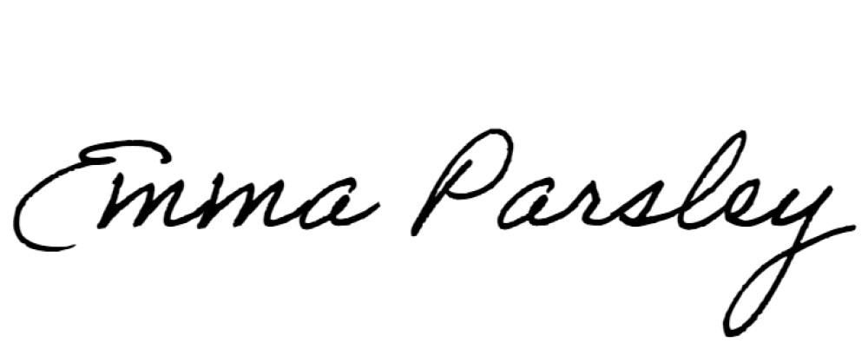
Minutes Submitted by: Quincey Pugh Minutes Approved by:

