A revised edition of “Why Geography Is Important” is now available. This booklet has been improved, mainly through editorial cooperation with the Association of American Geographers EDGE project. It tells the story of how and why geography is important and offers excellent examples of geographers with high visibility employment. The case is made that geographic understanding can lead to sensible decision making in politics, economic, and environmental citizenship. New sections include homeland security, geospatial technology, business location, infrastructure, and the balance between nature and society. Booklets are available at the following prices:
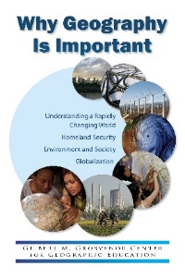
- 1-50 copies ………. $1.00 each
- 51 – 100 copies .... $0.75 each
- 101+ copies ...….... $0.50 each

Grosvenor Center for Geographic Education
Department of Geography ■ Texas State University

601 University Drive ■ San Marcos TX 78666
Phone: 512-245-1823
E-mail: vhc10@txstate.edu
http://www.geo.txstate.edu/grosvenor

Order Form

Name: _________________________________________________________
Mailing Address: _________________________________________________ ______________________________________________________________
City: ___________________ State: __________ Zip: _____________
E-mail: ____________________________ Phone: ___________________
Quantity: ____________

Method of Payment
Check Visa MasterCard American Express
Name of Cardholder ______________________________________________
Card Number ___________________________ Exp. Date __________ Billing Zip Code ____________
Signature _________________________________________________
Date _____________________
(If Applicable) Purchase Order # ___________________________________
If paying by check, please make checks payable to: The Grosvenor Center for Geographic Education

