TIME SHEET INSTRUCTIONS

Create a new timesheet each week to be completed and signed by you and your Field Instructor. Submit your completed typed timesheet to the designated course site each week . Timesheets are fillable word documents, and a handwritten copy will not be accepted.

Fill out the top section (name, agency, level, etc.). See example below for additional clarification.

Example:

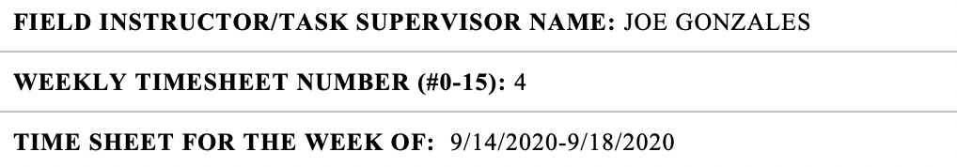

- Field Instructor/Task Supervisor Name: Use the contact who will confirm your hours and activities that week.
- Weekly Timesheet Number: This usually aligns to the semester week number
  - If you start prior to semester, write week #0
  - Spring Break or Thanksgiving count as a week (even if you did not complete contact hours).
- Timesheet for Week of: Put the month, date, and year
- If you begin your internship before the semester begins, be sure to write clearly PRE-SEMESTER TRAINING in the Time Sheet for the Week.
The figures on the timesheet need to be balanced and totaled. For "Balance of Hours” take the total hours of your required field contact hours and enter here (pictured below).

Each week you will carry forward the new balance remaining based on hours worked. Add work completed and hours for each day and then total for the week under “Week Total”. Then, subtract weekly total from the balance of hours and include under “Remining Hours.” By computing your total hours of fieldwork to date for each time sheet, you will have a current total of hours remaining until you reach a zero balance.

When recording work hours, use decimals. Write "1" for 1 hour, ".5" for 1/2 hour, ".75" for 3/4 hour. One-quarter hour should be the smallest fraction. Totals cannot be shown without a breakdown into fieldwork categories. Transportation Time to and from agency is not to be included in fieldwork hours.

FIELDWORK CATEGORIES (to be counted under “Fieldwork Duties Performed”):

Identify, in the box provided CSWE Comp, the CSWE Competency(ies) focused on for the day. If you have more than one, identify them by number. In fieldwork duties performed, be specific about your activities and do not copy/paste each day and week. Fieldwork duties performed but are not limited to:

- Direct face-to-face contact with or in behalf of your individual clients, client families, client groups, neighborhood community groups, advocates, etc.

- Planned supervisory sessions geared toward your individual social work education and professional development etc.

- In-service training, social work unit meetings, committees, staff meetings, etc.

- Consulting with specialists in other agencies, other disciplines, representing your client or agency at community meetings, public relations, etc.

- Observing your supervisor or other professional persons in client interviews or leading groups, conducting meeting, etc.

- Recording, posting on records, preparing reports, filing, office work, etc.

- Staff interaction, program planning, transporting, shopping with or in behalf of clients, reading, and research.
Note: Students may not count “other” field work hours outside of this list unless you have received pre-approval by the Agency Field Instructor/Supervisor and Faculty Liaison.

STUDENT INTERN HAD WEEKLY SOCIAL WORK SUPERVISION:

Weekly supervision is required by your field instructor who graduated from an accredited social work program and is two years post graduation with social work experience. Please reply with a Yes or No.

SIGNATURE(S): Make sure to discuss the option that works best for you and your field instructor.

Option 1: Type in document, print, sign (wet signatures), and scan.

Option 2: Type the names in the signature field and when submitted, include the following statement.

By submitting the timesheet electronically, I am acknowledging that this was verified by the field instructor and me. I agree that the electronic signature is the equivalent of a manual signature on this timesheet.

Option 3: Apps - Various apps or plug-ins are available, and the Office of Field Education does not recommend one specific program because they vary based on device type. A list of app options are listed below.

App Options:

- DocuSign is an additional download that can be used with your Microsoft account that will allow you to sign or obtain your supervisor’s signature.
- Microsoft Office (iPhone) – This app allows you to view your Microsoft files, but in the “Actions” menu, you can add your signature to a PDF or use Microsoft Lens to sign directly on your phone.
- Adobe
  - Adobe Fill and Sign is a free phone application (iPhone and Android) that allows you to sign using your finger if you have a smart phone.
  - Adobe Creative Cloud, specifically Adobe DC (Feature: Fill & Sign). Adobe Creative Cloud is paid service, but some students may have access via their agency.

NOTE: The Office of Field Education does not have the capacity to train and/or troubleshoot the software options. If you are not familiar with how to use these apps, please see Option 2 or search for videos on YouTube.

