Thermomechanical Analysis Q400

Location of Machine: Composites Lab, RFM 1218
Location of SOP and Machine Operating & Safety Manual: Composites Lab website under resources; Composites Lab TRACS site; and Hardcopy near machine.
Emergency Contact:
- Call 911
- Call EHS & Risk Management at 512-245-3616
- Call Head Lab Technician, Dr. Ray Cook (office 512-245-2050)
- Call Dr. Jitendra S Tate (office 512-245-4872)

Before using this machine:
- You must have permission from Dr. Tate.
- You must have received formal training from technician or, trained research student (designated by Dr. Tate) related to machine safety and operation.
- You must read and understand SOP and Machine Operating & Safety Manual.
- You must use this machine under direct supervision of Dr. Tate or, Dr. Cook or, trained research student (designated by Dr. Tate).
- You must have signed “Lab Rules” document with Dr. Tate. This document must be signed every semester fall, spring, and summer (as applicable).
- If you do NOT follow above instructions you will be held responsible for your own safety and damages.

Safety Precautions:
Protective Equipment: Prior to performing this procedure, the following personal protective equipment must be obtained and ready for use: Gloves, Safety Goggles, and Lab Coat.
Important Safeguards:
- Make sure to perform a Probe calibration – if it has not been done in a month.
- Make sure to perform a Force – if it has not been done in a month.
- Make sure to perform a Temperature – if it has not been done in a month.
- Make sure to perform a Cell constant – if it has not been done in a month.

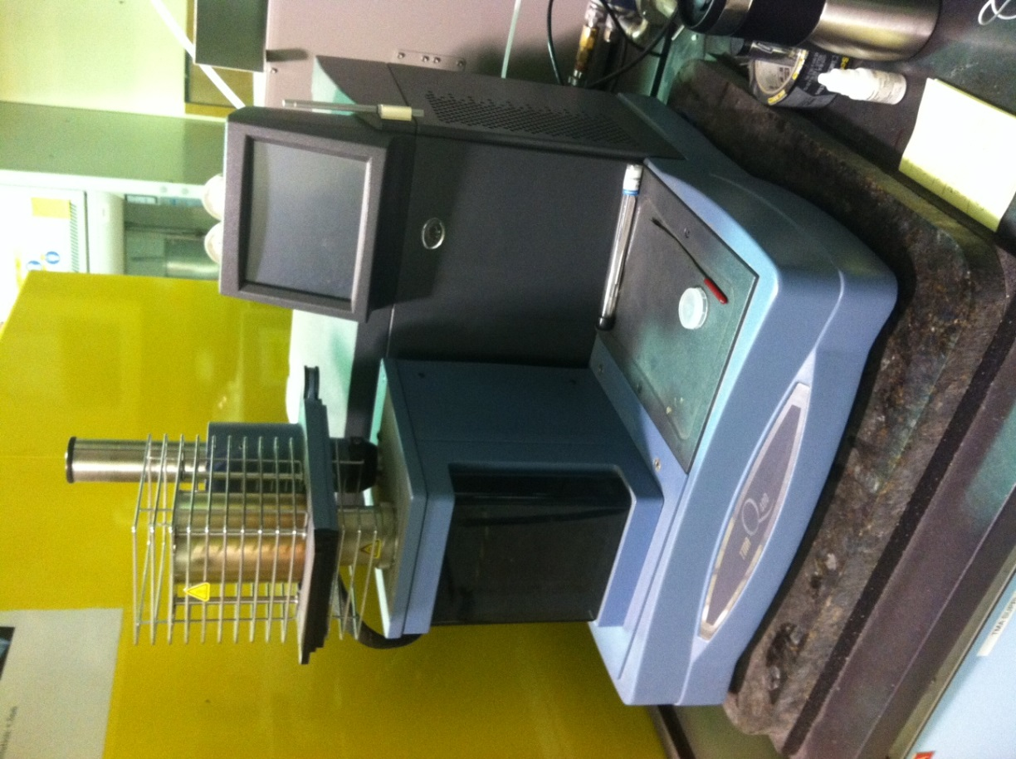

General information
A thermomechanical analyser reassures sample dimensional changes under conditions of controlled temperature, time, force, and atmosphere. In our lab we use TMA Q400 with vertical furnace. It is a high performance, ease-of-use device that is reliable and can be used in a wide variety of applications, including:
- Shrinkage Force Testing
- File Tensile Testing
- Fiber Stress/Strain Measurements
- Thermal Stress Analysis of Fibers
- Creep Analysis
- Stress Relaxation Analysis
- Viscoelastic Property Determination - Dynamic TMA
- Separation Overlapping Transition - Modulated TMA

Specifications:

Temperature Range (max): -150 to 1000ºC
Temperature Precision: ±1ºC
Furnace Cool Down Time (air cooling): <10 min from 600ºC to 50ºC
Maximum Sample Size – Solid: 26mm (L) x 10 mm (D)
Measurement Precision: ±0.1%
Sensitivity: 15nm
Displacement Resolution: <0.5nm
Force Range: 0.001 to 2N
Force Resolution: 0.001N

Standard Operating Procedure
- Switch on the instrument (Power On switch at the back of the instrument)
- These controls can be controlled using the computer | 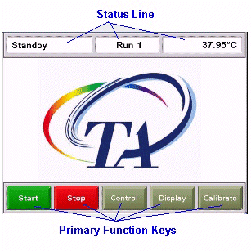
- Click on TA Explorer icon on desktop, select TMA. Should get following screen.
- Then by double clicking the above icon you will get the following screen.  - Perform Calibration – Force (do it once a month)  - Perform Calibration – Cell/Temp with Indium (refer procedure In Help) | 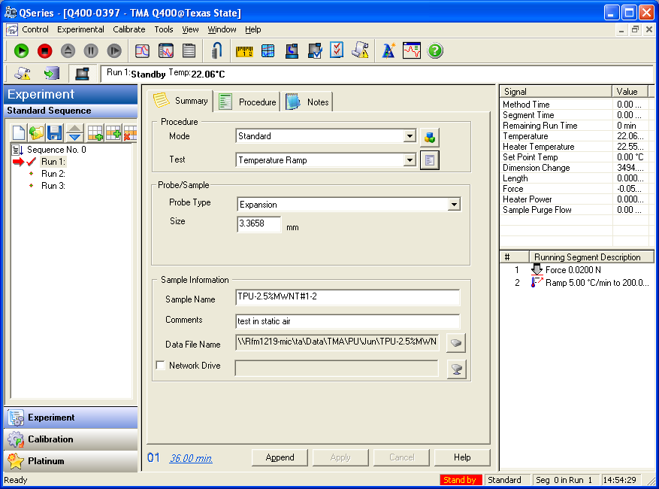
- In the above screen you will see 3 tabs i.e summary, procedure and notes. Before starting the test you can change the parameters as per the test.

Setup parameters for Tg and CTE
  - Summary
- Mode is in the “standard”.
- Test is in the “Temperature Ramp”.
- Probe type is whatever you use keep that one. For Tg and CTE we use the expansion probe. Perform Calibration-Probe (do this every time you change the probe) . This probe calibration is explained below.

- Size is the value that TMA measures and shows the value of the specimen size before the test starts.

- In sample information you can fill the information about the sample for example you can see the following picture.

- Next if you go to the second tab i.e “procedure”, you can set the test parameters here. The picture appears as

- In this above tab, you can keep the test as “Temperature Ramp”.
- Pre load force is 0.01 N as per the requirements.
- If you go to the method in the bottom of the above picture, you can set the “Applied Force to 0.02 N”.
- Start temperature “Use current”.
- Final temperature you can set it to 200 degree Celsius depending upon your requirement.
- Ramp rate is set to 5 degree Celsius per minute. ( This depends upon your test)
- If you want to the “Final Temperature” beyond 400 degree Celsius make sure to uncheck the “MCA attached” option
Tools→ Instrument preference→ TMA

- If you go to the “Advanced” in Method section in the above figure, You can keep the parameters as shown in the figure | 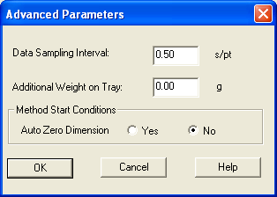
- If you go to the “Post Test” in Method section in the above figure, You can keep the parameters as shown in the figure | 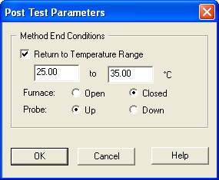
- Next go to the 3rd Tab i.e “Notes”, you can see the pic as:

In this you can write some notes like the Operator name, some information about the specimen in “Extended Text” and you can fill some extra information as seen in above picture.

- Whenever you change the probe you have to calibrate the probe by going to “Calibrate” tab and go to probe.

- Now after doing everything with these three tabs. Go to the “Control” tab at the top left of the above picture and follow the steps for doing Tg and CTE.
Control
- Go to “Contol”-then “Furnace”- then“open”. Then you move the furnace to left side so that you can easily load the sample.
- First we have to zero the length i.e go to “Contol”-then “length”- then“Zero” . Zeroing of the length will be done.
- Then go to “Contol”-then “probe”- then“up”
- Then Load the specimen such that it should not touch the thermocouple. The specimen should be very flat.
- go to “Contol”-then “length”- then“measure”. Now it will measure the exact length of the specimen and the you can see this measurement in the size box in millimeters. Then bring the “Furnace” from left side to the straight as before.
- Now Go to “Contol”-then “Furnace”- then“Close”.
- Now go to the “Start Button” which is like a Play button in the green color.
- The test will go on until the required temperature and stops. If you want to stop in the middle just hit the stop button in the red color.
- After test is done you can open the furnace and remove the sample by going to “Contol”-then “Furnace”- then“open” and then go to “Contol”-then “probe”- then“up”. Now you can remove the sample.
- If you perform the multiple tests , it is better you keep the dry ice with you. Keep the Dry ice after each test in the furnace holder.
- Then the entire data will be saved in the folder that you put. This saved data can be opened using the “ Universal Analysis” Software where you can calculate the Tg and CTE values.

Setup parameters for Flexure

- This is same as the above Tg and CTE but you need to change the Probe to “Flexure” .
- Whenever you change the probe you have to calibrate the probe as we did in the above procedure.
- Then there is a specimen holder where you can keep the specimen for flexure type. You have to keep the specimen holder on the stage and specimen should be kept on top of it.
- Do the same procedure as the previous one but the parameters will change according to the flexure test requirements that you can get from the ASTM standards.

Calibrating the TMA

To obtain accurate experimental results, calibrate the TMA when you first install it. To keep your TMA working to the highest level of performance possible, you should calibrate periodically thereafter.
- Probe calibration
- Force Calibration
- Temperature Calibration
- Cell constatnt Calibration

This procedure, sometimes called “initializing,” is used to calibrate zero force, the LVDT and the probe's compliance. This corrects for any difference in the different probes used on the TMA and should be done every time you change the instrument mode or when you change a probe on the TMA.

Probe Calibration Using the Controller
- Install the desired probe. Select Calibrate/Probe from the menu or located on the tool bar to open the Probe Calibration window. The Status of the probe and the Probe type are shown.
- Select the installed probe from the list.
- Remove any items from the weight tray and sample stage.
- Click the Calibrate button to begin.
- Click the Exit button when finished.
If you click the Abort button, you will need to come back and calibrate the probe later. The instrument will retain the probe calibration from the previous probe.

Force Calibration

Perform the force calibration procedure in the following situations:
- When you first receive the instrument
- When you change software
- Periodically (approximately once a month).

Calibrating TMA Force Using the Controller
Select Calibrate/Force from the instrument control menu and follow the directions that appear on the screen and are detailed in the following steps:

Step 1: Calibrate Zero Weight
The first step is performed to provide a zero reference point for calibration.
- Install the desired probe and its stage on the TMA. (Any probe type may be used.) If the probe type displayed is not correct, select Cancel to exit the calibration. Select the correct probe on the summary page, then click the Apply button. Clear the weight tray and the sample stage of any items.
- Select Calibrate to start the zero weight calibration.
- Wait for the calibration to be completed then select Next to advance to the next calibration step.

Step 2: Calibrate First Weight
This step is performed to provide a first calibration reference point. The recommended weight amount is 50 grams, although from 10 to 100 grams is allowable.
- Enter the weight, in grams, of the standard you are using. The first weight value entered must be between 10.0 and 100.0 grams. Keep in mind that the second weight in this calibration must be heavier than the first.
- Place the first weight on the weight tray.
- Select Calibrate to start this calibration.
- Wait for the calibration to be completed then select Next to advance to the next calibration step.
NOTE: If you choose Abort, you must restart from step 1 to complete the force calibration or select Exit to cancel the calibration.

Step 3: Calibrate Second Weight
This step is performed to provide a standard calibration reference point. The recommended weight amount is 100 grams.
- Enter the weight, in grams, of the standard you are using. The second weight value entered must be heavier than the first and be between 10.0 and 100.0 grams.
- Place the standard weight on the weight tray.
- Select Calibrate to start this calibration.
- Wait for the calibration to be completed then select Next to advance to the next calibration step.
NOTE: If you choose Abort, you must restart from step 1 to complete the force calibration or select Exit to cancel the calibration.

Step 4: Observe and Evaluate Results
The force calibration constants for weights 1 and 2 are calculated and displayed. The values should be acceptable if they fall within the Specifications displayed at the bottom of the window.
- If the force weights 1 or 2 calibration Slope and Offset fall within this range (marked as Passed), select Save.
- If the force weights 1 or 2 calibration Slope and Offset do not fall within the acceptable range (marked as Failed), select Exit and repeat the calibration procedure.
- Remove the weight from the tray when the calibration is complete.

Temperature calibration

Calibrating the TMA Temperature

Temperature calibration is based on a run in which a temperature standard (e.g., indium) is heated through its melting point. The recorded melting point of this standard is compared to the known melting point, and the difference is calculated for temperature calibration.
In addition, you can use up to four other standards to calibrate temperature. If you use one pair of known and observed points, the entire curve is offset, or shifted, to the actual melting point. If you use multiple standards, the temperature is corrected by a cubic spline fit. The multiple-point temperature calibration is more accurate than the one-point calibration.
This calibration should be performed when the sample thermocouple is changed, periodically (approximately once a month), and when you are changing the temperature range of interest.
- Select and install the desired probe on the TMA.
- Check that your purge gas is connected and set to the desired flow rate.
- Select Experiment View and access the summary page, then set the instrument to "Calibration" mode using the Mode drop-down list. (In the calibration mode the current temperature table data is ignored.)
- If you are switching between the probes, you will need to perform Probe calibration.
- Select the Ramp test from the Test list.
- Click on the Procedure tab. Enter the requested test parameters that will program the TMA to:
- Start the experiment at least 20°C below the desired start temperature limit.
- Heat the material, at the same heating rate that you will use in your subsequent experiments, to 20°C above the desired upper temperature limit. Use a preload and applied force of 0.01 to 0.05 N.
- Click on the notes tab. Enter/verify the requested information. If an MFC is installed, set the desired flow rate.
- Click on the Apply button to save the experimental and sample parameters entered for this run.
- Zero the probe using the ZERO LENGTH on the TMA touch screen.
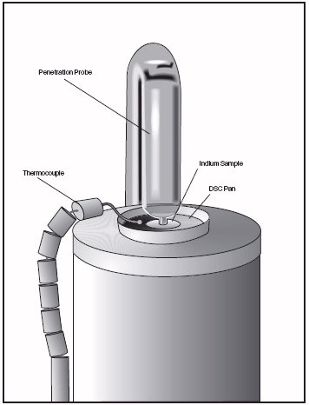
- Load the melting standard on the stage. For all probe types, except the film/fiber accessory, small flattened pieces of standard metals are placed on the stage. To protect the stage from amalgamation with the metal, it is recommended that a DSC pan or aluminum or platinum be placed between the stage and the metal standard. The end of the probe can also be wrapped with foil for added protection. For the film/fiber probe, metal wires can be crimped into the aluminum balls and used for calibration.
- Verify the thermocouple position. For all probes, except film/fiber accessory, position the tip of the thermocouple so that it is against the platform. The tip should be angled towards the sample location. For the film/fiber accessory, position the thermocouple tip so that it is at the middle of the sample length.
- Press MEASURE on the TMA touch screen. The size field on the Experimental View will be updated automatically once this process is complete. (Note that MEASURE is not applicable for the flexural probe.)
- If more than one run is in the run sequence list, schedule this run. (An arrow will appear next to the run number in the run sequence list for the scheduled run.) Select Start to begin the calibration run.
- Wait until the run is complete, then access the calibration program using Calibrate/Analysis on the TMA Menu. Select Open File on the Calibration window and then select the TMA temperature data file created above. Analyze the temperature data using the Analyze function to determine the onset of melting. Position the analysis markers before and after the onset of melting on the curve.
- Save the calibration results by clicking the Accept button (or by selecting Analyze/Accept results from the calibration menu). This will update the current temperature parameters with this calibration data.

Cell constant calibration

Calibrating TMA Cell Constant

Cell constant calibration is based on a run in which a known sample (standard) is heated through its transition temperature, and data is gathered for analysis. The cell constant is calculated by dividing the actual coefficient of expansion of the standard by the measured coefficient of expansion.
Follow these steps when gathering and analyzing TMA cell constant calibration data:
- Select and install the desired probe on the TMA. If you are switching probes you will need to perform the probe calibration procedure.
- Check that your purge gas is connected and set to the desired flow rate.
- Select Experiment View and access the summary page, then set the instrument to "Calibration" mode using the Mode drop-down list. (In the calibration mode the current temperature table data is ignored.) Select the Ramp test from the Test list.
- Click on the Procedure tab. Enter the requested test parameters that will program the TMA to:
- Start the experiment at least 20°C below the desired start temperature limit.
- Heat the material, at the same heating rate that you will use in your subsequent experiments, to 20°C above the desired upper temperature limit. Use a preload and applied force of 0.01 to 0.05 N.
- Click on the notes tab. Enter/verify the requested information. If an MFC is installed, set the desired flow rate.
- Click on the Apply button to save the experimental and sample parameters entered for this run.
- Zero the probe using the ZERO LENGTH on the TMA touch screen.
- Load the aluminum standard found in the TMA Accessory Kit or use aluminum foil for the film/fiber probe. (A copper standard may also be used.)
- Verify the thermocouple position. For all probes, except film/fiber accessory, position the tip of the thermocouple so that it is against the platform. The tip should be angled towards the sample location. For the film/fiber accessory, position the thermocouple tip so that it is at the middle of the sample length.
- Press MEASURE on the TMA touch screen.
- The size field on the Experimental View will be updated automatically once this process is complete.
- If more than one run is in the run sequence list, schedule this run. (An arrow will appear next to the run number in the run sequence list for the scheduled run.) Select Start to begin the calibration run.
- Wait until the run is complete, then access the calibration program using Calibrate/Analysis on the TMA Menu. Select Open File on the Calibration window and then select the TMA cell constant calibration data file created above. Determine the cell constant results using the Analyze function.
- Save the calibration results by clicking the Accept button (or by selecting Analyze/Accept results from the calibration menu). This will update the current cell parameters with this calibration data.

- Analyzing the test
- Go to Universal Analysis and open the data fie.
- When you open the file you will see the graph of particular test as shown in the figure.
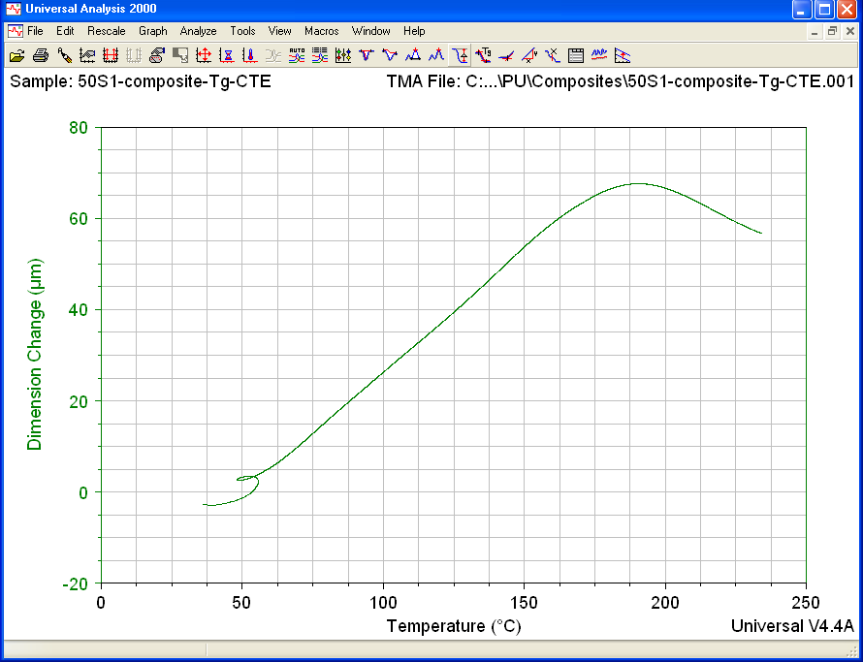

In this graph keep the cursor and right click and go to “Alpha fit X1 to X2” where it will show the following figure
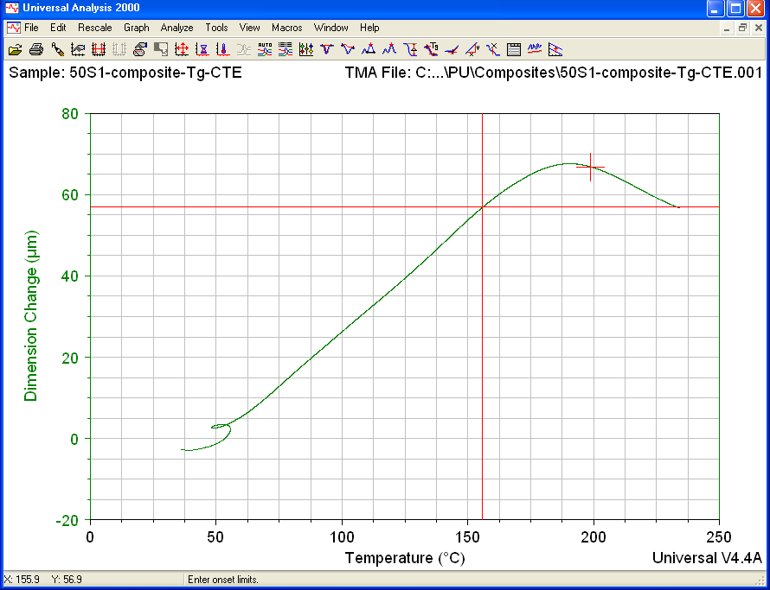

In the above you will see the two red “plus Marks” where you have to drag them so that the region between them shows the drastic change. After you fix the positions of those red “plus Marks” , right click and “Accept Limits”. Then you will see the following figure
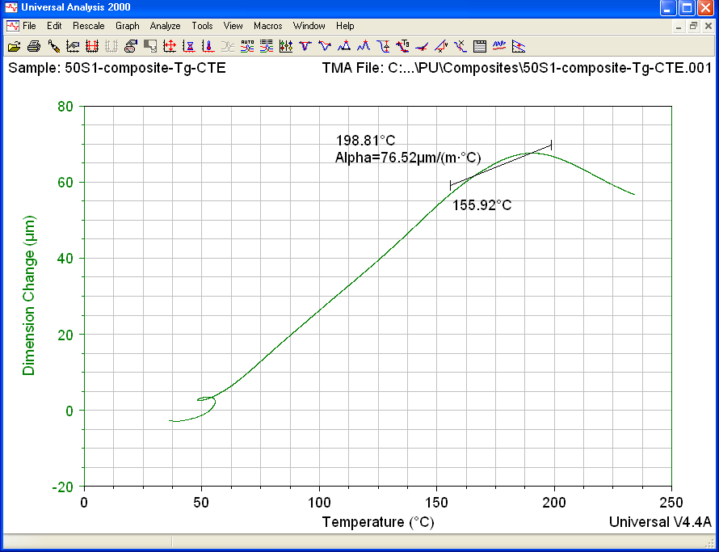

Shutting down the instrument.

- Utility Menu, Control –shut down
- On TMA screen message “Shutdown complete” It is safe to reboot your computer.
- Then swith off the TMA button which is located on back on TMA.

Exporting Data file for TMA, TGA, and DSC tests

  - Open TA Universal Analysis software and open the particular file.
  - Go to File then click on Export Data file.
  - After that click on File and Plot signals only.
  - Choose particular output format such as .txt, ASCII data file.
  - Click on finish and save the output file to particular location.
  - Similarly export PDF or plot graphs.

