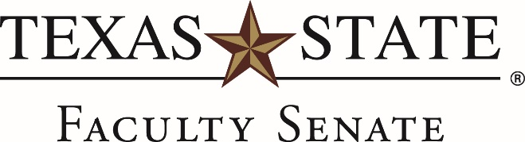

RESOLUTION IN SUPPORT OF AFFORDABLE LEARNING MATERIALS

WHEREAS: Access to quality instructional materials is critical to student academic success; and
WHEREAS: The significant rise in costs of textbooks can be a barrier to college attendance, student access, and student success; and
WHEREAS: Faculty are solely responsible for the selection of appropriate instructional materials in their courses; and
WHEREAS: The use of reduced cost or open educational resources (OER) is recognized as a promising strategy for meeting the goals of 60x30TX, the Texas higher education strategic plan; and
WHEREAS: The Texas Legislature adopted Senate Bill 810 in 2017, which establishes a grant program to encourage the use of open educational resources, and requires institutions of higher education to make reasonable efforts to disseminate information to students about institutional programs for textbook cost-savings strategies.
BE IT RESOLVED: That the Faculty Senate of Texas State University reaffirms the academic freedom of faculty to choose appropriate instructional materials for their students; and
BE IT FURTHER RESOLVED: That the Faculty Senate of Texas State University supports and encourages its faculty to consider using high quality, low cost or no cost, accessible instructional material alternatives including open educational resources.
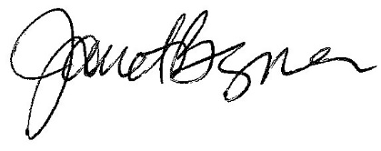
March 26, 2020
Janet Bezner, Chair

