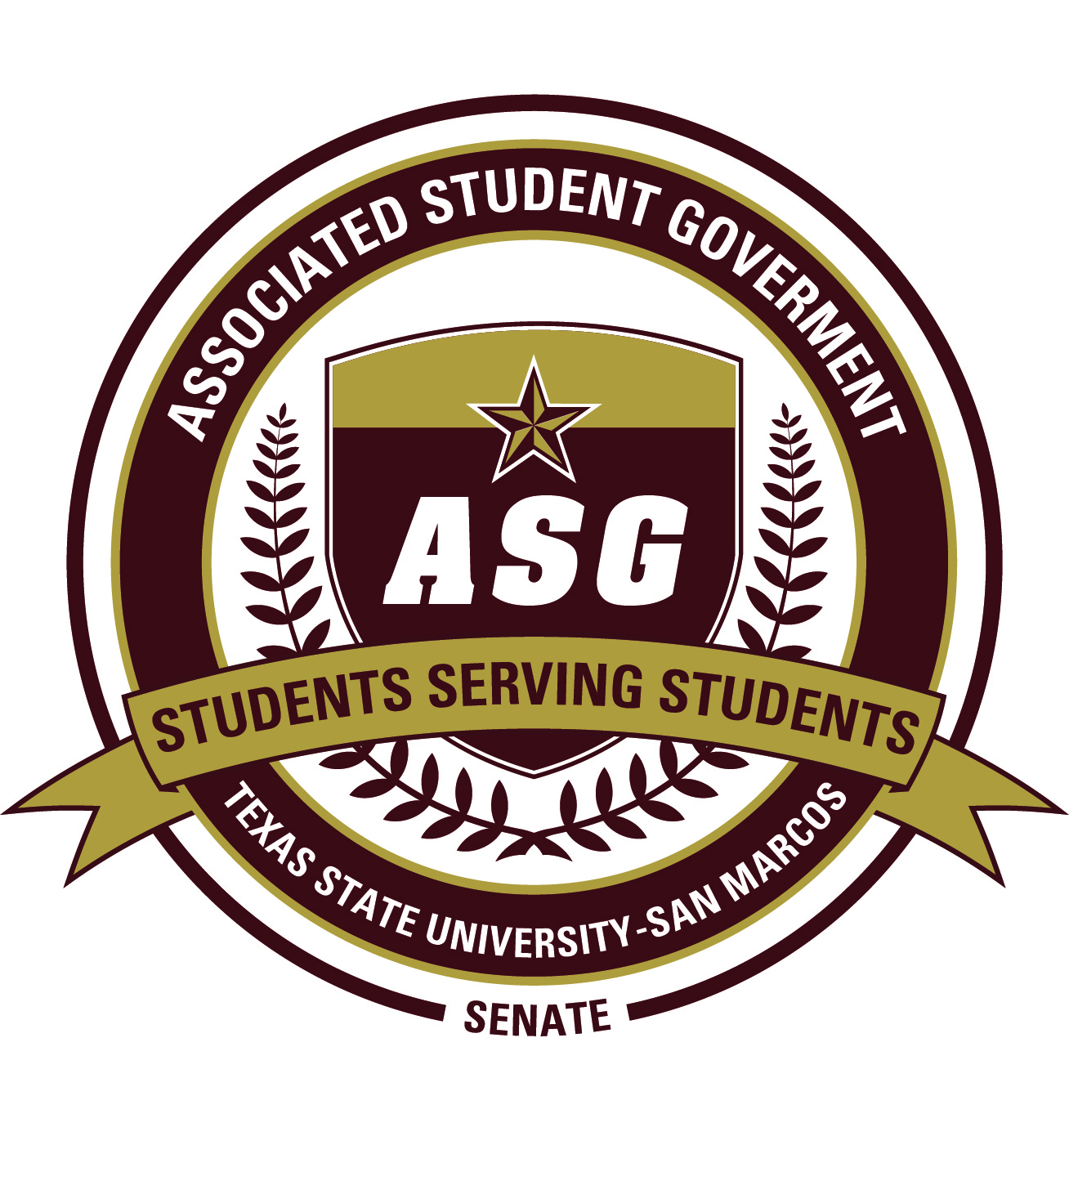
AUTHOR:
Sen. David Blanch

SPONSORS:
Sen. Adam Brass
Sen. Dominique Jackson
Sen. Joseph Flores
Sen. Paige Cook
Sen. Nicolle Guice
Sen. Caitlin Wilkerson

Date of First Reading: April 16th, 2012

S.R.F. 2011-2012/9

“Alcohol Sales Act of 2012”

- Whereas: The Associated Student Government at Texas State University-San
Marcos strives to promote pride and tradition throughout the campus community; and

- Whereas: the Athletics Department is always looking for ways to increase attendance at various sporting events, including football; and

- Whereas: on February 12 and 13, 2008; Texas State students voted 4,738 to 1,214 to increase student athletic fees in $2 per-year increments over five years; and

- Whereas: it is projected that students will pay $11,818,000 to support athletics in the 2012 annual budget; and

- Whereas: Texas State University-San Marcos competes in the Southland Conference for all sports, except football where they compete in the Football Championship Subdivision (FCS) as an independent; and

- Whereas: Southland Conference bylaws prohibit the sale of alcohol at on-campus facilities, except in premium seating areas; and

- Whereas: since its opening in 2009, alcoholic beverages have been sold in club and suite seating levels in The Jerry D and Linda Gregg Fields West Side Complex at Bobcat Stadium; and

- Whereas: Texas State University-San Marcos accepted an invitation to join the Western Athletic Conference (WAC) on November 10, 2010, thus beginning the transition to compete in the Football Bowl Subdivision (FBS); and

- Whereas: the Western Athletic Conference (WAC) does not prohibit the sale of alcohol at on-campus facilities and has had several member institutions sell alcohol at basketball, football, and hockey facilities; and

- Whereas: former and future members that sell alcohol include University of Nevada-Reno (Nevada), University of Hawaii-Monoa (Hawaii), University of Denver (Denver), and University of Texas-San Antonio (UTSA); therefore

- Be it resolved: that Texas State University-San Marcos implement a one-year pilot program as depicted in “Proposal to Sell Alcohol in all Seating Areas at Bobcat Stadium;” and

- Be it further resolved: that discretion be given to the Athletics Director as to how stadium-wide alcohol sales would be ultimately implemented at Texas State University-San Marcos; and

- Be it further resolved: that this piece of legislation be forwarded to ASG Advisor Kathy Weiser, Dean of Students Dr. Margarita Arellano, Head Football Coach Dennis Franchione, Athletics Director Dr. Larry Teis, Vice President for Student Affairs Dr. Joanne Smith, Vice President of Academic Affairs Dr. Gene Bourgeois, and University President Dr. Denise Trauth upon its passage.

