BLR |  |  | 1st Floor
Mon-Fri Sat-Sun | 7:00am Closed | - | 6:00pm
George’s
Mon-Fri Sat-Sun | Closed Closed
Basement
Chick-fil-A
Mon-Thur | 10:30am | - | 5:00pm
Fri | 10:30am | - | 2:00pm
Sat-Sun | Closed
Starbucks
Mon-Fri | 7:30am | - | 2:00pm
Sat-Sun | Closed
Tu Tacos
Mon-Sun | Closed
Information Desk |  |  | 2nd Floor
Mon-Fri Sat-Sun | 8:00am Closed | - | 5:00pm
Lair
Pizza Hut, Coyote Jack's, Wild Greens, Mondo Subs
Mon-Sun Closed
Outtakes Paws Market
Mon-Fri Sat-Sun | 9:00am Closed | - | 5:00pm
Parking Services
Open 24 hours | h ttp://www.parking.txstate.edu/visitors#pay-park
University Bookstore
Mon-Fri Sat-Sun | 8:00am Closed | - | 2:00pm
ID Services
Mon-Fri Sat-Sun | 8:00am Closed | - | 5:00pm
Wells Fargo
Mon-Fri Sat-Sun | Closed Closed

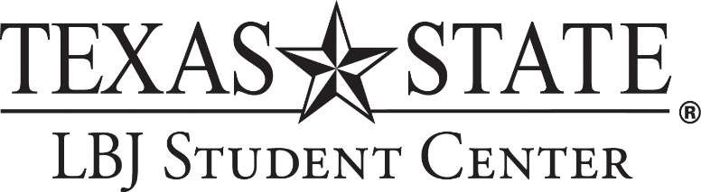

OPERATING MEMORANDUM

March 30 - April 12, 2020

Building Hours

Monday-Friday 7:00 am-6:00 pm
Saturday, Sunday CLOSED

***All hours are subject to change

Conference Services
Mon-Fri Sat-Sun |  | 8:00am Closed | - | 5:00pm
Welcome Center |  |  |  | 3rd Floor
Monday-Friday** Sat-Sun | **No Tours | 8:00am Closed | - | 5:00pm
Student Involvement |  |  |  | 4th Floor
Mon-Fri Sat-Sun |  | 8:00am Closed | - | 5:00pm

