Requesting N e t I D and AA Number to complete Rec for Hire in PeopleAdmin

Net ID Request
This program is required:
- To create the AA Number and NetID for all new salaried staff, and faculty being recommended for hire in PeopleAdmin.
- To reactivate a previous NetID for an individual who is being rehired, or students going to staff positions;

* Upon completion of the NET ID request, the hiring department is responsible for entering the Net ID an AA# into PeopleAdmin. These credentials will not be emailed. The requestor will log back into the Net ID portal and either plug the credentials directly into the Rec for Hire, or share with the hiring manager to plug into the Rec for Hire.

Net ID Request Process
Prepare Before You Begin
- Be accurate! Once requests are submitted, you cannot go back and edit the request details.
- You will need the candidate’s name, email address, phone number, date of birth, and social security number. This information may be found on the candidate’s criminal history check request form.
- Set the expiration date out as far as possible because the requests expire (at least 45 days), then you will be required to complete another request.

The Process
- NetID Request website: https://tim.txstate.edu/netidrequest
- Log in with your NetID and password.
- Click Create a New Request.
- Complete the appropriate form fields.
- Select TxState Staff or Faculty as appropriate
- In the field Sponsorship Reason: enter the candidate’s last name and/or job posting number.

7. Click Review & Confirm.
8. Click Submit Request.
9. An e-mail with instructions will be sent to the Requestor and Sponsor when processingis complete.
10. Log back into the NetID portal, click the arrow next to the request, expand and scroll down to see the AA Number and NetID - enter this data into the NetID request fields in the Rec for Hire.
Complete the Form Accurately and According to Instructions

Here are some helpful details!

Faculty | - Gives basic faculty access. This is intended for future faculty only.  - Set the expiration date 30-45 days after the expected hire date to allow time for the PCR to be processed  - If the faculty becomes permanent before the expiration date, the account will not be disabled
Staff | - Gives basic staff access. This is intended for future staff only.  - Set the expiration date 30-45 days after the expected hire date to allow time forthe PCR to be processed  - If the staff becomes permanent before the expiration date, the account will not be disabled
Figure 1. NetID Types

Request Info Section
- You only see NetID types that you have been given access to request.
- Select an expiration date. See Figure 1 (above) for expiration guidelines.
Requestor and Sponsor Sections
- Select either the checkbox next to I am also the sponsor, or enter the NetID of the Sponsor.
- A Sponsor phone number is required and will not fill in automatically if you are the sponsor.
User’s Section
- There are two ways to add the new NetID names – skip to H: (1) Enter individuals by selecting Add New User
- Import CV file for multiple entries
- Follow instructions for CV file
- Complete required fields for entry
- Expand drop down arrow to see assigned Net ID and Tx State ID Number.

Important Notes

H. Fill in the form completely and accurately. Use the person’s formal first and last name (no nicknames). Do not guess on any information. Incorrect data may lead to duplicate accounts, delay processing, and result in rejection. If your request is not approved, you will be required to start over with a new request.

SEE BELOW FOR ILLUSTRATION OF SCREEN

If you have questions about how to complete this form contact Human Resources at 512.245.2557 or Faculty Records at 512.245.2786.
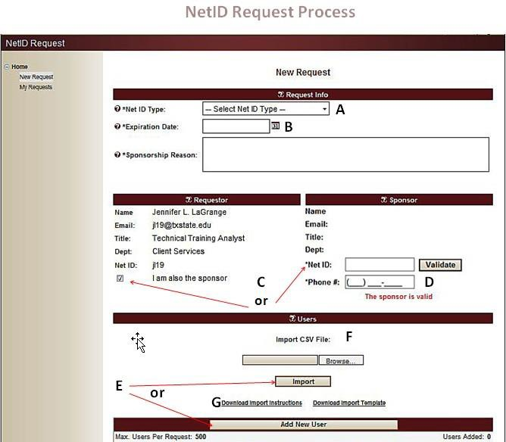

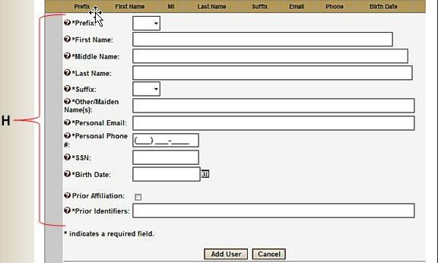

Expanding request to see Net ID and AA Number

I. Expand this arrow and scroll down to see Tx State ID and Net ID assignment for the PeopleAdmin Rec for Hire.

