Internal Review Round
Internal Review Round allows authorized users in the following offices: Procurement and Strategic Sourcing (P&SS), Facilities, Planning Design & Construction, ALERRT and Information Technology; to send a contract to any internal Texas State employee(s) for approvals required in the University Policy and Procedures (UPPS).. This process will be determined by UPPS requirements and the Buyer’s/Contract Specialist’s discretion.

Step-by-Step
- Buyer/Contract Specialist will create and initiate an internal review round and send the contract to the appropriate internal employee(s) and/or departmental representative(s) with a message in the “Message to Reviewers” field regarding the review.
  - Reviewers will receive a notification in the Marketplace and/or an email indicating that there is a contract to review. (To setup email notifications, see the How to Guides)
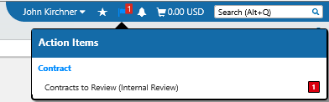
  - Reviewers will log into the Marketplace and select the “Action Flag” in the upper right-hand corner next to their name. A drop-down menu will appear, select the “Contracts to Review (Internal Review)”.
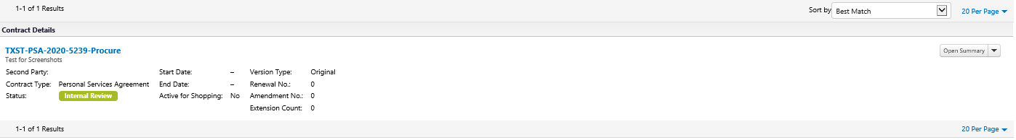
  - Click the blue colored Contract Number that you will be reviewing.
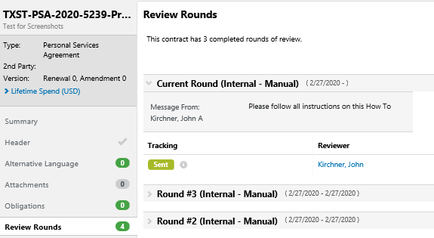
  - Read message left by Contract Manager to see what needs to reviewed, or what question(s) is/are being asked.

  - Click “Actions=>Checkout” to edit and update the contract.
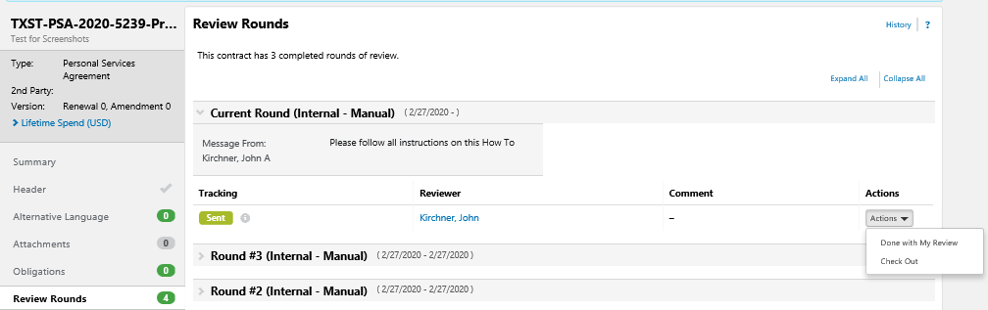
Note: Only one user may checkout the contract for changes at a time. Only after the other user has checked it in, may the subsequent user check it out. If you are unable to check out the contract, please look to see who has it checked out and ask them to check it back in.
  - Complete Review of the contract (Only use the “Attachments” Tab and the “Review Rounds” Tab
    - Internal Reviewer will review only the part they are responsible for.
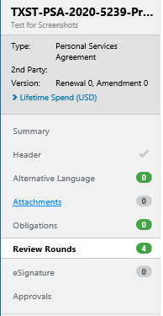
    - Click on the “Attachments” Tab
    - Internal Review will make all changes to the document with track changes on
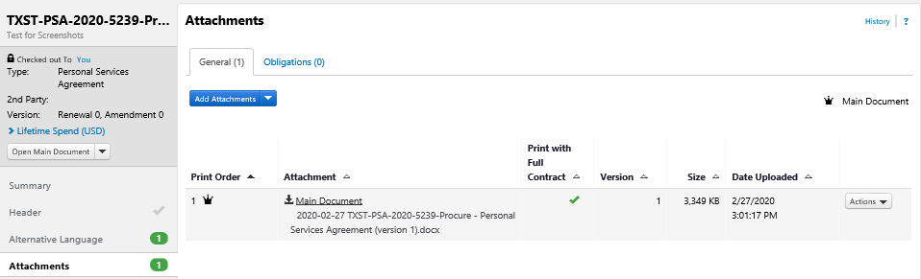
    - Click on the Attachment that you will be reviewing. A notification will pop up asking you to open the document. Open the documents and complete your review (with redlines on)
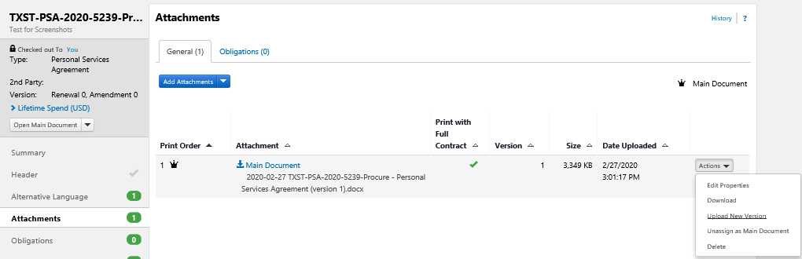
    - After making any changes to any document, the document must be uploaded as a “New Version” for the document that is being edited/reviewed.
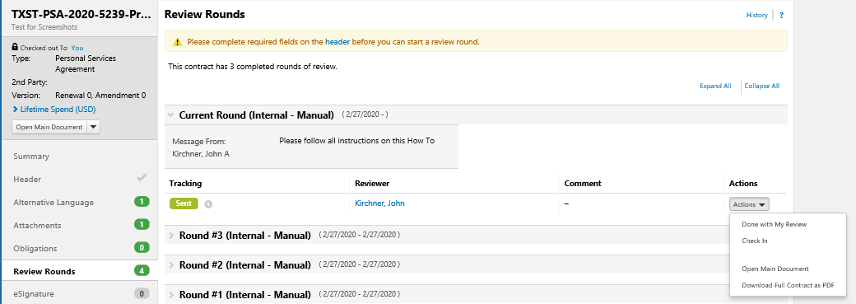
  - After uploading the new version and completing all other reviews required to be completed by you, then click on the “Review Rounds” Tab“. Click on “Actions” next to your name and then select “done with My Review” on the drop-down menu. This will complete your review.

Once all reviewers have completed their review, the review round will close, and the contract returns to Draft status. The completion of the review rounds will notify the Buyer/Contract Specialist that it is complete.

