Fact Sheet: The impacts of cocaine trafficking in Central America’s Protected Areas
This research:
- Presents case studies of three drug-trafficking hotspots existing within Central America’s remaining protected areas (Pas): Peten, Guatemala, Northeastern Honduras, and the Osa Peninsula in Costa Rica. These case studies were chosen for their importance as recognized transit nodes in regional drug trafficking networks, and in order to capture various stages of integration by drug trafficking organizations (DTOs).
- How does narco-deforestation work?: Drug traffickers seek remote landscapes to ensure physical transit routes for cocaine, but their local impact goes far beyond mere trafficking. The imperative to launder vast sums of money and establish physical control over key territories leads DTOs to rapidly expand into industries which contribute to both of these goals, such as cattle ranching, African palm, and other extractive activities. Their presence thus often implies a dramatic transformation of the local landscape, redefining boundaries and territories around new extractive economies, bringing new “regimes” of authority and control, associated with violence and the threat of violence. All of this undermines community organizations and state institutions key for conservation and development.
- Following military interdiction in Mexico, cocaine trafficking appeared first in northern Guatemala’s Petén region in the mid-2000s, then moved to Northeastern Honduras in the late 2000s, and radiated across Nicaragua’s Region Autónoma Atlántico Norte and Sur, accounting for between 15% and 30% of annual national forest loss in Nicaragua, Guatemala, and Honduras between 2000 and 2014 (Sesnie et al. 2017).
- The case of the Maya Biosphere Reserve in Peten, Guatemala is illustrative (a & b below). Forest loss in Peten’s PAs drive the national trend through the mid-2000s. While wilderness refuges, biosphere reserves and the UNESCO-designated core of the MBR suffer heavy forest losses during this period, overall, national parks are the biggest forest losers. During the same period, however, communally-managed forest concessions register very low forest losses (see rectangular polygons just northeast of the center, fig. a, b). Secure, long term local control over forests is key for preventing further emissions from narco related deforestation, as this example shows.
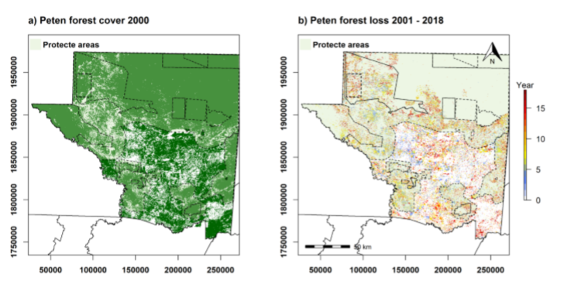
Research question and methods
- Our research asks: How does cocaine trafficking affect the environment and protected area governance in Central America? To answer this question, we interviewed over 50 conservation stakeholders from key institutions at various levels in the three drug-trafficking hotspots, and organized a mapping exercise to identify areas of drug trafficking activity and their environmental impacts. This research produced rich, spatialized information on illicit activities, and the ways in which drug trafficking influences the environment, impacts communities, and influences government institutions. Field work also included 9 workshops with 70 protected areas stakeholders to identify cultural and natural resources under threat.
Our findings:
- Cocaine trafficking is linked to multiple forms of environmental degradation inside Central American protected areas, that include land grabbing in protected areas, infill of wetland areas, forest fires, mangrove degradation, timber poaching, flora and fauna trafficking, gold mining, and airstrip and road building, to name a few.
- Investing in community land rights and participatory governance in protected areas is a key strategy to combat drug trafficking and climate change simultaneously.
- Drug trafficking impacts governance in protected areas in three ways: 1) it fuels booms in extractive activities inside protected lands; 2) it undermines long standing conservation coalitions; and 3) it exploits differences in governance models and geography. Narco-related activities undermine legal and customary forest uses and resource governance, which produce significant social and ecological costs.
- Not all PAs, forest dwelling communities, and conservation governance types are equally susceptible to the influence of DTOs. Areas of strict conservation policies like national parks where absentee states or private sector actors monopolize governance are most vulnerable. Community-based land rights and participatory resource governance can be more effective than strict conservation in deterring narco-land grabs. Geographic features, like savannahs, river systems, marine access, and proximity to international borders, make certain PAs more susceptible than others.
- The key to co-management models is secure land tenure, which takes many forms across the region, including communal titling and participatory decision-making regarding resource use. In Guatemala´s Maya Biosphere Reserve (MBR), for example, land tenure is guaranteed through 25-year forest concessions, which contrasts with communal titling conventions in Indigenous communities in Honduras.
- Community leaders from the Northeastern Honduras and Guatemala’s MBR suggest land titling is not enough; titles must be accompanied by long-term planning and financing for community organizations. As one leader explained: “If we don’t organize, we don’t develop. … And if we don’t develop, the drugs will keep moving.”
Recommendations
Invest climate change mitigation funds directly into grassroots organizations managing protected areas as a means of combating climate change and increasing security.
Forest communities must have long-term, local control over land and forest resources to avoid the dangerous anthropogenic interference in the atmosphere caused by the new illicit drivers of deforestation.
The renewal of the community concessions in the Maya Biosphere Reserve, which begin to expire in three years, is among the most pressing needs to avoid further losses.

