Tutorial on Uploading and Reviewing Research Lab and Field Research SOP Plans Using Texas State Ready (Kuali Ready) System
IMPORTANT NOTE: LAB MANAGERS MUST FIRST EMAIL THEIR TEXAS STATE NET ID AND DEPARTMENT NAME TO YS11@TXSTATE.EDU IN ORDER TO ACCESS THE KUALI PORTAL.

Step 1 – Access the Texas State Ready Page

- Open an Internet browser (the site works best on Chrome)

- Login to the Texas State Ready Dashboard https://txstate.kuali.co/ready/dashboard

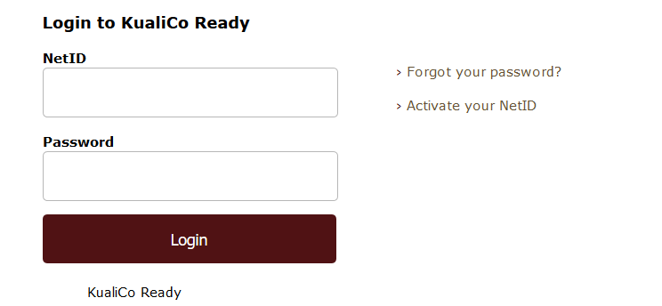

- From the Dashboard, under My Plans, locate the plan named “ACAD – Continuity of Research Work Group”
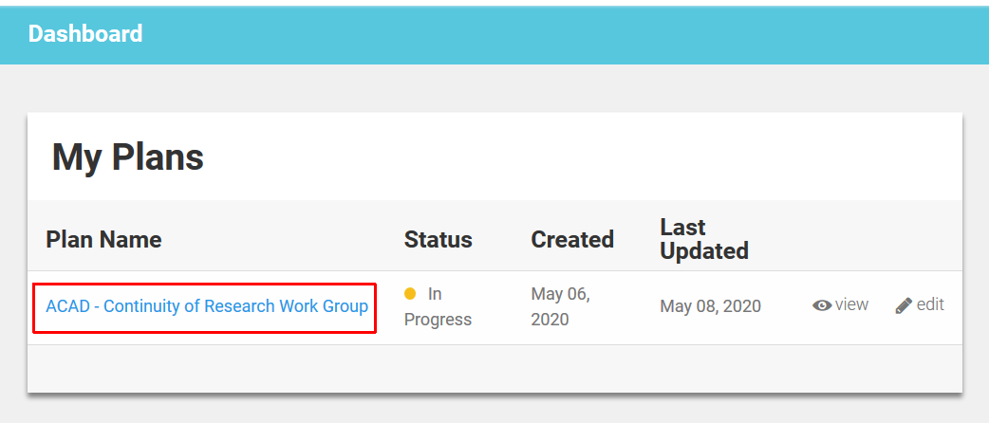

Step 2 – Locate Repository of Department and Center Plans

Click the “Continuity of Research Work Group” and then select the “Critical Functions” tab in the top center of the page.

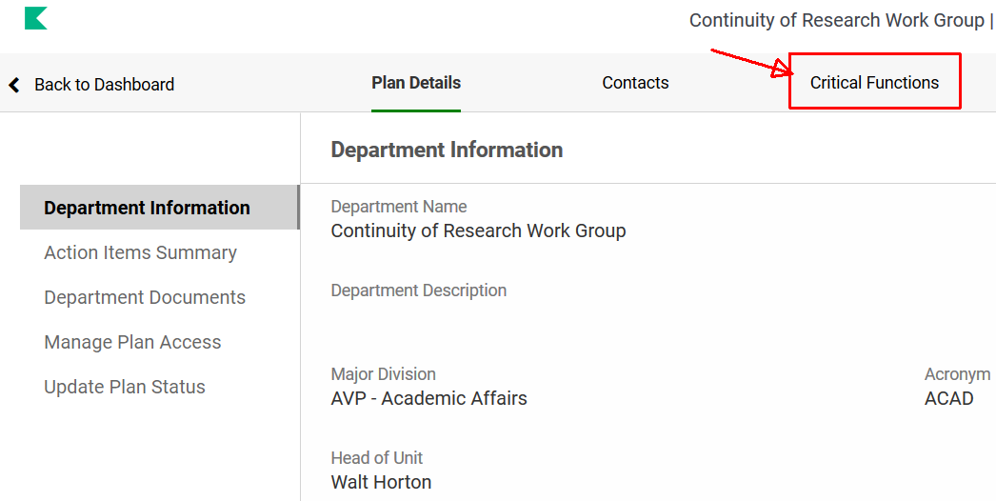

Step 3 – Locate Specific Department or Center

From the “Critical Functions” tab, locate the department/center you want to interact with from the list in the center and click the “View” button on the right.

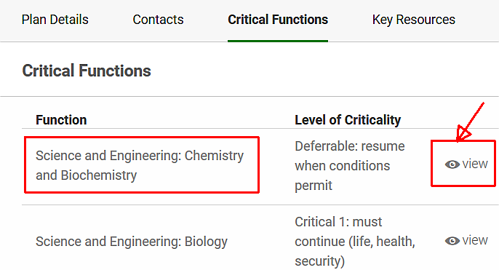

Step 4 – Locate the “Documents” for the chosen Department/Center

From within the chosen department/center page, navigate to and select the “Documents” tab on the left.

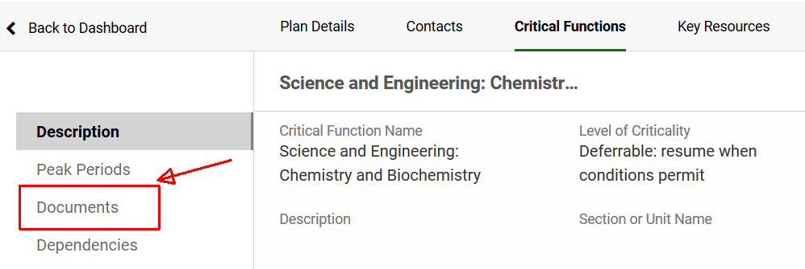

Step 5A – Document Entry and Update by the Head of a Research Lab

- Upload a SOP Document

- From within the department/center’s document page, select “Edit Page” on the right.

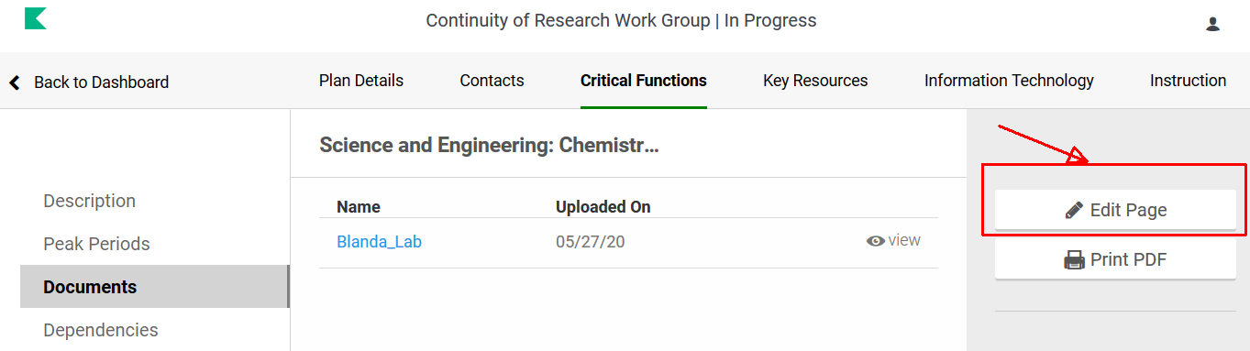

- Select “Add Document” to add a researcher filled out SOP template.

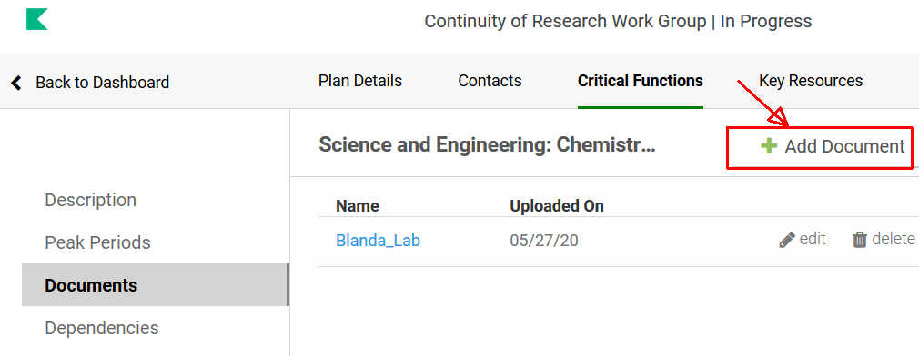

- In the “New Document” window, fill out the form as follows:

  - Name: [Researcher’s name]_Lab

Note: You do not need to fill in other boxes

  - Drag and Drop into or click the box with the label “Attachment” at the bottom to upload the researchers filled out SOP.

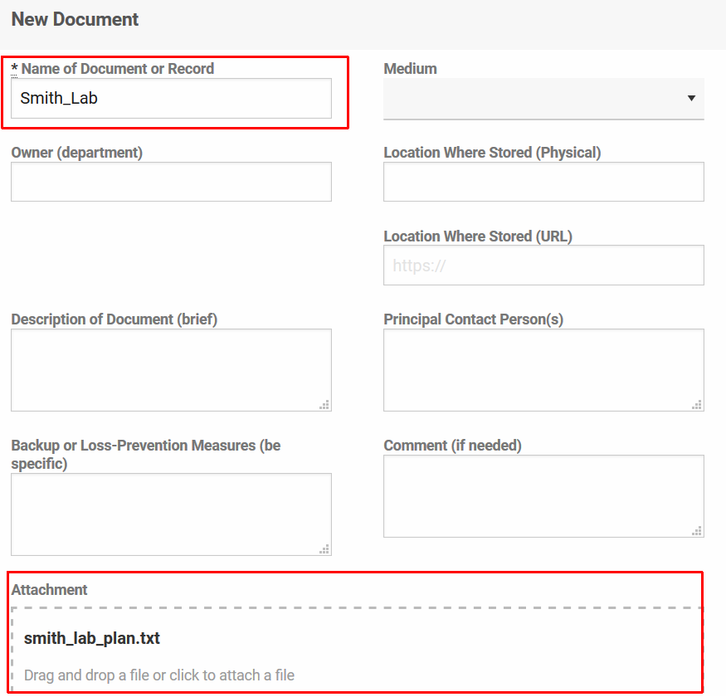
  - Select “Save”

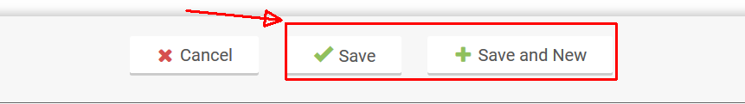

2. Update a SOP Document

*Any edits of an individual’s plan after it has been uploaded will have to be done by the author outside of the system and re-uploaded to the department/center documents page.

- Locate the document and click the “edit” button.

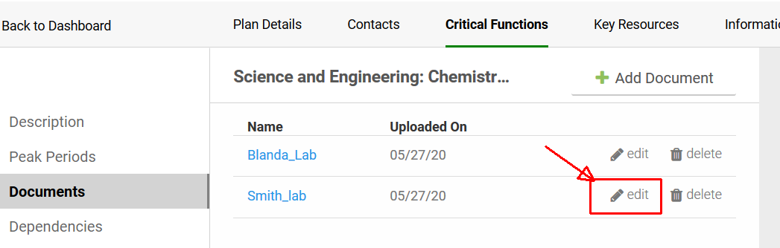

2) Click the Attachment box to upload a new SOP document.

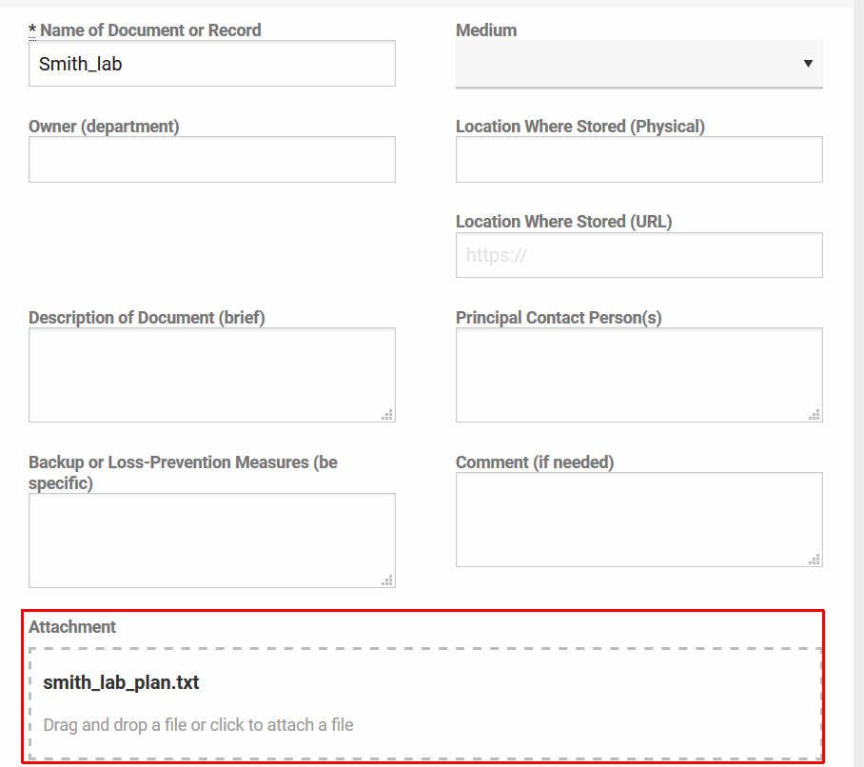

2. Delete a SOP Document

Locate the document and click the “delete” button.

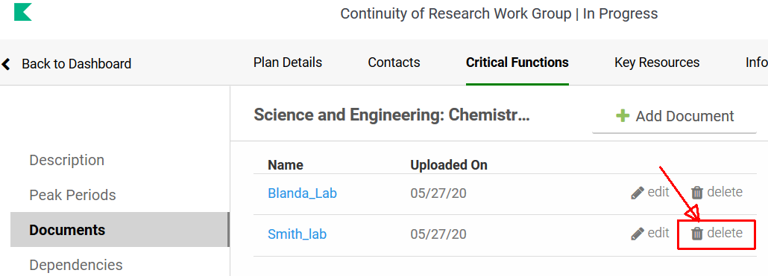

Step 5B – Document Viewing – Reviewers

- Listed in the “Documents” tab will be all the plans uploaded in for review.

- Locate the researcher plan you would like to review and select “View” to the right of it.

